**CourseraCapstone**

**Problem**: The challenge is to find a suitable apartment for rent near Hyderabad that complies with the demands on location, price and venues.

**Data required:**

The following data is required to answer the issues of the problem:

* List of Boroughs and neighborhoods of Mumbai with their geodata (latitude and longitude)
* List of Subway metro stations in Mumbai with their address location
* List of apartments for rent in Mumbai area with their addresses and price
* Preferably, a list of apartment for rent with additional information, such as price, address, area, # of beds, etc
* Venues for each Mumbai neighborhood ( than can be clustered)
* Venues for subway metro stations, as needed

**Introduction:**

Mumbai is the capital of India's Maharashtra state. It has the highest number of millionaires and billionaires among all cities in India. Mumbai is home to three UNESCO World Heritage Sites: the Elephanta Caves, Chhatrapati Shivaji Maharaj Terminus, and the city's distinctive ensemble of Victorian and Art Deco buildings.

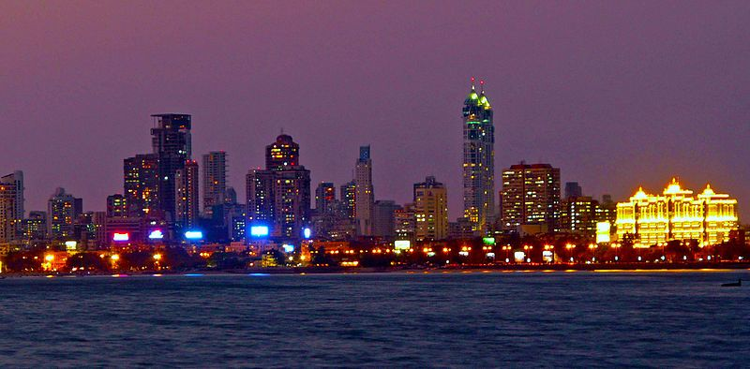

**Description of the Data**

* The following data is required to answer the issues of the problem:
* List of Boroughs and neighborhoods of Mumbai with their geodata (latitude and longitude)
* List of Subway metro stations in Mumbai with their address location
* List of apartments for rent in Mumbai area with their addresses and price
* Preferably, a list of apartment for rent with additional information, such as price, address, area, # of beds, etc
* Venues for each Mumbai neighborhood ( than can be clustered)
* Venues for subway metro stations, as needed

**Using FourSquare api obtained venues in each**

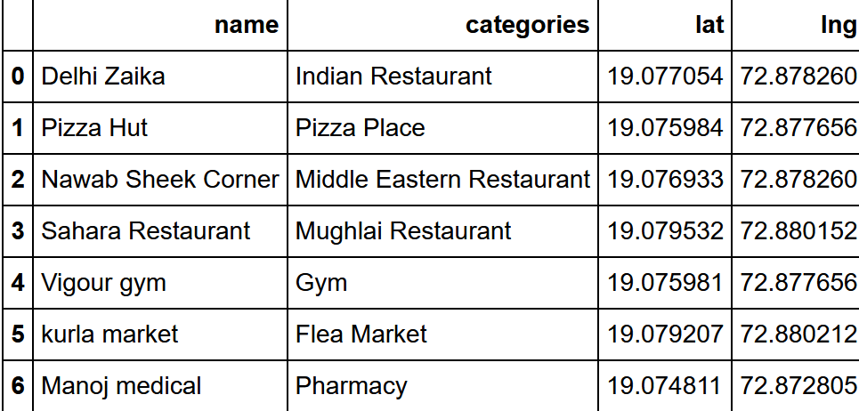

**Result:**

