**CourseraCapstone**

**Problem**: The challenge is to find a suitable apartment for rent near Hyderabad that complies with the demands on location, price and venues.

**Data required:**

The following data is required to answer the issues of the problem:

* List of Boroughs and neighborhoods of secunderabad with their geodata (latitude and longitude)
* List of Subway metro stations in secunderabad with their address location
* List of apartments for rent in secunderabad area with their addresses and price
* Preferably, a list of apartment for rent with additional information, such as price, address, area, # of beds, etc
* Venues for each secunderabad neighborhood ( than can be clustered)
* Venues for subway metro stations, as needed

**Introduction:**

Hyderabad is the capital of southern India's Telangana state. A major center for the technology industry, it's home to many upscale restaurants and shops. Its historic sites include Golconda Fort, a former diamond-trading center that was once the Qutb Shahi dynastic capital. The Charminar, a 16th-century mosque whose 4 arches support towering minarets, is an old city landmark near the long-standing Laad Bazaar.

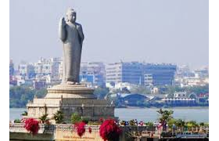

**Description of the Data**

* The following data is required to answer the issues of the problem:
* List of Boroughs and neighborhoods of secunderabad with their geodata (latitude and longitude)
* List of Subway metro stations in secunderabad with their address location
* List of apartments for rent in secunderabad area with their addresses and price
* Preferably, a list of apartment for rent with additional information, such as price, address, area, # of beds, etc
* Venues for each secunderabad neighborhood ( than can be clustered)
* Venues for subway metro stations, as needed

**Using FourSquare api obtained venues in each**

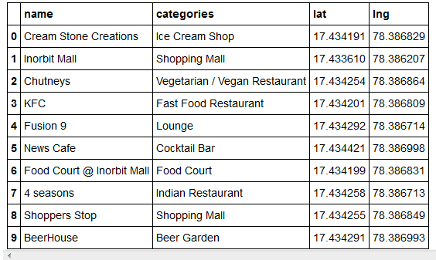

**Result:**

