MPP Midterm Exam 4/11/16

Name:__________________________ StudentId:_____________________

There are a total of 35 points possible. Write your answers on the blank paper provided. You have until12:00 Noon to complete all the questions.

---------------------------------------------------------------------------------------

1. (4pts) Name two ways of guaranteeing that no user of your class MyClass can create a subclass of MyClass.
2. (4pts) A Person may *like* other Persons, and may also be *liked by* other Persons. Draw a class diagram showing these relationships. Use one or more associations; each should have a name and appropriate multiplicities. You must indicate clearly whether associations are 1-way or 2-way.
3. (2pts) Describe one advantage of using a static method.
4. (2pts)What is the “diamond problem?” Draw a diagram showing the problem.
5. (2pts)What is Java’s approach to handle the “diamond problem?”
6. (4pts) Name two differences between interfaces and abstract classes in Java (restricted to Java SE 7 and earlier).
7. (2pts)What is the Evolving API Problem?
8. A rectangle can be specified by specifying two sides, but it can also be specified by specifying one side and a diagonal.
9. (2pts) The following code attempts to implement a Rectangle class and provide support for the two ways of constructing a Rectangle. Explain the problem with this code.
10. (4pts) Write a pseudo-code solution for the rectangle class for the solving the problem you identified in part A of this question.

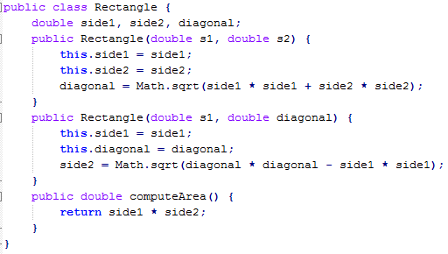

1. (9pts) Create a sequence diagram for this use case in our project management tracking system: **A developer estimates the remaining hours of development needed for a feature.** Assume the developer for this use case is already logged in. Do not show the login use case.

Business rules are:

* + 1. Remaining development time cannot be a negative number.
    2. A developer may only estimate his/her features.
    3. For each time a developer estimates the development time we want a WorkLogRecord which will contain the date and time the estimate was entered and the estimated development time remaining for the feature. WorkLogRecords will be saved in our DataAccess subsystem.

Your sequence diagram must show how you check the above business rules.