Q1) A company consists of departments. Departments are located in one or more offices, each with one or more departments. One office acts as headquarter. Each department has a set of employees and a manager recruited from this set of employees. Your task is to create a class diagram based on the above description.

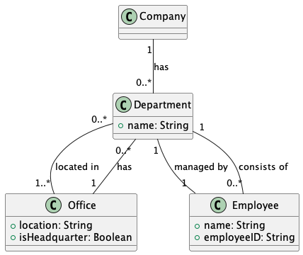

Q2) Complete the following code which has two classes having 1-1 bidirectional relationship between customer and account classes.

public class Customer {

private String name;

private Account account;

public Customer(String name, String accountId) {

this.name = name;

this.account = new Account(accountId, this);

}

public String getName() {

return name;

}

public Account getAccount() {

return account;

}

public void setAccount(Account account) {

this.account = account;

}

}

public class Account {

private String accountId;

private Customer customer;

public Account(String accountId, Customer customer) {

this.accountId = accountId;

this.customer = customer;

}

public String getAccountId() {

return accountId;

}

public Customer getCustomer() {

return customer;

}

public void setCustomer(Customer customer) {

this.customer = customer;

}

}