OEDI Task 3 Documentation – Transient Data Generation
Transient Use Case 3.a – Data Generation – IEEE 123xx Bus System with Distributed PVs
Model Selection
This document serves as a guideline for transient use case data generation using the IEEE123_PV.atp model example from the local OEDI repository. The user may first select the appropriate folder labeled by the system network model (in ATP-EMTP) format and download the corresponding zip file containing affiliated circuit data, topology zoning info and any other pertinent project files (.atp, .py, .txt, .rar, etc.).
Details of the network base case IEEE 123xx system with solar PV are given below:
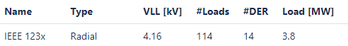

Steady State Settings
After extraction of the model zip folder into a local directory, the user may select between several IEEE123_PV.atp circuit files, each representing the same base network, but exhibiting a different loading condition and solar PV capacity. The base case (default) ATP file using 90% loading and 100% PV capacity is labeled IEEE123_PV_net.atp. See Table 1 below with a description of the various ATP steady-state (ss) cases available to the user for the IEEE123 bus network.

ATP File | Total Load Multiplier | Total Solar PV Capacity
IEEE123_PV_net.atp | 90% | 100%
IEEE123_PV_L1C1_net.atp | 36% | 20%
IEEE123_PV_L1C2_net.atp | 36% | 100%
IEEE123_PV_L2C1_net.atp | 63% | 20%
IEEE123_PV_L2C2_net.atp | 63% | 100%
IEEE123_PV_L3C1_net.atp | 90% | 20%
IEEE123_PV_L3C2_net.atp | 90% | 100%
Table 1 IEEE123 Bus Circuit SS Configurations
By brief examination of the IEEE123_PV.atp file (see line 13), you can see that this file is used to call the default case, but may be substituted using one of the above detailed .atp circuit files. Thus, the user may edit this line using a general text editor to call any of the other configuration files in place of the base case.

Transient State Settings
Next, the user may select preferred simulation transient settings, i.e. fault types and locations or select the default settings. These parameters may be reconfigured via manipulation of the python script ATPLoopFaults_all_IEEE123_PV.py or left as is for a default case study. This file is designed to run all fault types (L-G, LL-G, LLL-G) in all zones of the network. If the user wishes to run the default scenario, simply edit the necessary file paths, zone names and .pl4 destination folders for any particular zone. Otherwise, some editing of python script is required (discussed below). Additional python scripts ATPLoopFaults_xph_IEEE123_PV.py are also available for running single phase faults only (A, B, or C). The following section describes the main default case file, provides a brief explanation of the code and its purpose, and highlights locations which may be edited by the user to customize fault settings prior to execution.
Transient Settings - ATPLoopFaults_all_IEEE123_PV.py
- no_sims - sets the number of randomized fault simulations.
- run_atp_fault_case()- sets the fault parameters and runs the ATP file
  - Fault timing (line 23) - tfault = random.uniform(0.15, 0.15 + 1/60) creates a fault on a cycle sampled from a uniform distribution over the interval ($t_{min}$, $t_{max}$) in seconds.
  - ATP write parameters (lines 26-30) writes to ATP the fault parameter and simulation timing, e.g. print(‘____TMAX =0.40, file=fp)sets a 0.4 sec maximum simulation time.
  - Fault types (lines 31 – 80) – delineates conditionals to fault execution into ATP as L-G, LL-G, or LLL-G using (‘_TFAULTx__ = {:.5f}’.format(tfault), file=fp)for the associated phase x=A,B or C - where the fault is set to occur.
Additional Settings - ATPLoopFaults_all_feeders_PV.py
The ATPLoopFaults_all_feeders.py was originally intended to generate fault events on multiple different feeder models. Most of the development centered around the IEEE13 feeder, with capabilities for the IEEE123 feeder partially added. Note that many files have IEEE13 hardcoded in so use them with caution. Updates to use an options file are recommended to make future use easier. Here are a few updated features:
- run_atp_fault_case()- additional parameters now add randomness (these don’t require user adjustment)
  - Starting phase variation: ATP always starts at the same phase angle. To introduce phase variability to training data, time is added through the extra_time variable and later trimmed (in gen_npz.py).
  - Loading and PV variation: the ATP network file is now randomly selected from the available 3 different loading percentages (40%, 70%, 100%) and two generation percentations (20% and 100%).
  - Note that source voltage is hardcoded (source_vbase variable) so this must be changed depending on the feeder voltage.
- Conversions added. The end of the script now has the option to automatically call the various conversion scripts (detailed in the companion file pl4_data_conversion_documentation.doc).
The user must set directory paths to the ATP files using atp_path and an output path to store the .pl4 files created using pl4path. An accompanying .csv file in the models folder zone_info_IEEE123_PV_v2.csv contains all zones of the network, set by the zones variable read via Pandas, while the specific zone selected by the user in zone=zones.zone_xx from the .csv labels, runs a case study for the selected bus in that zone. Additional python script(s) included in the model folder create the .csv files and allow the user to manipulate their own zoning labels if preferred via zone_classification_IEEE123_PVxx.py, and are not needed for running transient simulations. Having access to such a collection of files in one package allows the user to customize their code to simulate various fault types in different locations across the distribution network, while logging transient outputs.
Finally, in ATPLoopFaults_all_IEEE123_PV.py, a for loop is used to access the zoning file at each iteration and randomly select a node/bus in the zone in which to perform the fault study. Since the network is an unbalanced, three phase distribution system, some buses will contain all three phases and others may contain only one or two phases. For example, in zone_35, bus 11 contains all three phases, noted in the zoning file by ‘11_ABC’, while bus 7 is only single phase, noted as ‘7_C’. Similarly, in zone_23, bus 44 has only two phases, noted as ‘44_AC’. The code inside the loop checks the phase count of the randomly selected bus and runs a maximum of seven fault cases (if three phase – LLL-G, LL-G, and L-G for each phase combination), three cases if the bus selected contains only two phases, or a minimum of one fault case if the bus selected is single phase only. For example, zone_23 bus 44 contains only phases A & C, thus a double line-to-ground fault case with phases A and C is run, followed by two single line-to-ground fault cases (one for each phase A and C). After running the script, we recommend the user check the generated ATP transient output using the PlotXY package (in ATP directory) to load the .pl4 files and verify correct voltage and current waveforms based on the fault condition settings.
An example of the ATP transient waveform plots for a test case run in zone_35 on bus 51 (three-phase) using the script ATPLoopFaults_all_IEEE123_PV.py are shown below. As noted above, a three-phase fault is conducted initially, followed by three double line-to-ground faults for each phase combination (only BC shown) and three single line-to-ground faults for each phase (only A shown). Output files are plotted below using PlotXY.

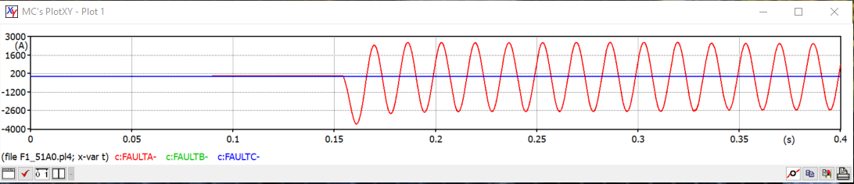
Table 2 Single Line-to-Ground Fault Phase A
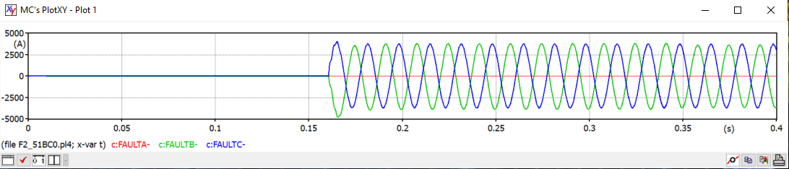
Table 3 Double Line-to-Ground Fault Phases B,C
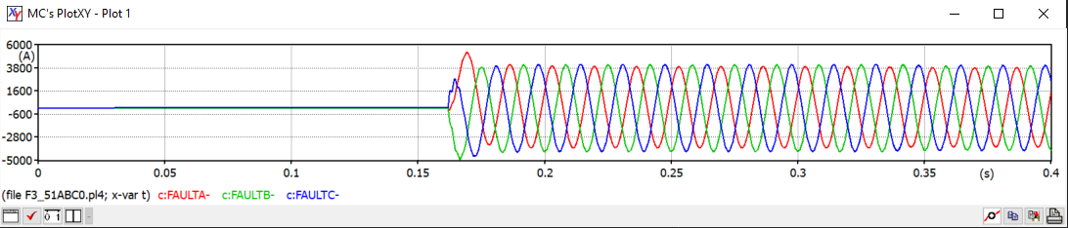
Table 4 Three phase Line-to-Ground Fault

