**Airbus A320 Neo Asobo**

# Limits

|  |  |  |
| --- | --- | --- |
| **Category** | **Pax** | **Weight [LB]** |
| **Max Payload 1)** *(Pax + Cargo, without Fuel)* |  | **47400,00** |
| Business Class | 12 Max | 2340,00 |
| Economy | 138 Max | 26190,00 |
| **Max Cargo 2)** |  | **20800,00** |
| Max FWD Cargo |  | 13300,00 |
| Max Rear Cargo |  | 7500,00 |
| **Max Fuel 3)** *(Order: Inner -> Outer -> Center)* |  | **41989,00** |
| Inner R, L each |  | 12167,19 |
| Outer R, L each |  | 1527,59 |
| Center |  | 14599,29 |
| **Default Empty CG 3)** |  | **26,8%** |

Sources:  
*1) A320neo Realistic Weight Calculator https://flightsim.to/file/9939/a320neo-realistic-weight-calculator  
2) EASA Type Certificate for Variant A320-251N  
4) MSFS Fuel Editor*

# Fuel Setups

|  |  |
| --- | --- |
| **Fuel Load** | **[FuelSystem.0]** |
| **25%:**  10464 LB | Tank.1=0  Tank.2=0.43  Tank.3=0.43  Tank.4=0  Tank.5=0 |
| **50%:**  20928 LB | Tank.1=0  Tank.2=0.86  Tank.3=0.86  Tank.4=0  Tank.5=0 |
| **87%** 36587 LB | Tank.1=0.63  Tank.2=1  Tank.3=1  Tank.4=1  Tank.5=1 |

# Max Structural Payload

|  |  |  |  |  |  |  |  |  |
| --- | --- | --- | --- | --- | --- | --- | --- | --- |
| **Payload** | | **Fuel** | | **CG** | **Comment** | **Tanks** | | |
| ***LB*** | ***%*** | ***LB*** | ***%*** | ***%*** |  | ***2xINR*** | ***2xOUT*** | ***CTR*** |
| **46750** | 63,8% | 10464 | **25%** | 39,17% | **Max CG** | 43% | 0% | 0% |
| 74,4% | 20928 | **50%** | 37,87% |  | 86% | 0% | 0% |
| 99,1% | 36534 | **87%** | 36,11% | **Max Takeoff Weight** | 100% | 100% | 63% |

12/12 Business + 138/138 Economy

Do not go below 25% fuel, as it would violate the CG < 40%

PayloadList= 200.0, 200.0,2340.0,7500.0,26910.0,9600.0

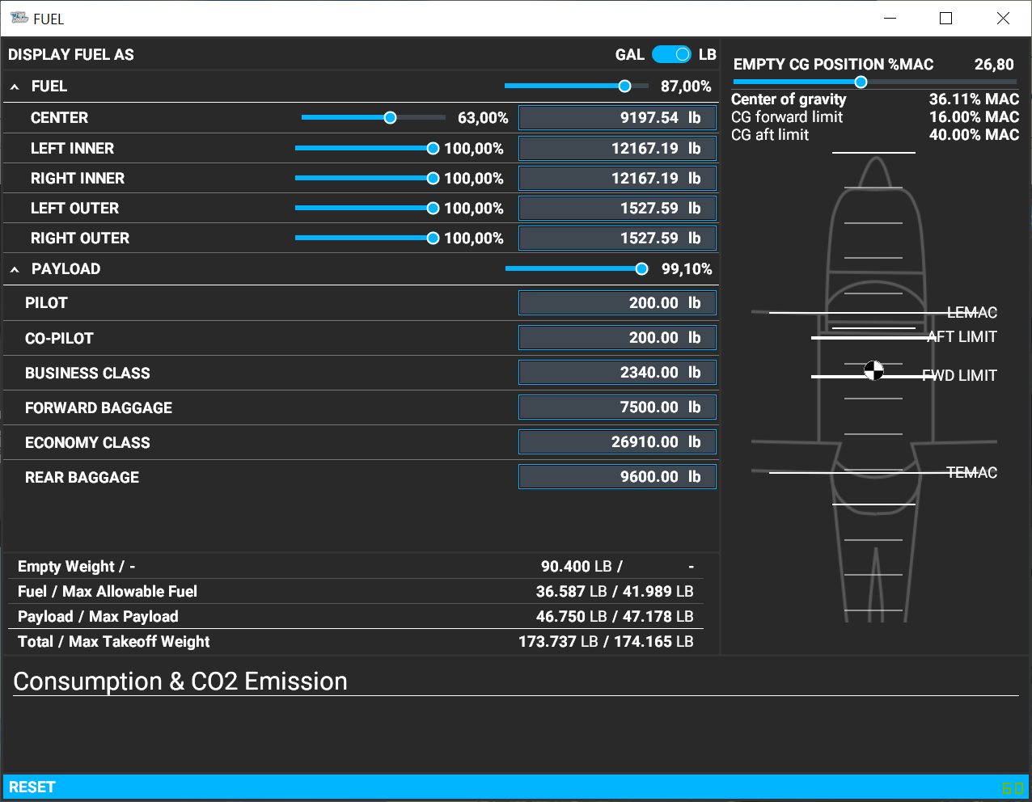

# Medium Payload

|  |  |  |  |  |  |  |  |  |
| --- | --- | --- | --- | --- | --- | --- | --- | --- |
| **Payload** | | **Fuel** | | **CG** | **Comment** | **Tanks** | | |
| ***LB*** | ***%*** | ***LB*** | ***%*** | ***%*** |  | ***2xINR*** | ***2xOUT*** | ***CTR*** |
| **29325**  **Medium** | 40,0% | 10464 | **25%** | 29,64% |  | 43% | 0% | 0% |
| 46,7% | 20928 | **50%** | 28,90% |  | 86% | 0% | 0% |
| 62,2% | 36587 | **87%** | 27,83% |  | 100% | 100% | 63% |

6/12 Business + 69/138 Economy

PayloadList= 200.0, 200.0,1170.0,7500.0,13455.0,6800.0

# Light Payload

|  |  |  |  |  |  |  |  |  |
| --- | --- | --- | --- | --- | --- | --- | --- | --- |
| **Payload** | | **Fuel** | | **CG** | **Comment** | **Tanks** | | |
| ***LB*** | ***%*** | ***LB*** | ***%*** | ***%*** |  | ***2xINR*** | ***2xOUT*** | ***CTR*** |
| **18310**  **Light** | 25,0% | 10464 | **25%** | 26,87% |  | 43% | 0% | 0% |
| 29,1% | 20928 | **50%** | 26,29% |  | 86% | 0% | 0% |
| 38,8% | 36587 | **87%** | 25,42% |  | 100% | 100% | 63% |

3/12 Business + 15/138 Economy

PayloadList= 200.0, 200.0, 585.0,6500.0,2925.0,7900.0