Experiment No: 01

Student Name: Devendra Singh UID: 23BCS12483
Branch: BE-CSE Section/Group: KRG_2B
Semester: 6th Date of Performance: 07/01/26
Subject Code: 23CSH-314 Subject Name: System Design

Aim:

To design, implement, and evaluate a simple URL redirection system that converts long URLs into short URLs.

Objective:
- To understand the basic working of a URL shortening service.
- To implement a functional URL redirection mechanism.
- To design the HLD and LLD using draw.io.
- To analyze the impact of design choices on system performance.
Procedure:
- Study the working principles of a URL shortening service and identify its core components.
- Design the High-Level Design (HLD) representing system architecture and request flow using draw.io.
- Create the Low-Level Design (LLD) showing database schema, APIs, and component interactions using draw.io.
- Implement the URL shortening logic and store the short-to-long URL mappings in the database. 5.
Implement the URL redirection mechanism to redirect users from short URLs to original URLs.
- Simulate multiple user requests to generate load on the system.
- Measure system latency and throughput under different load conditions.
- Analyze the collected performance metrics and relate them to the system design decisions.

Functional Requirements:

- Accept long URLs from users.
- Generate a unique short URL.
- Store short–long URL mappings.
- Redirect short URLs to original URLs. V. Track access count for short URLs.
VI. Display if the URL already exists

Non Functional Requirements:

- Low latency(less than 20ms).
- High concurrent request handling.
- Horizontal scalability.
- High availability.
- Data consistency and reliability.
- Secure URL handling.

Outcome:
  - The URL shortening system was successfully designed and implemented based on the defined HLD and LLD.
  - The system correctly generated unique shortened URLs and performed accurate redirection to the original URLs.
  - The integration of an in-memory cache such as Redis/Memcached significantly reduced database lookups for frequently accessed URLs.
  - Cache usage resulted in lower redirection latency and improved throughput under high read traffic.
  - Performance testing under simulated user loads showed stable response times at low and moderate traffic levels.
  - Throughput scaled effectively with increased load until hardware or resource limits were reached.
  - The system handled concurrent requests reliably while maintaining consistency and availability.
High Level Design:-
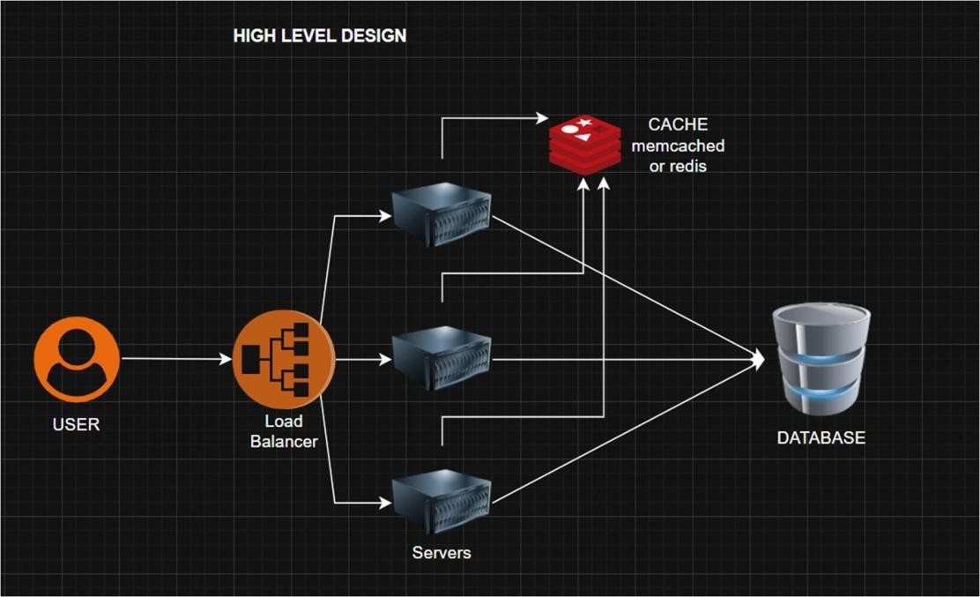

Low Level Design:
-

