MuPdna Link:

[muAoPS (mu-sigma.com)](https://eoc.mu-sigma.com/aops/eoc/mu-pdna/6693b0e3bb2efa01556f1029/overview?m=1)

MuOBI:  
[muAoPS (mu-sigma.com)](https://eoc.mu-sigma.com/aops/eoc/mu-obi/669e9313f02ea8005ab5d7a8/waves?m=1)

BPF:

<https://app.diagrams.net/#G1ckQXjKzV7I-PIKUX7ITBGjCcUSipWqxA#%7B%22pageId%22%3A%22TbHgw3xdZSN63gTfhyjT%22%7D>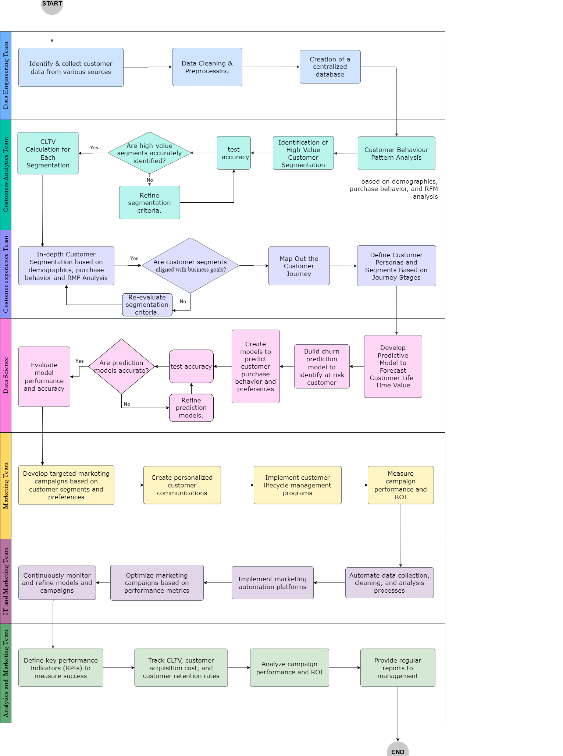

ADF:

<https://eoc.mu-sigma.com/muFlow-Web/editor/#/editor/617ca8ed-5ea6-46fd-ac87-655d6ad5ed55>

