

Safety Plan Lane Assistance

**Document Version: [Version]**

**Template Version 1.0, Released on 2017-06-21**



# Document history

**[Instructions: Fill in the date, version and description fields. You can fill out the Editor field with your name if you want to do so. Keep track of your editing as if this were a real world project.**

**For example, if this were your first draft or first submission, you might say version 1.0. If this is a second submission attempt, then you'd add a second line with a new date and version 2.0]**

|  |  |  |  |
| --- | --- | --- | --- |
| Date | Version | Editor | Description |
| 23/12/2018 | V1.0 | Xu YP | Safety plan initial version |
|  |  |  |  |
|  |  |  |  |
|  |  |  |  |
|  |  |  |  |

# Table of Contents

**[Instructions: We have provided a table of contents. If the table of contents is not showing up correctly in your word processor of choice, please update it. The table of contents should show each section of the document and page numbers or links. Most word processors can do this for you. In [Google Docs](https://support.google.com/docs/answer/116338?co=GENIE.Platform%3DDesktop&hl=en), you can use headings for each section and then go to Insert > Table of Contents. [Microsoft Word](https://support.microsoft.com/en-us/help/285059/how-to-create-a-table-of-contents-by-marking-text-in-word) has similar capabilities]**

Document history

Table of Contents

Introduction

Purpose of the Safety Plan

Scope of the Project

Deliverables of the Project

Item Definition

Goals and Measures

Goals

Measures

Safety Culture

Safety Lifecycle Tailoring

Roles

Development Interface Agreement

Confirmation Measures

# Introduction

## Purpose of the Safety Plan

Before analyzing a system under ISO 26262, we need to create a plan.The safety plan forces us to define roles then outline the steps we will take to achieve the functional safety of a lane assistance system.

## Scope of the Project

For the lane assistance project, the following safety lifecycle phases are in scope:

Concept phase

Product Development at the System Level

Product Development at the Software Level

The following phases are out of scope:

Product Development at the Hardware Level

Production and Operation

## Deliverables of the Project

The deliverables of the project are:

Safety Plan

Hazard Analysis and Risk Assessment

Functional Safety Concept

Technical Safety Concept

Software Safety Requirements and Architecture

# Item Definition

The lane assistance item alerts the drivers that the vehicle has accidentally departed its lane, and attempts to steer the vehicle back towards the center of the lane.

A lane assistance system generally has two functions:

**lane departure warning**:If a driver departs a lane without using a turn signal, the system assumes that the driver has become distracted and did not mean to leave the lane then alert the driver.

**lane keeping assistance**:The system will vibrate the steering and also move the steering wheel back towards the lane center.

The boundaries of the item includes three sub-systems which are all responsible for each function:

**Camera system**•

**Electronic Power Steering subsystem (EPS)**

**Car Display subsystem**

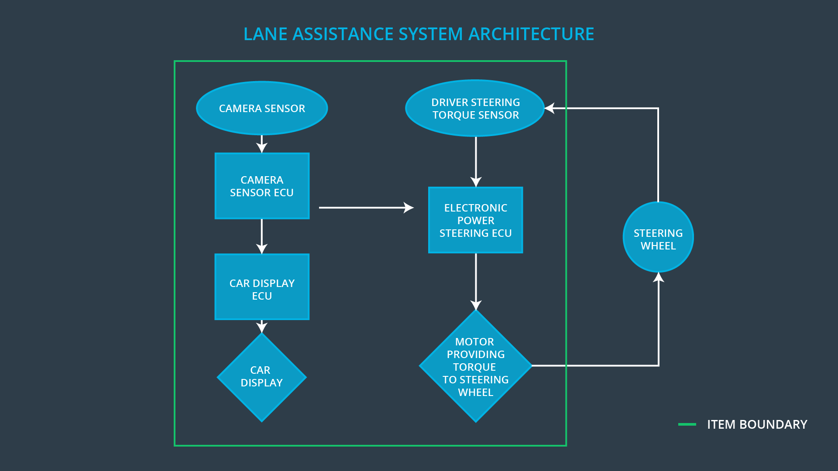

# Goals and Measures

## Goals

The goals of this functional safety project are:

**Identifying Hazards**:Identifying potential problems that could injure people or damage people’s health.

**Measuring Risk**: Evaluating the risks of these hazards.

**Low risk to reasonable levels**:Using systerms engineering to lower risks to acceptable levels.

## Measures

|  |  |  |
| --- | --- | --- |
| Measures and Activities | Responsibility | Timeline |
| Follow safety processes | All Team Members | Constantly |
| Create and sustain a safety culture | All Team Members | Constantly |
| Coordinate and document the planned safety activities | Safety Manager | Constantly |
| Allocate resources with adequate functional safety competency | Project Manager | Within 2 weeks of start of project |
| Tailor the safety lifecycle | Safety Manager | Within 4 weeks of start of project |
| Plan the safety activities of the safety lifecycle | Safety Manager | Within 4 weeks of start of project |
| Perform regular functional safety audits | Safety Auditor | Once every 2 months |
| Perform functional safety pre-assessment prior to audit by external functional safety assessor | Safety Manager | 3 months prior to main assessment |
| Perform functional safety assessment | Safety Assessor | Conclusion of functional safety activities |

# Safety Culture

Here are some characteristics of a good safety culture:

* **High priority**: safety has the highest priority among competing constraints like cost and productivity
* **Accountability**: processes ensure accountability such that design decisions are traceable back to the people and teams who made the decisions
* **Rewards**: the organization motivates and supports the achievement of functional safety
* **Penalties**: the organization penalizes shortcuts that jeopardize safety or quality
* **Independence**: teams who design and develop a product should be independent from the teams who audit the work
* **Well defined processes**: company design and management processes should be clearly defined
* **Resources**: projects have necessary resources including people with appropriate skills
* **Diversity**: intellectual diversity is sought after, valued and integrated into processes
* **Communication**: communication channels encourage disclosure of problems

# Safety Lifecycle Tailoring

For the lane assistance project, the following safety lifecycle phases are in scope:

* Concept phase
* Product Development at the System Level
* Product Development at the Software Level

The following phases are out of scope:

* Product Development at the Hardware Level
* Production and Operation

# Roles

|  |  |
| --- | --- |
| Role | Org |
| Functional Safety Manager- Item Level | OEM |
| Functional Safety Engineer- Item Level | OEM |
| Project Manager - Item Level | OEM |
| Functional Safety Manager- Component Level | Tier-1 |
| Functional Safety Engineer- Component Level | Tier-1 |
| Functional Safety Auditor | OEM or external |
| Functional Safety Assessor | OEM or external |

# Development Interface Agreement

A DIA (development interface agreement) defines the roles and responsibilities between companies involved in developing a product. All involved parties need to agree on the contents of the DIA before the project begins.

The DIA also specifies what evidence and work products each party will provide to prove that work was done according to the agreement.

As the tier-1 organization of OEM, we would need the following:

1. Appointment of customer and supplier safety managers
2. Joint tailoring of the safety lifecycle
3. Activities and processes to be performed by the customer; activities and processes to be performed by the supplier
4. Information and work products to be exchanged
5. Parties or persons responsible for each activity in design and production
6. Any supporting processes or tools to ensure compatibility between customer and supplier technologies

# Confirmation Measures

Confirmation measures serve two purposes:

* that a functional safety project conforms to ISO 26262
* that the project really does make the vehicle safer.

**Confirmation review:**

Ensures that the project complies with ISO 26262. As the product is designed and developed, an independent person would review the work to make sure ISO 26262 is being followed.

**Functional safety audit:**

Checking to make sure that the actual implementation of the project conforms to the safety plan is called a functional safety audit.

**Functional safety assessment:**

Confirming that plans, designs and developed products actually achieve functional safety is called a functional safety assessment.

A safety plan could have other sections that we are not including here. For example, a safety plan would probably contain a complete project schedule.

There might also be a "Supporting Process Management" section that would cover "Part 8: Supporting Processes" of the ISO 26262 functional safety standard. This would include descriptions of how the company handles requirements management, change management, configuration management, documentation management, and software tool usage and confidence.

Similarly, a confirmation measures section would go into more detail about how each confirmation will be carried out.