

Functional Safety Concept Lane Assistance

**Document Version: [Version]**

**Template Version 1.0, Released on 2017-06-21**



# Document history

**[Instructions: Fill in the date, version and description fields. You can fill out the Editor field with your name if you want to do so. Keep track of your editing as if this were a real world project.**

**For example, if this were your first draft or first submission, you might say version 1.0. If this is a second submission attempt, then you'd add a second line with a new date and version 2.0]**

|  |  |  |  |
| --- | --- | --- | --- |
| Date | Version | Editor | Description |
| 24/12/2018 | V1.0 | Xu YP | Version 1 |
|  |  |  |  |
|  |  |  |  |
|  |  |  |  |
|  |  |  |  |

# Table of Contents

**[Instructions: We have provided a table of contents. If you change the document structure, please update the table of contents accordingly. The table of contents should show each section of the document and page numbers or links. Most word processors can do this for you. In [Google Docs](https://support.google.com/docs/answer/116338?co=GENIE.Platform%3DDesktop&hl=en), you can use headings for each section and then go to Insert > Table of Contents. [Microsoft Word](https://support.microsoft.com/en-us/help/285059/how-to-create-a-table-of-contents-by-marking-text-in-word) has similar capabilities]**

Document history

Table of Contents

Purpose of the Functional Safety Concept

Inputs to the Functional Safety Analysis

Safety goals from the Hazard Analysis and Risk Assessment

Preliminary Architecture

Description of architecture elements

Functional Safety Concept

Functional Safety Analysis

Functional Safety Requirements

Refinement of the System Architecture

Allocation of Functional Safety Requirements to Architecture Elements

Warning and Degradation Concept

# Purpose of the Functional Safety Concept

In order to achieve the ultimate goal of functional safety, we need figure out which subsystems and elements can be used to meet safety goals. Then refine these high level goals into what we call functional safety requirements and allocates functional safety requirements to the relevant parts in the system architecture.

# Inputs to the Functional Safety Concept

## Safety goals from the Hazard Analysis and Risk Assessment

|  |  |
| --- | --- |
| **ID** | **Safety Goal** |
| Safety_Goal_01 | The oscillating steering torque from the lane departure warning function shall be limited |
| Safety_Goal_02 | The lane keeping assistance function shall be time limited, and the additional steering torque shall end after a given time interval so that the driver cannot misuse the system for autonomous driving. |

## Preliminary Architecture

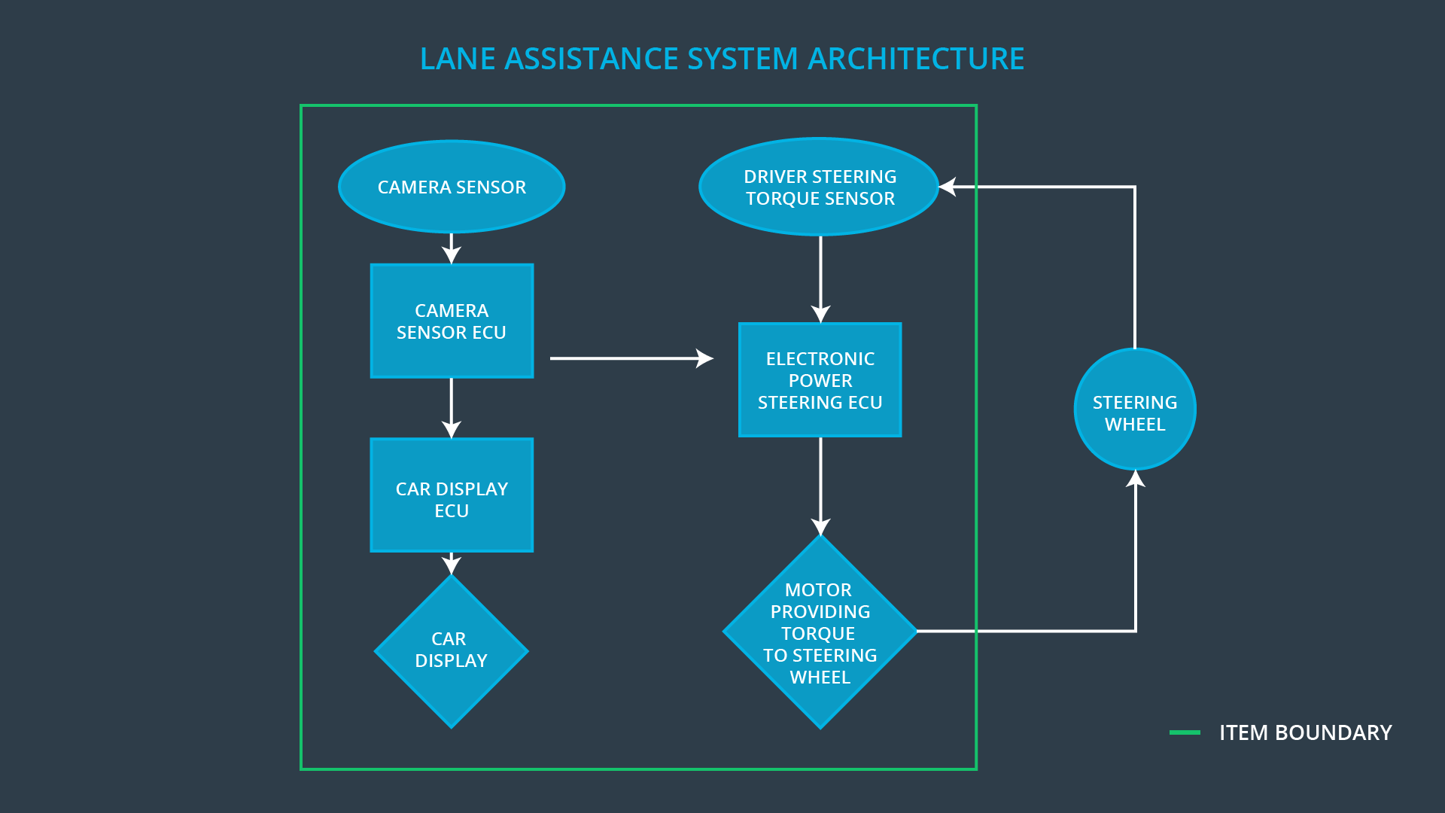

## Description of architecture elements

|  |  |
| --- | --- |
| **Element** | **Description** |
| Camera Sensor | Capture road images and send them to the Camera Sensor ECU |
| Camera Sensor ECU | Detect lane line and estimate the position on the road from the images provided by Camera Sensor. |
| Car Display | Display the lane departure warning signal and the Lane Departure Assistance status. |
| Car Display ECU | Implement digital computing logic. |
| Driver Steering Torque Sensor | Measure the torque applied to the steering wheel by  the driver. |
| Electronic Power Steering ECU | Vibrates the steering wheel when vehicle is drifting  away from the current lane unintentionally. Add  appropriate amount of torque based on feedback from  torque sensor to keep vehicle in current lane. |
| Motor | Actuator used to apply requested torque to steering  wheel. |

# Functional Safety Concept

The functional safety concept consists of:

* Functional safety analysis
* Functional safety requirements
* Functional safety architecture
* Warning and degradation concept

## Functional Safety Analysis

|  |  |  |  |
| --- | --- | --- | --- |
| **Malfunction ID** | **Main Function of the Item Related to Safety Goal Violations** | **Guidewords (NO, WRONG, EARLY, LATE, MORE, LESS)** | **Resulting Malfunction** |
| Malfunction_01 | Lane Departure Warning (LDW) function shall apply an oscillating steering torque to provide the driver a haptic feedback | MORE | The lane departure warning function applies an oscillating torque with very high torque amplitude (above limit) |
| Malfunction_02 | Lane Departure Warning (LDW) function shall apply an oscillating steering torque to provide the driver a haptic feedback | MORE | The lane departure  warning function  applies an oscillating  torque with very high  torque frequency  (above limit) |
| Malfunction_03 | Lane Keeping Assistance (LKA) function shall apply the steering torque when active in order to stay in ego lane | NO | The lane keeping  assistance function is  not limited in time  duration which leads  to misuse as an  autonomous driving  function |

## Functional Safety Requirements

Lane Departure Warning (LDW) Requirements:

|  |  |  |  |  |
| --- | --- | --- | --- | --- |
| **ID** | **Functional Safety Requirement** | **ASIL** | **Fault Tolerant Time Interval** | **Safe State** |
| Functional  Safety  Requirement  01-01 | The lane keeping item shall ensure that the  lane departure oscillating torque amplitude  is below Max_Torque_Amplitude | C | 50ms | Vibration torque  amplitude below  Max_Torque_Am  plitude. |
| Functional  Safety  Requirement  01-02 | The lane keeping item shall ensure that the  lane departure oscillating torque frequency  is below Max_Torque_Frequency | C | 50ms | Vibration  frequency is  below  Max_Torque_Fre  quency. |

Lane Departure Warning (LDW) Verification and Validation Acceptance Criteria:

|  |  |  |
| --- | --- | --- |
| **ID** | **Validation Acceptance**  **Criteria and Method** | **Verification Acceptance**  **Criteria and Method** |
| Functional  Safety  Requirement  01-01 | The value of Max_Torque_Amplitude has to be chosen and validated that it is a reasonable and comfortable value. | Verify that the LDW system turn off when the torque amplitude exceed the limit. |
| Functional  Safety  Requirement  01-02 | The value of Max_Torque_Frequency has to be chosen and validated that it is a reasonable and comfortable value. | Verify that the LDW system turn off when the torque frequency exceed the limit. |

Lane Keeping Assistance (LKA) Requirements:

|  |  |  |  |  |
| --- | --- | --- | --- | --- |
| **ID** | **Functional Safety Requirement** | **ASIL** | **Fault Tolerant Time Interval** | **Safe State** |
| Functional  Safety  Requirement  02-01 | The electronic power steering ECU shall  ensure that the Lane Keeping Assistance  torque is applied only Max_Duration. | B | 500ms | Lane Keeping  Assistance  torque is zero. |

Lane Keeping Assistance (LKA) Verification and Validation Acceptance Criteria:

|  |  |  |
| --- | --- | --- |
| **ID** | **Validation Acceptance**  **Criteria and Method** | **Verification Acceptance**  **Criteria and Method** |
| Functional  Safety  Requirement  02-01 | Test and validate that the Max_Duration  chosen dissuades drivers from taking  their hands off the wheel | Verify that the LKA function turned off every exceeded Max_Duration |

## Refinement of the System Architecture

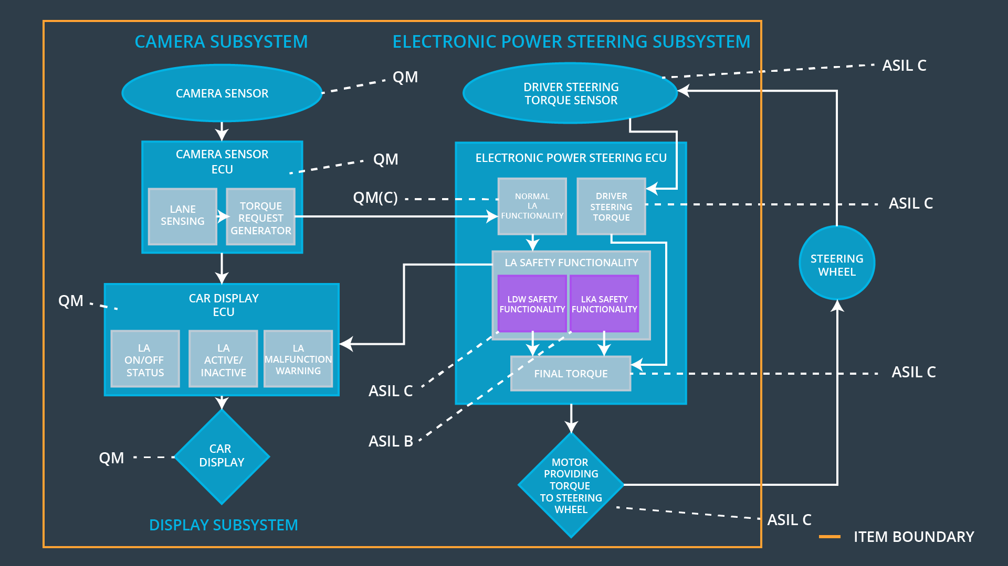

## Allocation of Functional Safety Requirements to Architecture Elements

|  |  |  |  |  |
| --- | --- | --- | --- | --- |
| **ID** | **Functional Safety Requirement** | **Electronic Power Steering ECU** | **Camera ECU** | **Car Display ECU** |
| Functional  Safety  Requirement  01-01 | The lane keeping item shall ensure that the lane departure  oscillating torque amplitude is  below Max_Torque_Amplitude | **√** |  |  |
| Functional  Safety  Requirement  01-02 | The lane keeping item shall  ensure that the lane departure  oscillating torque frequency is  below Max_Torque_Frequency | **√** |  |  |
| Functional  Safety  Requirement  02-01 | The electronic power steering  ECU shall ensure that the lane  keeping assistance torque is  applied for only Max_Duration | **√** |  |  |

## Warning and Degradation Concept

|  |  |  |  |  |
| --- | --- | --- | --- | --- |
| **ID** | **Degradation Mode** | **Trigger for Degradation Mode** | **Safe State invoked?** | **Driver Warning** |
| WDC-01 | Turn off LDW functionality | Malfunction_01  Malfunction_02 | Yes | Car Display the warning of LDW Malfunction |
| WDC-02 | Turn off LKA functionality | Malfunction_03 | Yes | Car Display the warning of LKA Malfunction |