

Technical Safety Concept Lane Assistance

**Document Version: [Version]**

**Template Version 1.0, Released on 2017-06-21**



# Document history

**[Instructions: Fill in the date, version and description fields. You can fill out the Editor field with your name if you want to do so. Keep track of your editing as if this were a real world project.**

**For example, if this were your first draft or first submission, you might say version 1.0. If this is a second submission attempt, then you'd add a second line with a new date and version 2.0]**

|  |  |  |  |
| --- | --- | --- | --- |
| Date | Version | Editor | Description |
| 25/12/2018 | V1.0 | Xu YP | Version 1 |
|  |  |  |  |
|  |  |  |  |
|  |  |  |  |
|  |  |  |  |

# 

# Table of Contents

**[Instructions: We have provided a table of contents. If the table of contents is not showing up correctly in your word processor of choice, please update it. The table of contents should show each section of the document and page numbers or links. Most word processors can do this for you. In [Google Docs](https://support.google.com/docs/answer/116338?co=GENIE.Platform%3DDesktop&hl=en), you can use headings for each section and then go to Insert > Table of Contents. [Microsoft Word](https://support.microsoft.com/en-us/help/285059/how-to-create-a-table-of-contents-by-marking-text-in-word) has similar capabilities]**

Document history

Table of Contents

Purpose of the Technical Safety Concept

Inputs to the Technical Safety Concept

Functional Safety Requirements

Refined System Architecture from Functional Safety Concept

Functional overview of architecture elements

Technical Safety Concept

Technical Safety Requirements

Refinement of the System Architecture

Allocation of Technical Safety Requirements to Architecture Elements

Warning and Degradation Concept

# Purpose of the Technical Safety Concept

**[Instructions: Answer what is the purpose of a technical safety concept?]**

# Inputs to the Technical Safety Concept

## Functional Safety Requirements

**[Instructions: Provide the functional safety requirements derived in the functional safety concept ]**

|  |  |  |  |  |
| --- | --- | --- | --- | --- |
| **ID** | **Functional Safety Requirement** | **ASIL** | **Fault Tolerant Time Interval** | **Safe State** |
| Functional  Safety  Requirement  01-01 | The lane keeping item shall ensure that the  lane departure oscillating torque amplitude  is below Max_Torque_Amplitude | C | 50ms | Vibration torque  amplitude below  Max_Torque_Am  plitude. |
| Functional  Safety  Requirement  01-02 | The lane keeping item shall ensure that the  lane departure oscillating torque frequency  is below Max_Torque_Frequency | C | 50ms | Vibration  frequency is below  Max_Torque_Frequency |
| Functional  Safety  Requirement  02-01 | The electronic power steering ECU shall  ensure that the lane keeping assistance  torque is applied for only Max_Duration | B | 500ms | Lane keeping  assistance  torque is 0 when  fault detected |

## Refined System Architecture from Functional Safety Concept

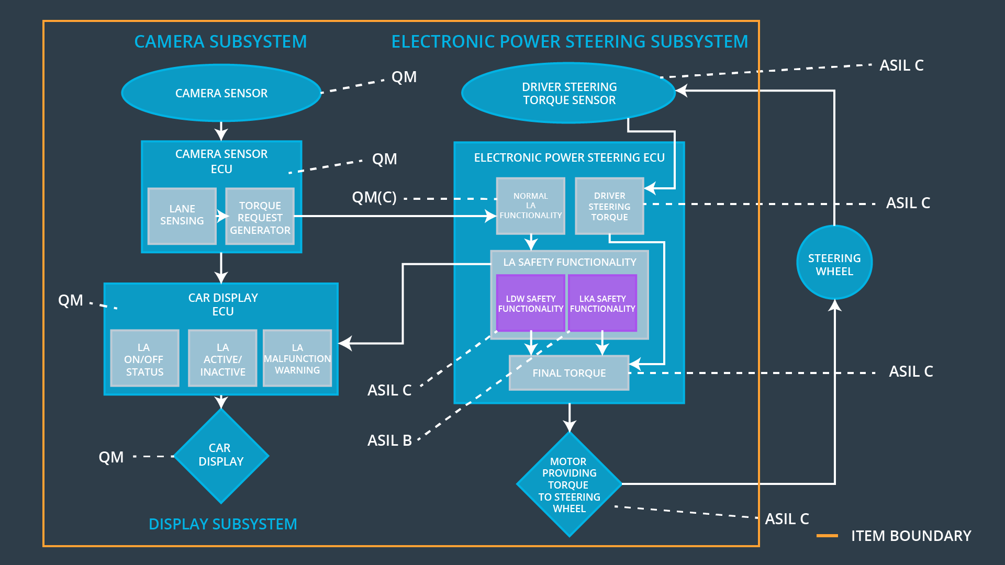

### 

### Functional overview of architecture elements

**[Instructions: Provide a description for each functional safety element; what is each element's purpose in the lane assistance item? ]**

|  |  |
| --- | --- |
| **Element** | **Description** |
| Camera Sensor | Capture road images and send them to the Camera  Sensor ECU |
| Camera Sensor ECU - Lane Sensing | Detect lane line and estimate the position on the road |
| Camera Sensor ECU - Torque request generator | Calculating the reasonable torque  to be requested to the Electronic Power Steering  ECU |
| Car Display | Display the lane departure warning signal and the  Lane Departure Assistance status. |
| Car Display ECU - Lane Assistance On/Off Status | Switch the signal corresponding to Lane  Assistance to On/Off |
| Car Display ECU - Lane Assistant Active/Inactive | Decide when to activate the Lane Assistance system |
| Car Display ECU - Lane Assistance malfunction warning | Display the warning message of LA system malfunctioning |
| Driver Steering Torque Sensor | Measure the torque applied to the steering wheel by the driver. |
| Electronic Power Steering (EPS) ECU - Driver Steering Torque | Measuring the driver's steering torque. |
| EPS ECU - Normal Lane Assistance Functionality | Receiving the Camera Sensor ECU torque request |
| EPS ECU - Lane Departure Warning Safety Functionality | Limit the torque amplitude to below Max_Torque_Amplitude and torque frequency to below Max_Torque_Frequency. |
| EPS ECU - Lane Keeping Assistant Safety Functionality | Keep the car to stay in the lane within the Max_Duration time. |
| EPS ECU - Final Torque | Compute the final torque from the Driver Steering  Torque subsystem and the Lane Assistance Safety  Functionality |
| Motor | Actuator used to apply requested torque to  steering wheel. |

# Technical Safety Concept

## Technical Safety Requirements

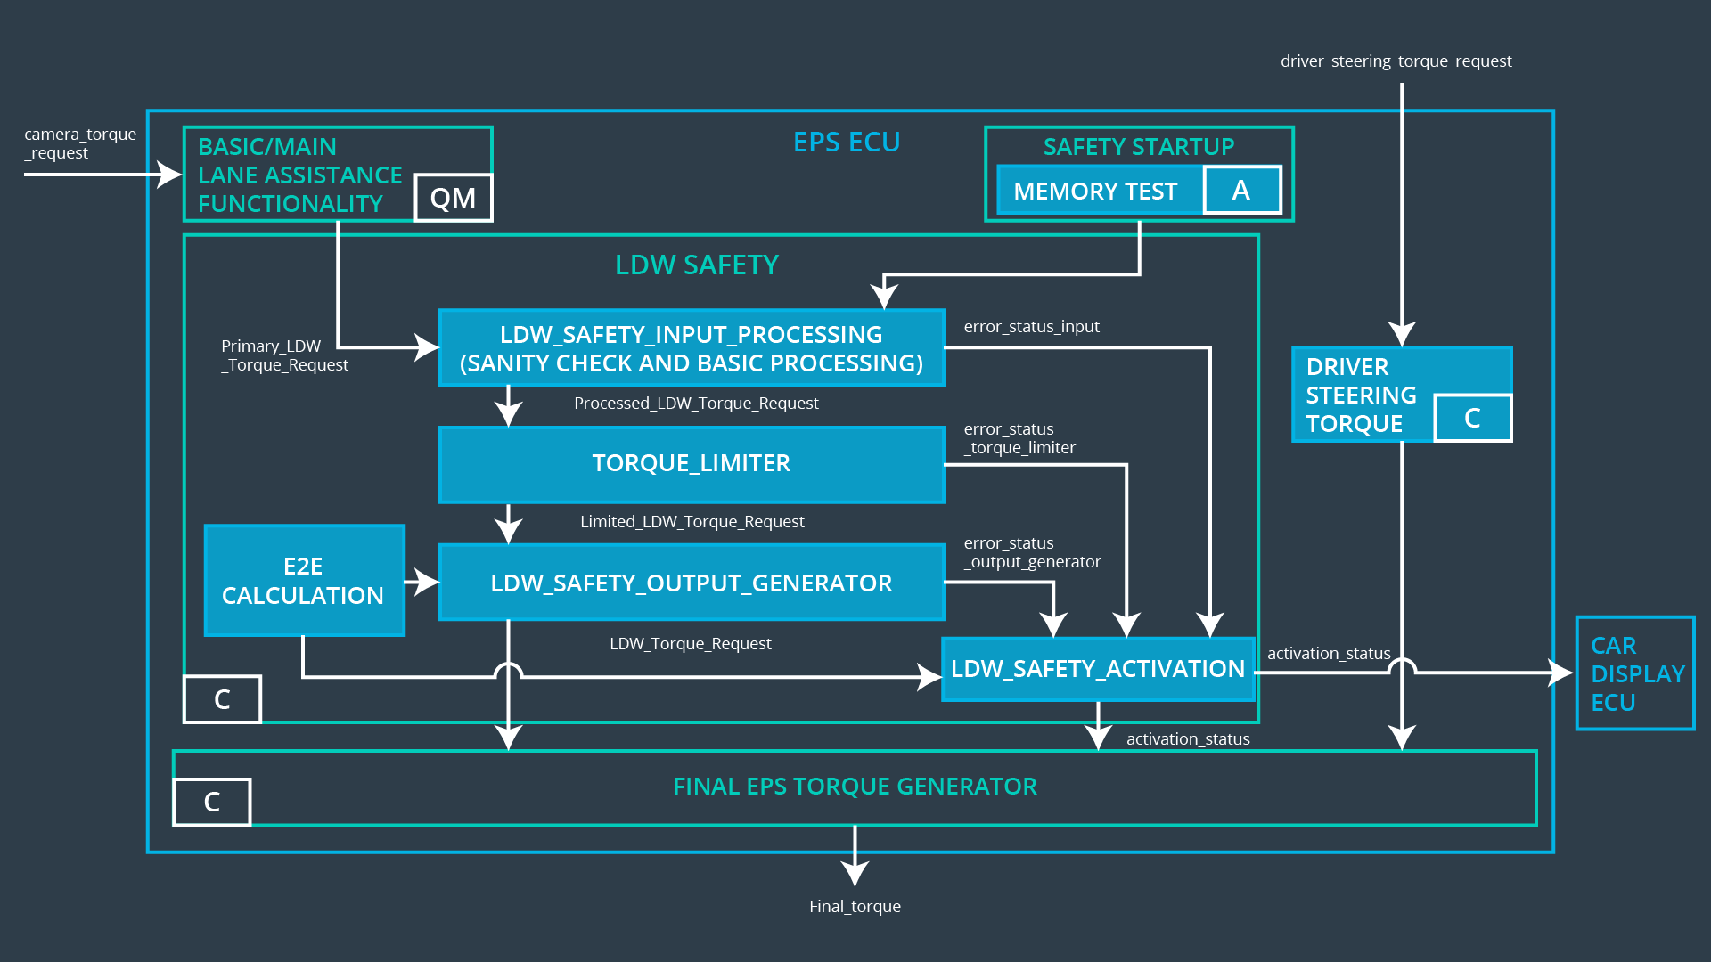

**Lane Departure Warning (LDW) Requirements:**

Functional Safety Requirement 01-01 with its associated system elements

(derived in the functional safety concept)

|  |  |  |  |  |
| --- | --- | --- | --- | --- |
| **ID** | **Functional Safety Requirement** | **Electronic Power Steering ECU** | **Camera ECU** | **Car Display ECU** |
| Functional  Safety  Requirement  01-01 | The lane keeping item shall ensure that the lane departure oscillating torque amplitude is below Max_Torque_Amplitude | X |  |  |

Technical Safety Requirements related to Functional Safety Requirement 01-01 are:

|  |  |  |  |  |  |
| --- | --- | --- | --- | --- | --- |
| **ID** | **Technical Safety Requirement** | **ASIL** | **Fault Tolerant Time Interval** | **Architecture Allocation** | **Safe State** |
| Technical  Safety  Requirement  01 | The LDW safety component shall ensure that the amplitude of the 'LDW_Torque_Request' sent to the 'Final electronic power steering Torque' component is below 'Max_Torque_Amplitude. | C | 50ms | LDW Safety | Lane  Departure  Warning  torque to  zero. |
| Technical  Safety  Requirement  02 | As soon as the LDW function deactivates the LDW feature, the 'LDW Safety' software block shall send a signal to the car display ECU to turn on a warning light. | C | 50ms | LDW Safety | Lane  Departure  Warning  torque to  zero. |
| Technical  Safety  Requirement  03 | As soon as a failure is detected by the LDW function, it shall deactivate the LDW feature and the 'LDW_Torque_Request' shall be set to zero. | C | 50ms | LDW Safety | Lane  Departure  Warning  torque to  zero. |
| Technical  Safety  Requirement  04 | The validity and integrity of the data transmission for 'LDW_Torque_Request' signal shall be ensured. | C | 50ms | Data Transmission Integrity Check | Lane  Departure  Warning  torque to  zero. |
| Technical  Safety  Requirement  05 | Memory test shall be conducted at start up of the EPS ECU to check for any faults in memory. | A | ignition cycle | Memory Test | Lane  Departure  Warning  torque to  zero. |

Functional Safety Requirement 01-2 with its associated system elements

(derived in the functional safety concept)

|  |  |  |  |  |
| --- | --- | --- | --- | --- |
| **ID** | **Functional Safety Requirement** | **Electronic Power Steering ECU** | **Camera ECU** | **Car Display ECU** |
| Functional  Safety  Requirement  01-02 | The lane keeping item shall ensure that the lane departure oscillating torque frequency is below Max_Torque_Frequency | X |  |  |

Technical Safety Requirements related to Functional Safety Requirement 01-02 are:

|  |  |  |  |  |  |
| --- | --- | --- | --- | --- | --- |
| **ID** | **Technical Safety Requirement** | **ASIL** | **Fault Tolerant Time Interval** | **Architecture Allocation** | **Safe State** |
| Technical  Safety  Requirement  01 | The LDW safety component shall ensure the frequency of the  ‘LDW_Torque_Request' sent to the  ‘Final electronic power steering  Torque’ component is below  ‘Max_Torque_Frequency.’ | C | 50ms | LDW Safety | Lane  Departure  Warning  torque to  zero. |
| Technical  Safety  Requirement  02 | As soon as the LDW  function deactivates the  LDW feature, the 'LDW  Safety' software block shall  send a signal to the car  display ECU to turn on a  warning light | C | 50ms | LDW Safety | Lane  Departure  Warning  torque to  zero. |
| Technical  Safety  Requirement  03 | As soon as a failure is  detected by the LDW  function, it shall deactivate  the LDW feature and the  'LDW_Frequency_Request'  shall be set to zero | C | 50ms | LDW Safety | Lane  Departure  Warning  torque to  zero. |
| Technical  Safety  Requirement  04 | The validity and integrity of  the data transmission for  'LDW_Frequency_Request'  signal shall be ensured | C | 50ms | Data  Transmission  Integrity Check | Lane  Departure  Warning  torque to  zero. |
| Technical  Safety  Requirement  05 | Memory test shall be  conducted at start up of the  EPS ECU to check for any  faults in memory | A | Ignition cycle | Memory Test | Lane  Departure  Warning  torque to  zero. |

**Lane Departure Warning (LDW) Verification and Validation Acceptance Criteria:**

**[OPTIONAL: For each technical safety requirement, identify both the verification and validation acceptance criteria. “Validation” asks whether or not you chose the appropriate parameters. “Verification” involves testing to make sure the vehicle behaves as expected when the parameter value is crossed. There is not necessarily one right answer. Look at your verification and validation acceptance criteria from the functional safety concept for inspiration.]**

**Lane Keeping Assistance (LKA) Requirements:**

Functional Safety Requirement 02-1 with its associated system elements

(derived in the functional safety concept)

|  |  |  |  |  |
| --- | --- | --- | --- | --- |
| **ID** | **Functional Safety Requirement** | **Electronic Power Steering ECU** | **Camera ECU** | **Car Display ECU** |
| Functional  Safety  Requirement  02-01 | The lane keeping item shall ensure that the lane keeping assistance torque is applied for only Max_Duration | X |  |  |

Technical Safety Requirements related to Functional Safety Requirement 02-01 are:

|  |  |  |  |  |  |
| --- | --- | --- | --- | --- | --- |
| **ID** | **Technical Safety Requirement** | **ASIL** | **Fault Tolerant Time Interval** | **Allocation to Architecture** | **Safe State** |
| Technical  Safety  Requirement  01 | The LKA safety component shall ensure the duration of the lane keeping assistance torque is applied for less than Max_Duration | C | 500ms | LKA Safety | Lane  Keeping  Assistance  torque to  zero |
| Technical  Safety  Requirement  02 | When the LKA function deactivates, the ‘LKA Safety’ shall send a signal to the Car Display ECU to turn on a warning light. | C | 500ms | LKA Safety | Lane  Keeping  Assistance  torque to  zero |
| Technical  Safety  Requirement  03 | When a failure is detected, the  LKA function shall deactivate and the ‘LKA_Torque_Request’ shall be zero. | C | 500ms | LKA Safety | Lane  Keeping  Assistance  torque to  zero |
| Technical  Safety  Requirement  04 | The validity and integrity of the  data transmission for  ‘LKA_Torque_Request’ signal  shall be ensured. | C | 500ms | Data  Transmission  Integrity Check | Lane  Keeping  Assistance  torque to  zero |
| Technical  Safety  Requirement  05 | Memory test shall be conducted  at start up of the EPS ECU to  check for any memory problems | A | Ignition cycle | Memory Test | Lane  Departure  Warning  torque to  zero. |

**Lane Keeping Assistance (LKA) Verification and Validation Acceptance Criteria:**

**[OPTIONAL: For each technical safety requirement, identify both the verification and validation acceptance criteria. “Validation” asks whether or not you chose the appropriate parameters. “Verification” involves testing to make sure the vehicle behaves as expected when the parameter value is crossed. There is not necessarily one right answer. Look at your verification and validation acceptance criteria from the functional safety concept for inspiration.]**

## Refinement of the System Architecture

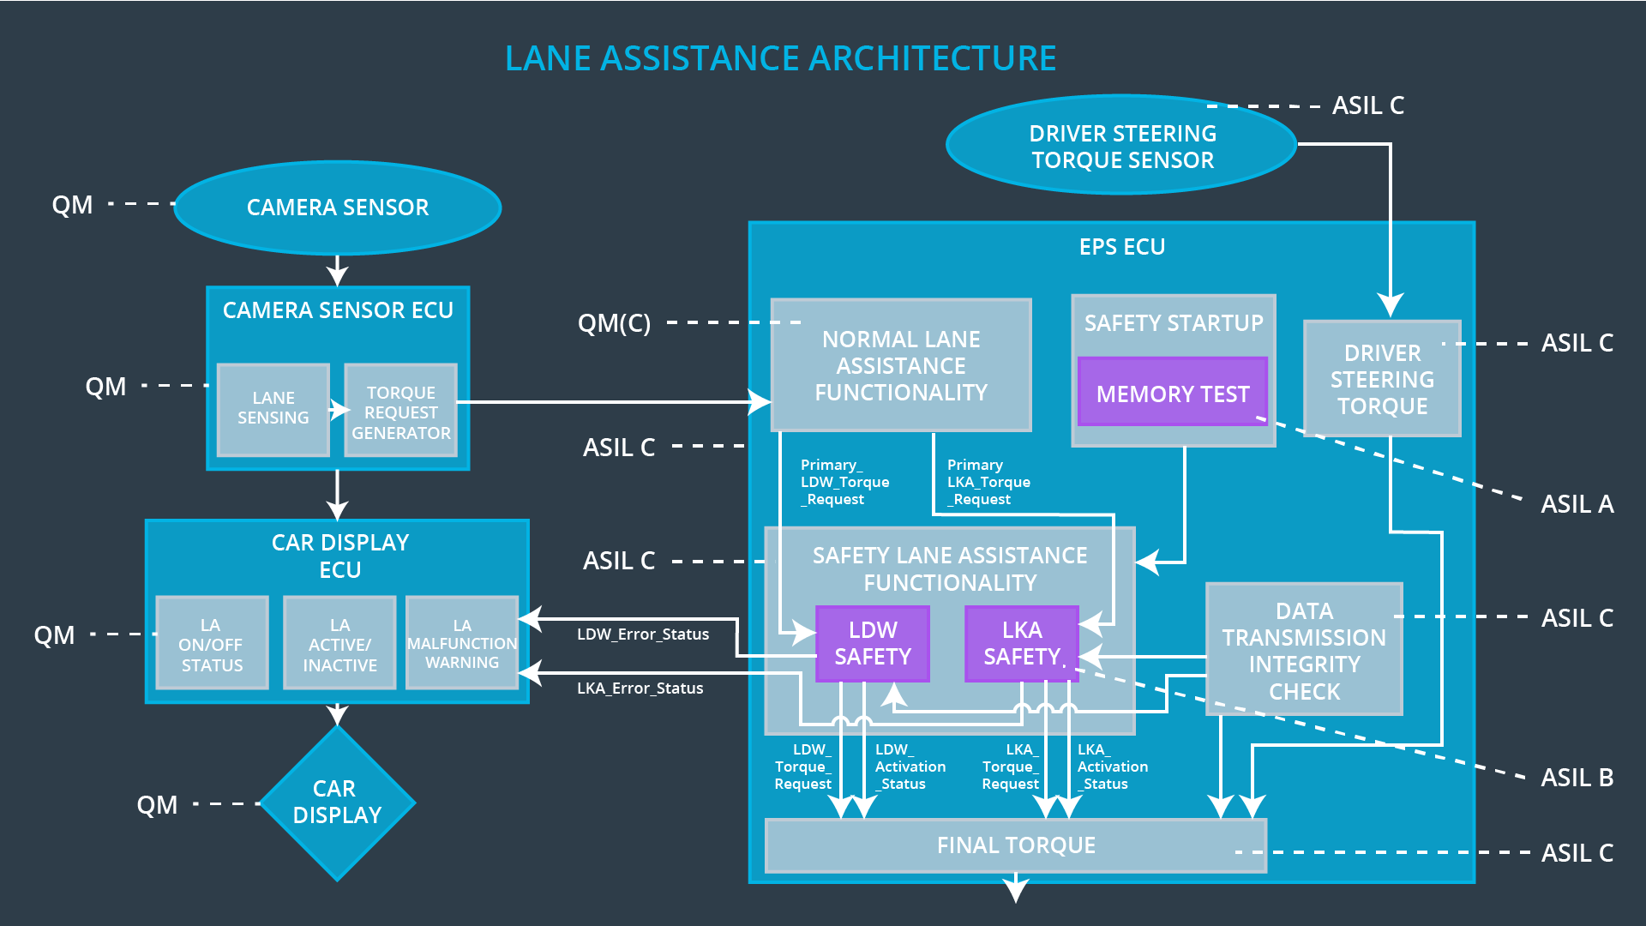

## Allocation of Technical Safety Requirements to Architecture Elements

|  |  |  |  |  |
| --- | --- | --- | --- | --- |
| **ID** | **Functional Safety Requirement** | **Electronic Power Steering ECU** | **Camera ECU** | **Car Display ECU** |
| Technical  Safety  Requirement  01-01-01 | The LDW safety component shall ensure that the amplitude of the 'LDW_Torque_Request' sent to the 'Final electronic power steering Torque' component is below 'Max_Torque_Amplitude. | X |  |  |
| Technical  Safety  Requirement  01-01-02 | As soon as the LDW function deactivates the LDW feature, the 'LDW Safety' software block shall send a signal to the car display ECU to turn on a warning light. | X |  |  |
| Technical  Safety  Requirement  01-01-03 | As soon as a failure is detected by the LDW function, it shall deactivate the LDW feature and the 'LDW_Torque_Request' shall be set to zero. | X |  |  |
| Technical  Safety  Requirement  01-01-04 | The validity and integrity of the data transmission for 'LDW_Torque_Request' signal shall be ensured. | X |  |  |
| Technical  Safety  Requirement  01-01-05 | Memory test shall be conducted at start up of the EPS ECU to check for any faults in memory. | X |  |  |
| Technical  Safety  Requirement  01-02-01 | The LKA safety component shall ensure the duration of the lane keeping assistance torque is applied for less than Max_Duration | X |  |  |
| Technical  Safety  Requirement  01-02-02 | When the LKA function deactivates, the ‘LKA Safety’ shall send a signal to the Car Display ECU to turn on a warning light. | X |  |  |
| Technical  Safety  Requirement  01-02-03 | When a failure is detected, the  LKA function shall deactivate and the ‘LKA_Torque_Request’ shall be zero. | X |  |  |
| Technical  Safety  Requirement  01-02-04 | The validity and integrity of the  data transmission for  ‘LKA_Torque_Request’ signal  shall be ensured. | X |  |  |
| Technical  Safety  Requirement  01-02-05 | Memory test shall be conducted  at start up of the EPS ECU to  check for any memory problems | X |  |  |

## Warning and Degradation Concept

|  |  |  |  |  |
| --- | --- | --- | --- | --- |
| **ID** | **Degradation Mode** | **Trigger for Degradation Mode** | **Safe State invoked?** | **Driver Warning** |
| WDC-01 | Turn off LDW functionality | Malfunction_01  Malfunction_02 | Yes | Car Display the warning of LDW Malfunction |
| WDC-02 | Turn off LKA functionality | Malfunction_03 | Yes | Car Display the warning of LKA Malfunction |