35 Days Training
Day 1 Project

Project Breakdown

Part 1: Creating and Editing Text Files (20 minutes)
Scenario: You are tasked with documenting the configurations and settings for a new server.
You'll use different text editors to create and update these documents.
1. Using Nano
Create a file server_config.txt using Nano:
nano server_config.txt
○
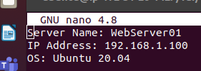
Add the following content:
Server Name: WebServer01
IP Address: 192.168.1.100
OS: Ubuntu 20.04

Using Vi
Edit the same file with Vi:
vi server_config.txt

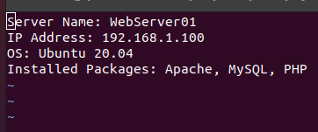
Append the following text:
Installed Packages: Apache, MySQL, PHP

- Save and exit (Esc, :wq).

Using Vim
Further edit the file with Vim:
vim server_config.txt

Add the following text:
Configuration Complete: Yes
Save and exit (Esc, :wq).

Part 2: User & Group Management (20 minutes)

Scenario: You need to set up user accounts and groups for a new team joining the project.
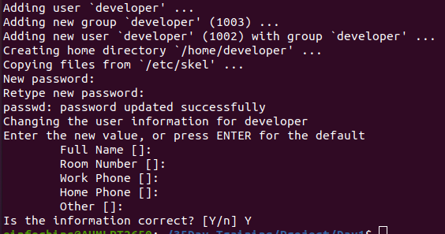
- Adding/Removing Users
Add a new user developer:
sudo adduser developer

Remove the user developer:
sudo deluser developer
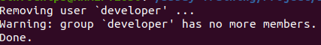

Managing Groups
Create a group devteam:
sudo groupadd devteam
Add the user developer to the devteam group:
sudo usermod -aG devteam developer
Remove the user developer from the devteam group:
sudo gpasswd -d developer devteam
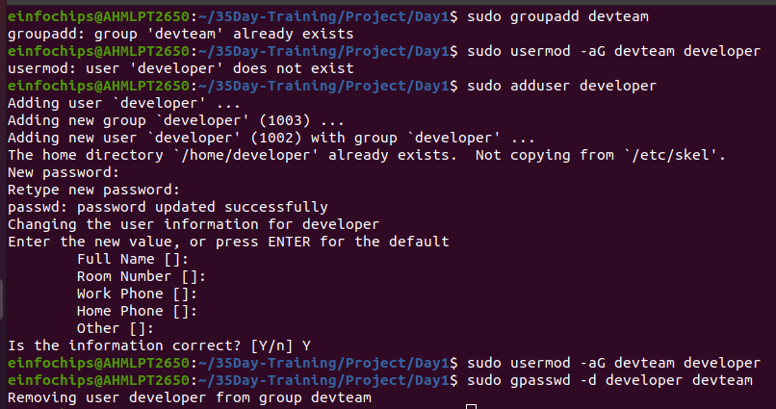

Part 3: File Permissions Management (20 minutes)
Scenario: Ensure that only the appropriate users have access to specific files and directories.

Understanding File Permissions
View permissions for server_config.txt:
ls -l server_config.txt

Changing Permissions and Ownership
Change permissions to read/write for the owner and read-only for others:
chmod 644 server_config.txt

Verify the change:
ls -l server_config.txt

Change the owner to developer and the group to devteam:
sudo chown developer:devteam server_config.txt

Verify the change:
ls -l server_config.txt
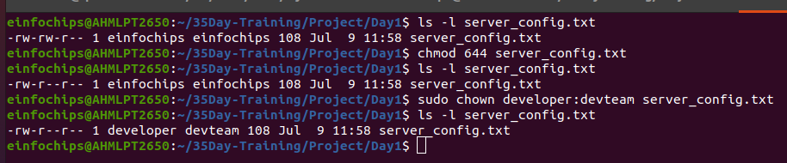

Creating and Deploying a Static Website with Apache2

Preparation (5 minutes)
- Ensure you have access to a Linux environment (e.g., virtual machines, EC2 instances, or local installations) with sudo privileges.

Activity Breakdown

Part 1: Installing Apache2 (5 minutes)
- Update Package Lists
Open the terminal and run:
sudo apt update
- Install Apache2
Install Apache2 by running:
sudo apt install apache2
- Start and Enable Apache2
Start the Apache2 service:
sudo systemctl start apache2
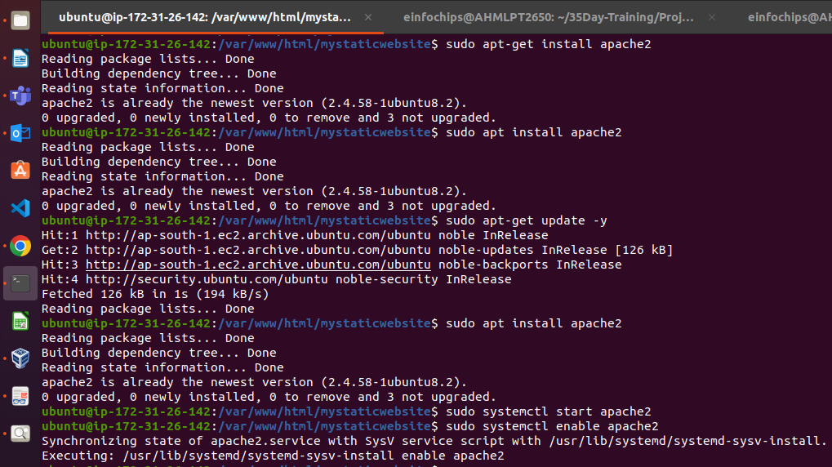
Enable Apache2 to start on boot:
sudo systemctl enable apache2
Verify Installation
  - Open a web browser and navigate to http://your_server_ip. You should see the Apache2 default page.
My Ec2 Instance Public IP was 65.2.137.210.
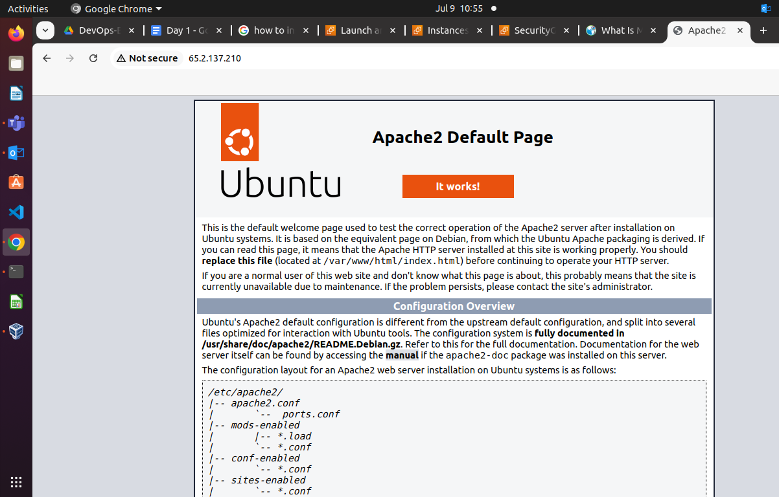
Part 2: Creating the Website (10 minutes)
Navigate to the Web Directory

Change to the web root directory:
cd /var/www/html
- Create a New Directory for the Website

