35 Days Training – Day 2 – Project Ans

1. Install Git: Ensure Git is installed on your system. Verify with git –version.\
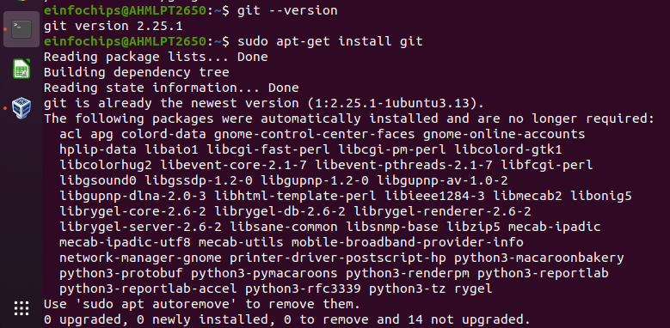

Set Up Git: Configure your Git username and email:

git config --global user.name "Your Name"
git config --global user.email "your.email@example.com"
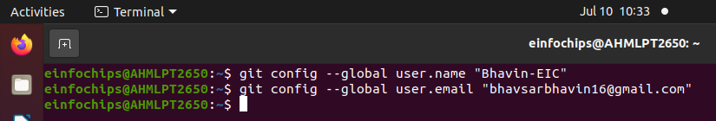

2. Create a GitHub Repository:
○ Go to GitHub and create a new repository named website-project.
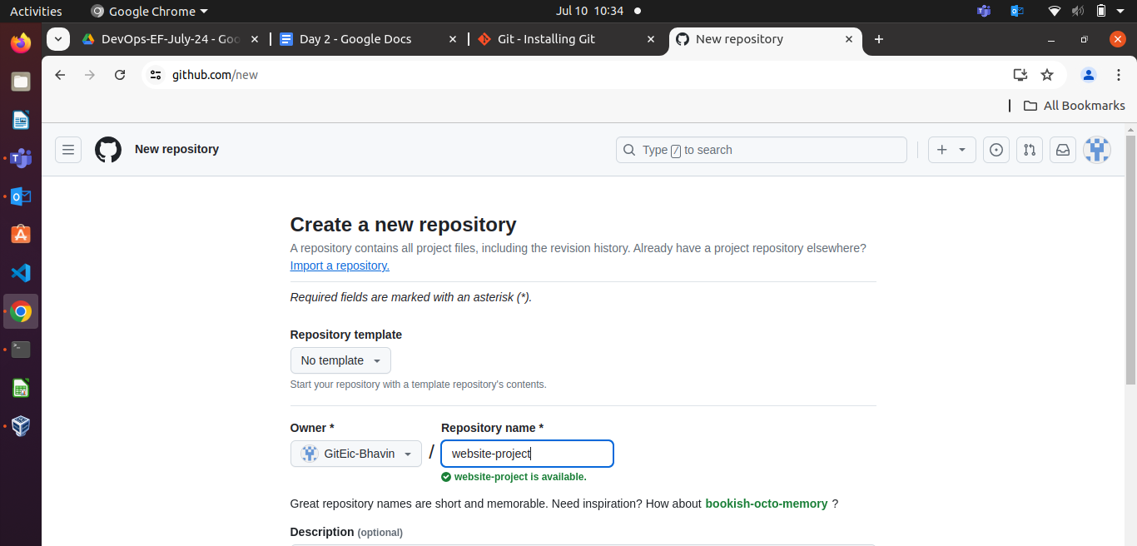

Clone the repository to your local machine:
git clone https://github.com/GitEic-Bhavin/website-project.git

3. Initialize the Project:
Navigate to the project directory:
cd website-project

Create initial project structure:
mkdir src
touch src/index.html
echo "<!DOCTYPE html><html><head><title>My
Website</title></head><body><h1>Welcome to my
website!</h1></body></html>" > src/index.html
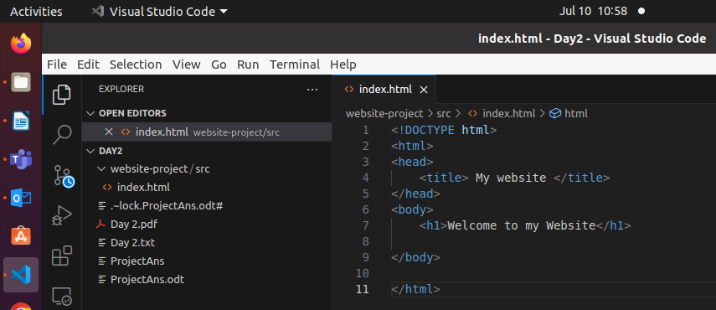

Commit and push the initial project structure:
git add .
git commit -m "Initial commit: Added project structure and
index.html"
git push origin main
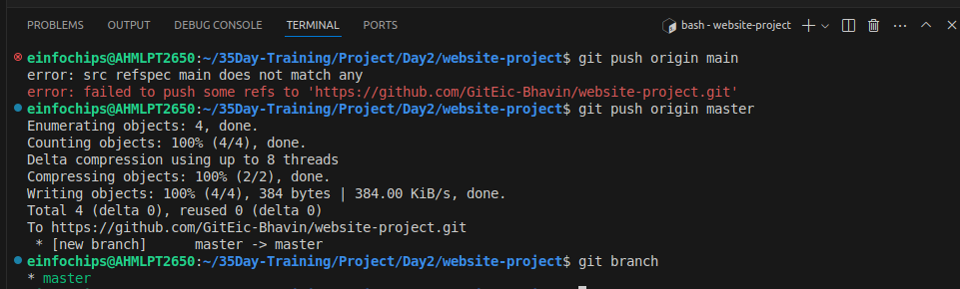

Exercise 1: Branching and Basic Operations (10 minutes)
Create a New Branch:
git checkout -b feature/add-about-page
- Add a New Page:
Create about.html:
touch src/about.html
echo "<!DOCTYPE html><html><head><title>About Us</title></head><body><h1>About Us</h1></body></html>" > src/about.html
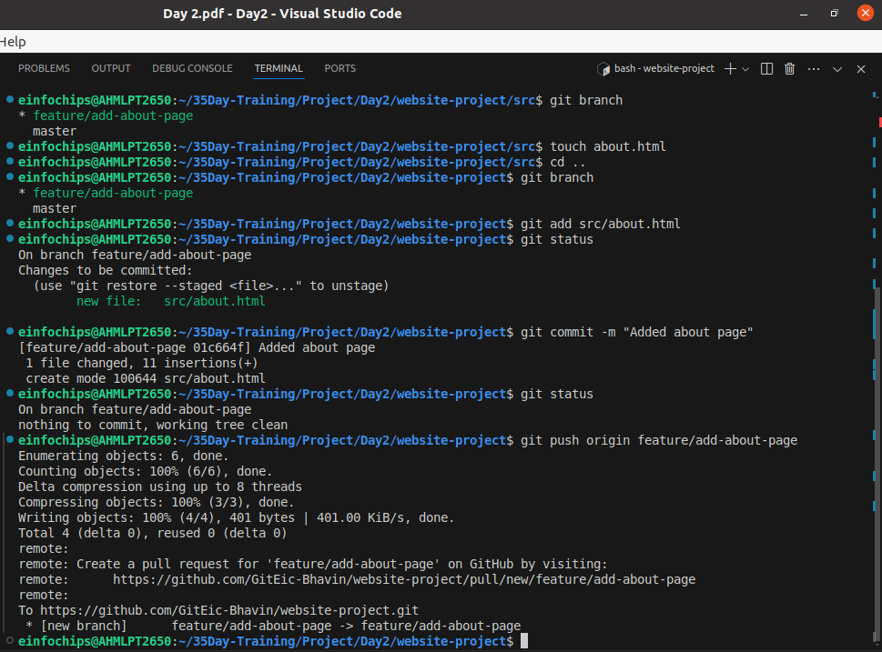
Exercise 2: Merging and Handling Merge Conflicts (15 minutes)
Create Another Branch:

git checkout main
git checkout -b feature/update-homepage
1.Update the Homepage:
Modify index.html:
echo "<p>Updated homepage content</p>" >> src/index.html
Commit and push changes:
git add src/index.html
git commit -m "Updated homepage content"
git push origin feature/update-homepage
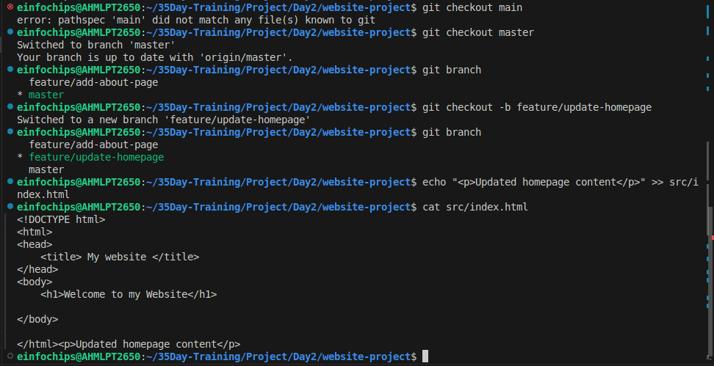
Commit and push changes:
git add src/index.html
git commit -m "Updated homepage content"
git push origin feature/update-homepage

2. Create a Merge Conflict:
Modify index.html on the feature/add-about-page branch:

git checkout feature/add-about-page
echo "<p>Conflict content</p>" >> src/index.html
git add src/index.html
git commit -m "Added conflicting content to homepage"
git push origin feature/add-about-page
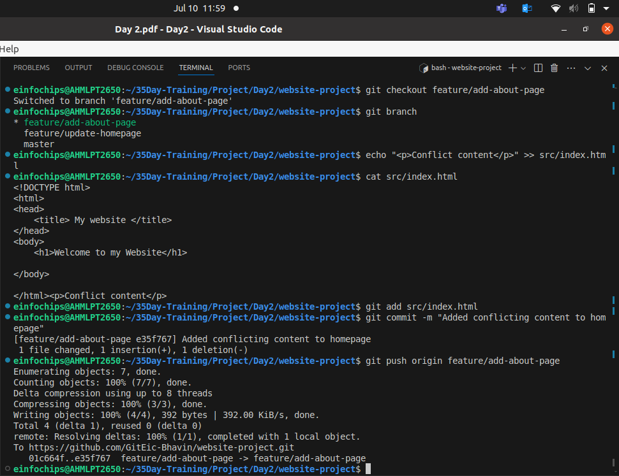
3. Merge and Resolve Conflict:
Attempt to merge feature/add-about-page into main:

git checkout main
git merge feature/add-about-page

Resolve the conflict in src/index.html, then:
git add src/index.html
git commit -m "Resolved merge conflict in homepage"
git push origin main

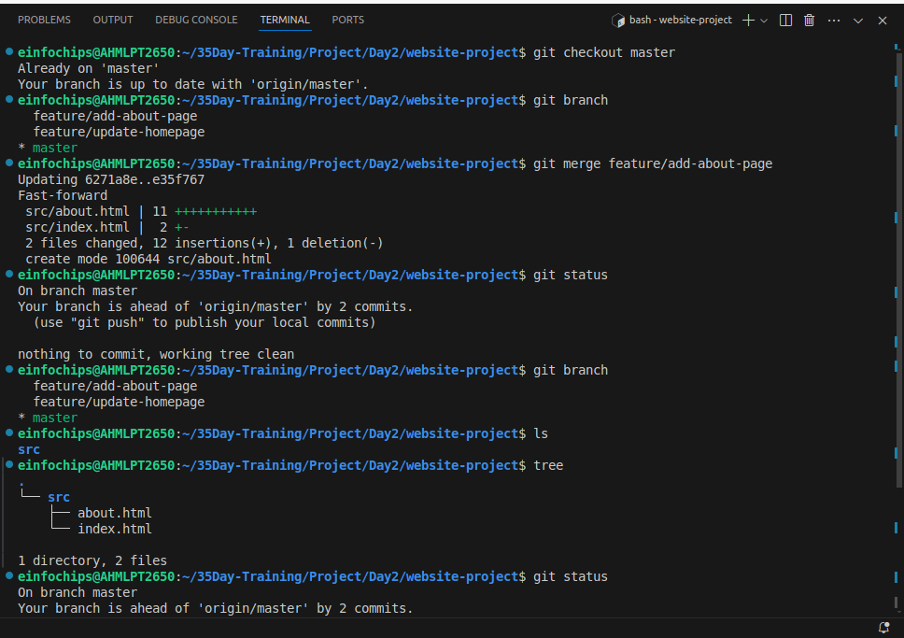
This above pic is stating is only merge from feature/add-about-page branch to master branch locally & not bring chagnes in remote repo.
To Bring chages in reomte repo , do this
git push
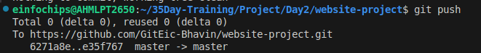
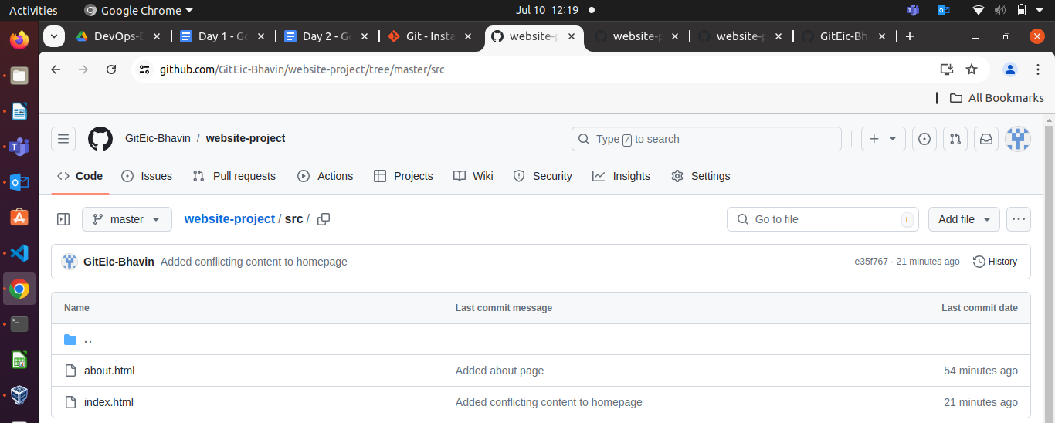
Exercise 3: Rebasing (10 minutes)

1. Rebase a Branch:
Rebase feature/update-homepage onto main:
git checkout feature/update-homepage
git rebase main
Resolve any conflicts that arise during rebase.
Any conflict you see , add its manually. ex. if should any new line delete/add do it & git push to bring reflect this at your remote repo.
Push the Rebased Branch:
git push -f origin feature/update-homepage

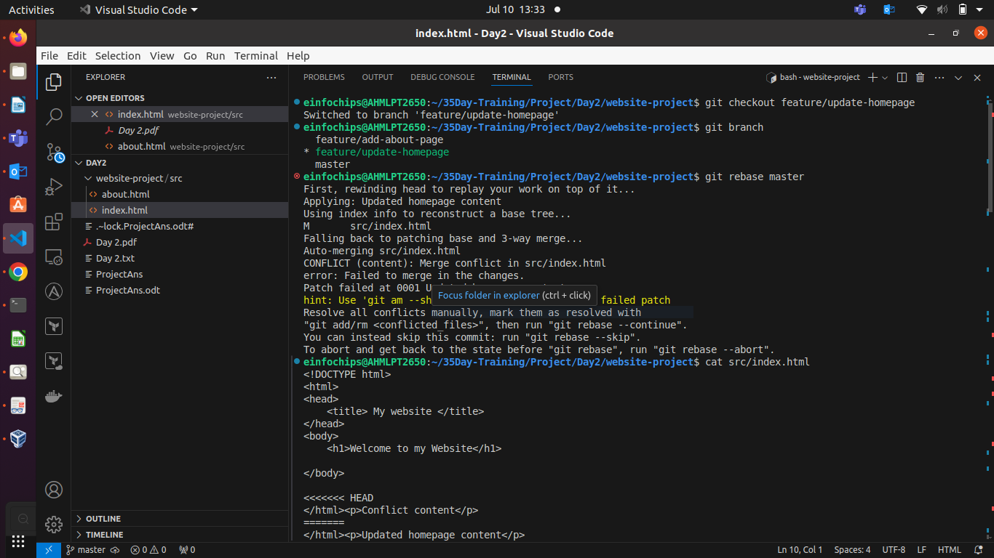
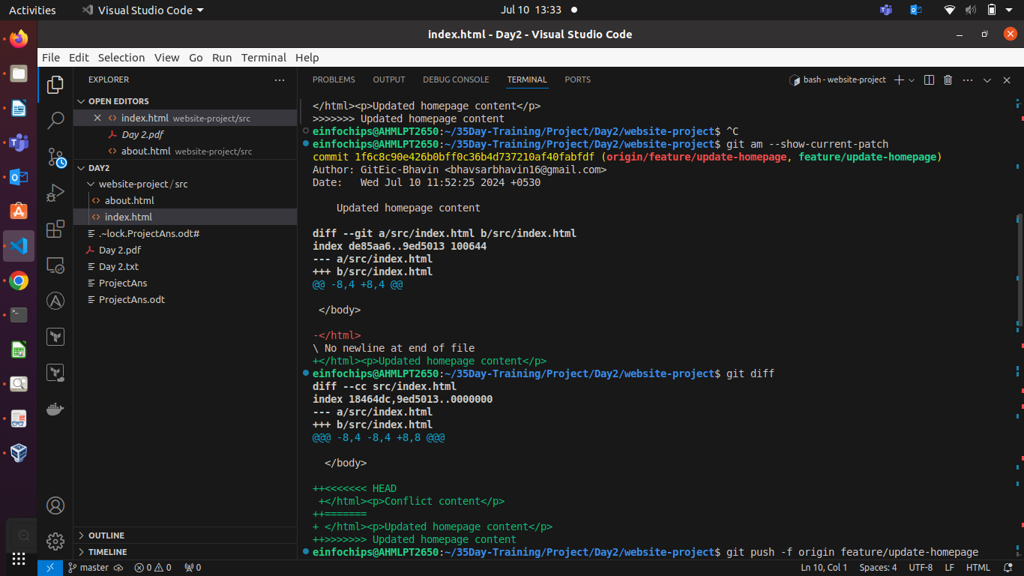

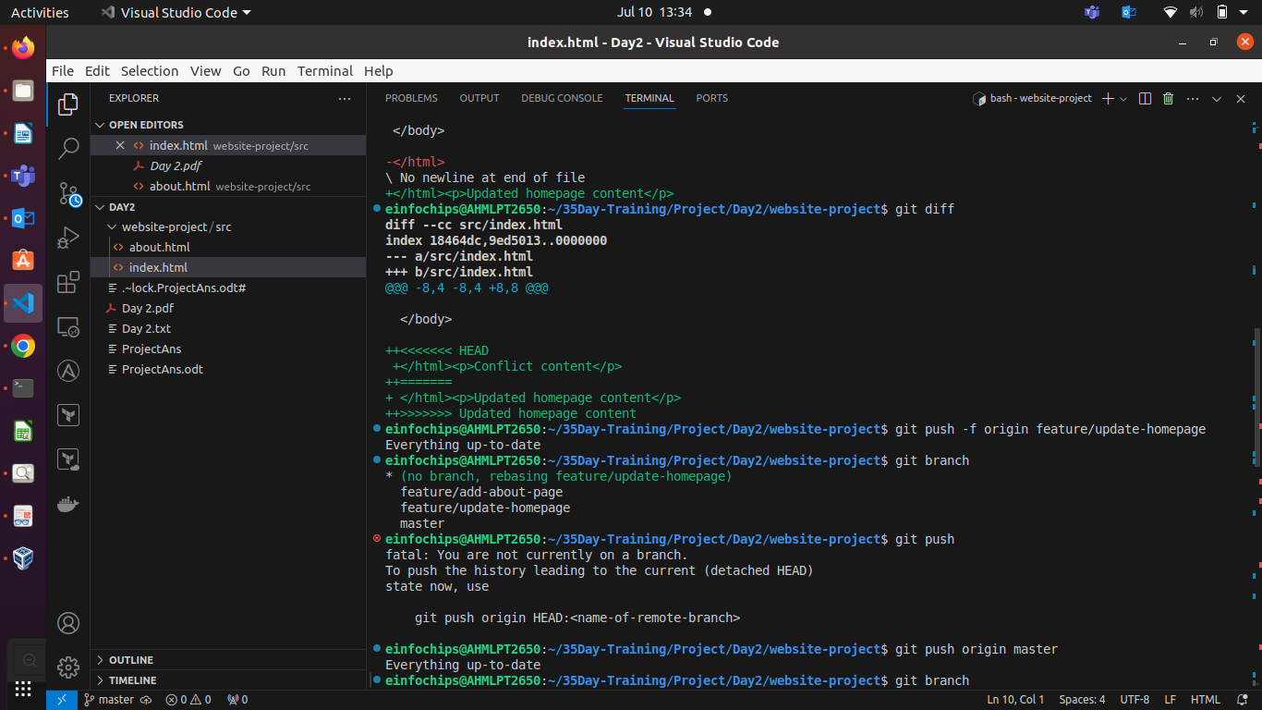

Exercise 4: Pulling and Collaboration (10 minutes)
1.Pull Changes from Remote:
Ensure the main branch is up-to-date:
git checkout main
git pull origin main
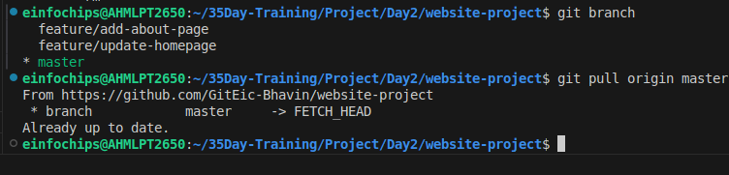

2. Simulate a Collaborator's Change:
Make a change on GitHub directly (e.g., edit index.html).
3. Pull Collaborator's Changes:
Pull the changes made by the collaborator:
git pull origin main
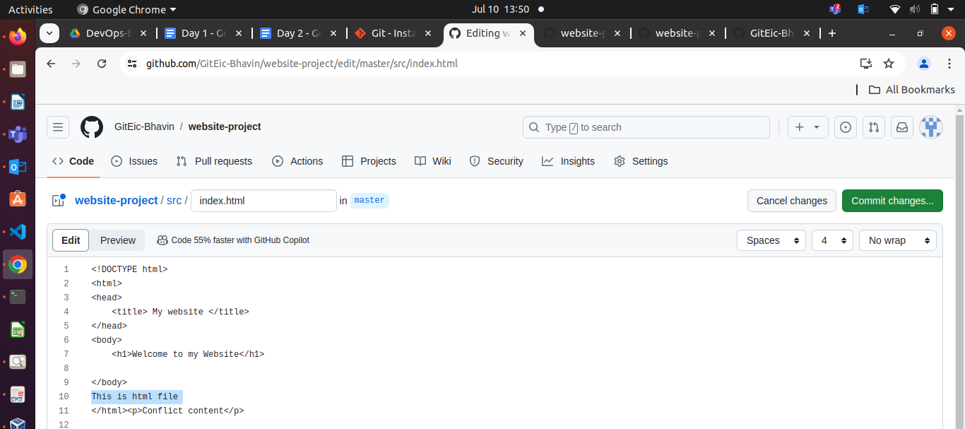
After git pull origin master.

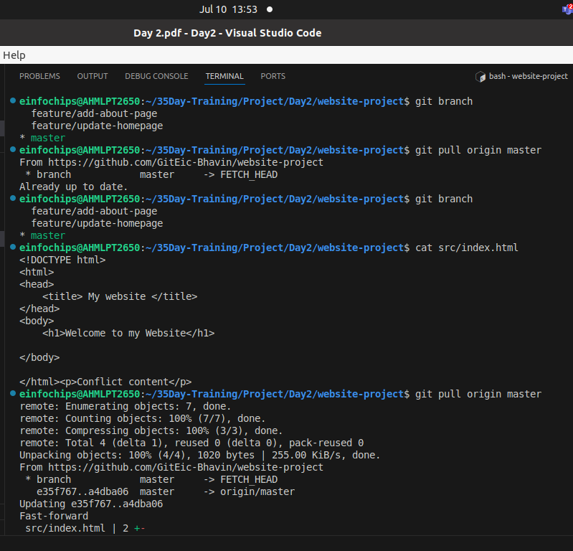

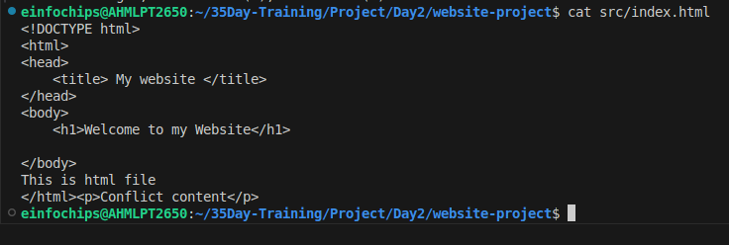

Exercise 5: Versioning and Rollback (15 minutes)
1. Tagging a Version:
Tag the current commit as v1.0:
git tag -a v1.0 -m "Version 1.0: Initial release"
git push origin v1.0
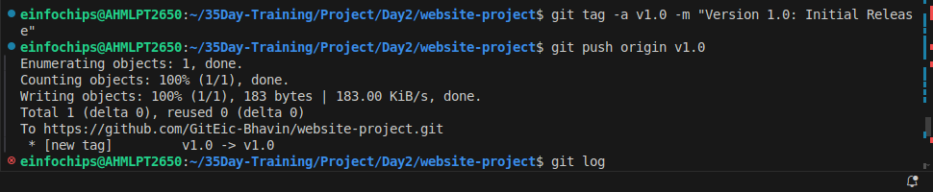

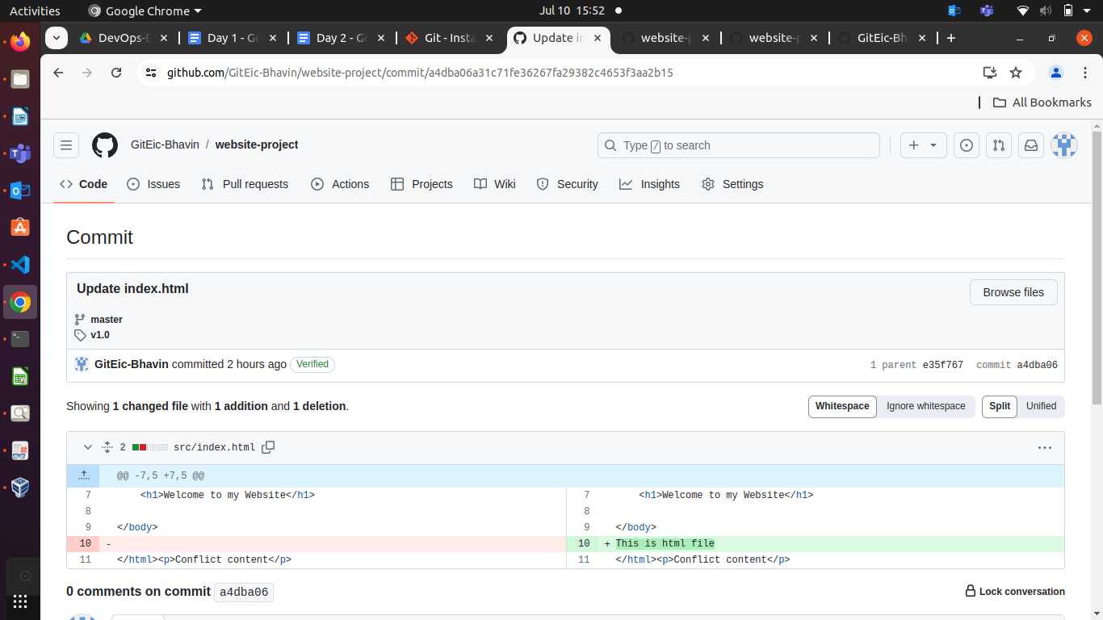
2. Make a Change that Needs Reversion:
Modify index.html:
echo "<p>Incorrect update</p>" >> src/index.html
git add src/index.html
git commit -m "Incorrect update"
git push origin main
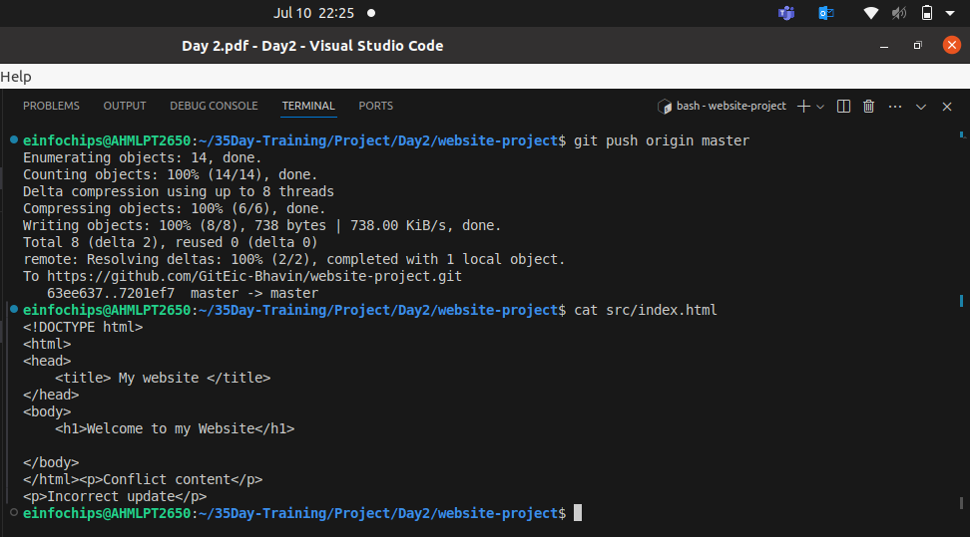
3. Revert to a Previous Version:
Use git revert to undo the last commit:
git revert HEAD
git push origin main
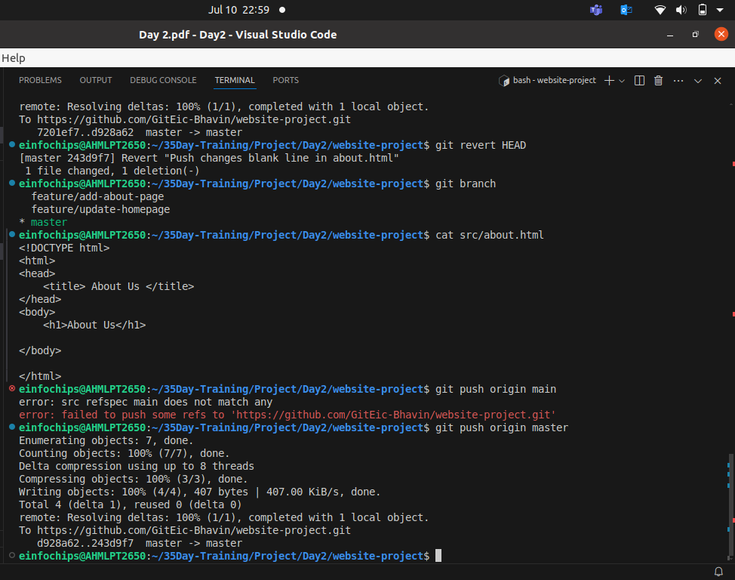
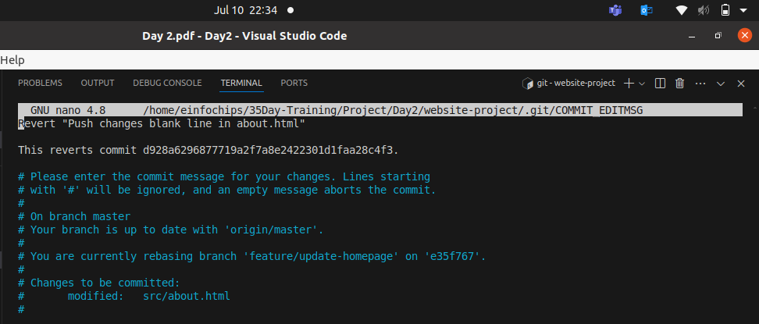

When you do git revert HEAD , it ask you to why you want to revert & write commit for it.
Here, wirte a commit like, “revert for last commit in master branch”, Save & Exit.

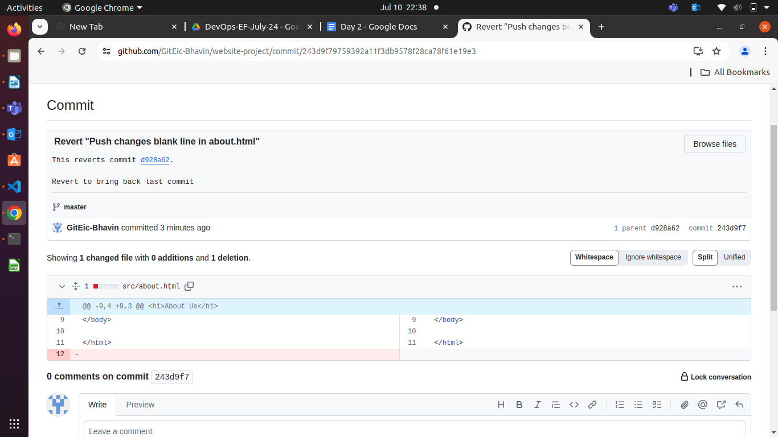

Extra Activities (10 minutes)
1. Stashing Changes:
Make some local changes without committing:
echo "<p>Uncommitted changes</p>" >> src/index.html
Stash the changes:
git stash

- Viewing Commit History:
Use git log to view commit history:
git log –oneline

Output of git log
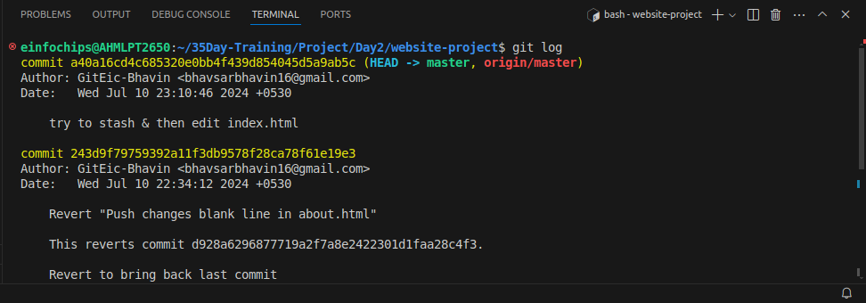

Output of git log --online
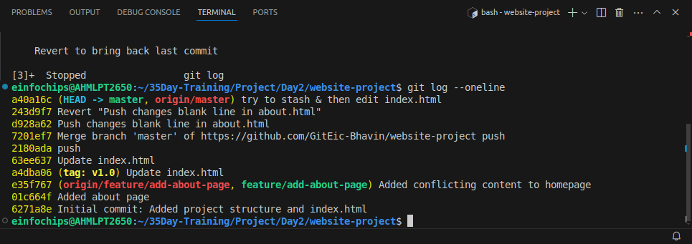

3. Cherry-Picking Commits:
Create a new branch and cherry-pick a commit from another branch:
git checkout -b feature/cherry-pick
git cherry-pick <commit-hash> means , do git log –online & Look for 7 digit called commit id , which commit you want to use to bring it in your custom / dest branch.
git push origin feature/cherry-pick

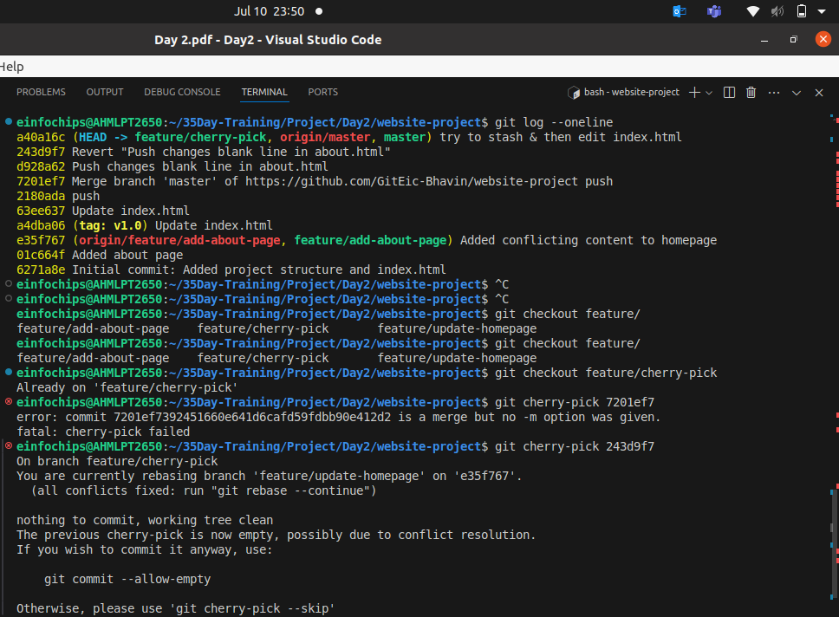
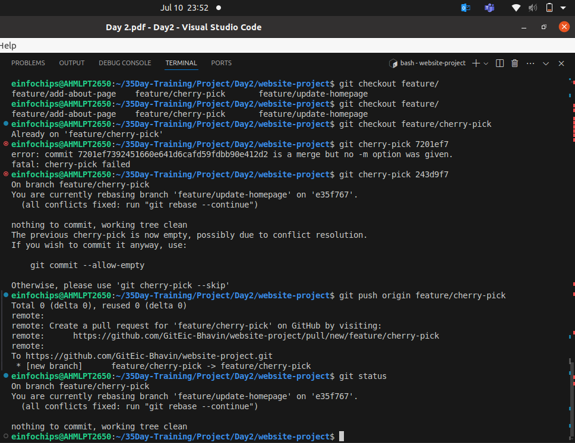

See Actual reflection in git remote repo, using git cherry-pick.
This is use to bring changes of specific commit of any branch into your custom/dest branch.
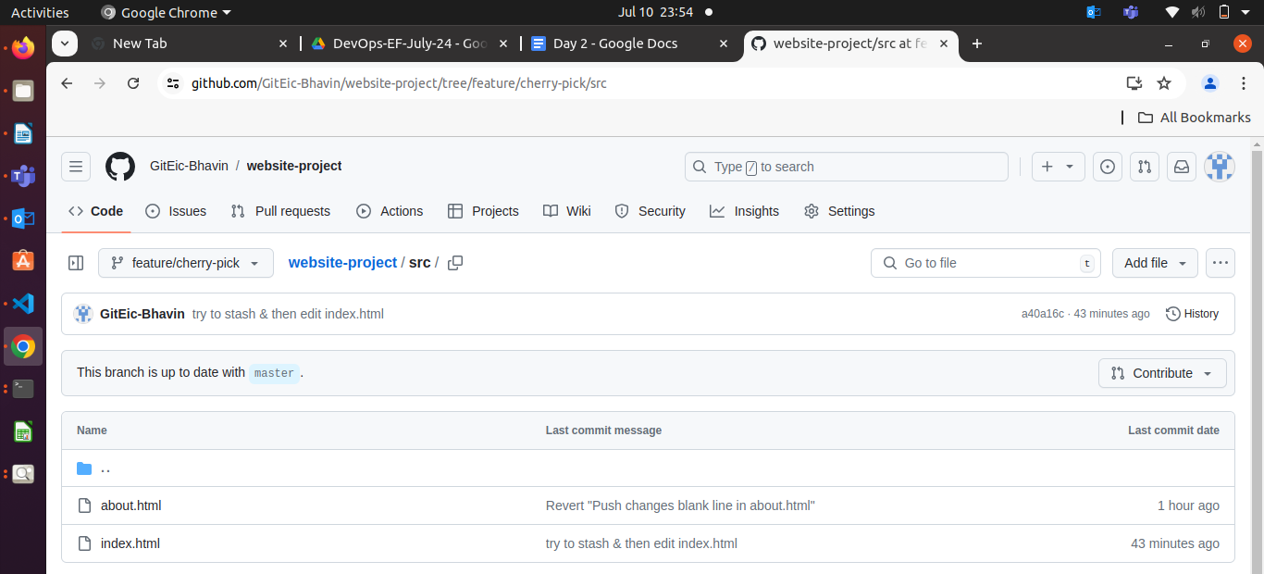

4. Interactive Rebase:
Use interactive rebase to squash commits:
git checkout main
git rebase -i HEAD~3

