Docker Compose

In Dockefile we write multiple commands to perform the tasks.
While we have write lot of commands for ex. setup wordpress on ubuntu, setup sonarqube with psql db in ubuntu.
We generally do this by using ansible roles playbook.
We make each roles & each roles has main.yml where each tasks are defined.

Only have to run ansible-playbook -i inventory.cfg main.tf
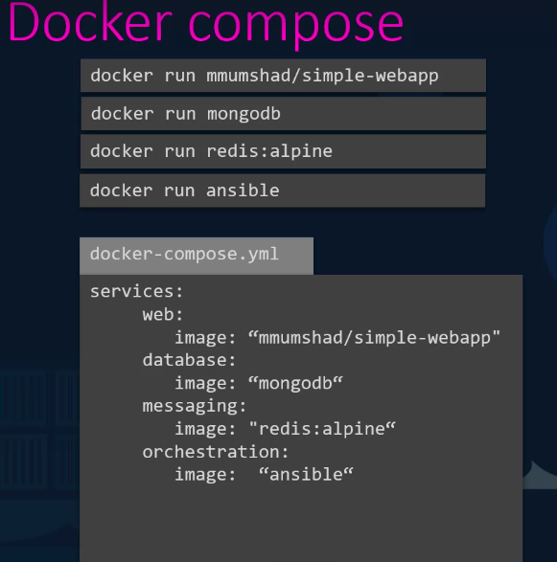
And your Project will be setup in a few minutes.

Like that, in Docker ex. We have to setup sonarqube with psql deb in ubuntu using docker contaier, we wouldn’t prefer to werite all tasks, steps, for sonarqube, psql db, dependencies install, craete config file etc in single Dockefile.
This is not good approach.

In Docker for perform this tasks we will create ‘docker-compose.yml’ file to compose.
In this file, we can write all tasks like playbook.

Ex. Voting app , Result app for Voting Result
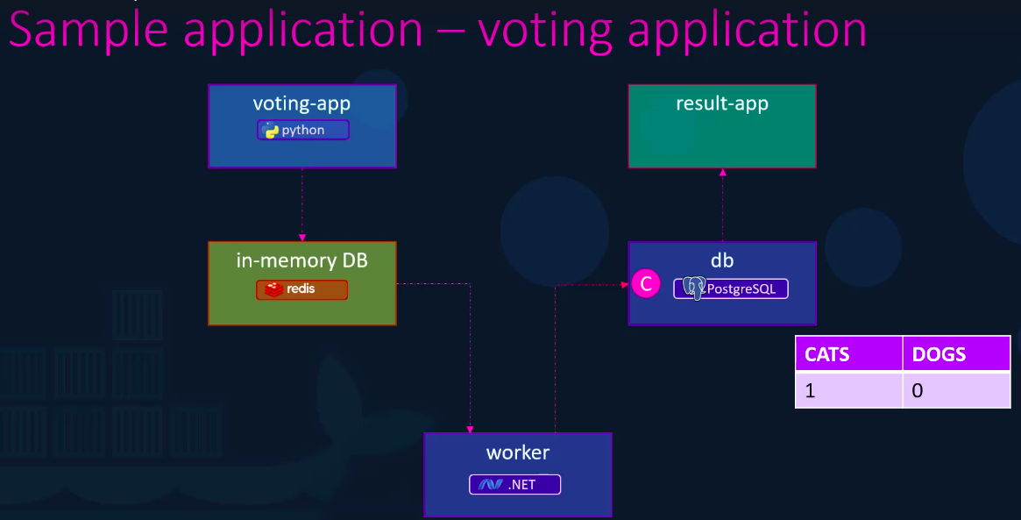
Here, Voting-app based on python – Users can give vote here for cat vs dog .
-- User Interface

in-memory DB – Is Database for stores the voting value for cats & dogs.
Based on redis database

Worker – Will process the vote – take input from in-memory DB & update DB table of Result App, DB is postgresql.
Based on .NET

Result App – Show the final result for cat vs dog vots on different result app.
Based on node.js

Lets See the picture and Understood
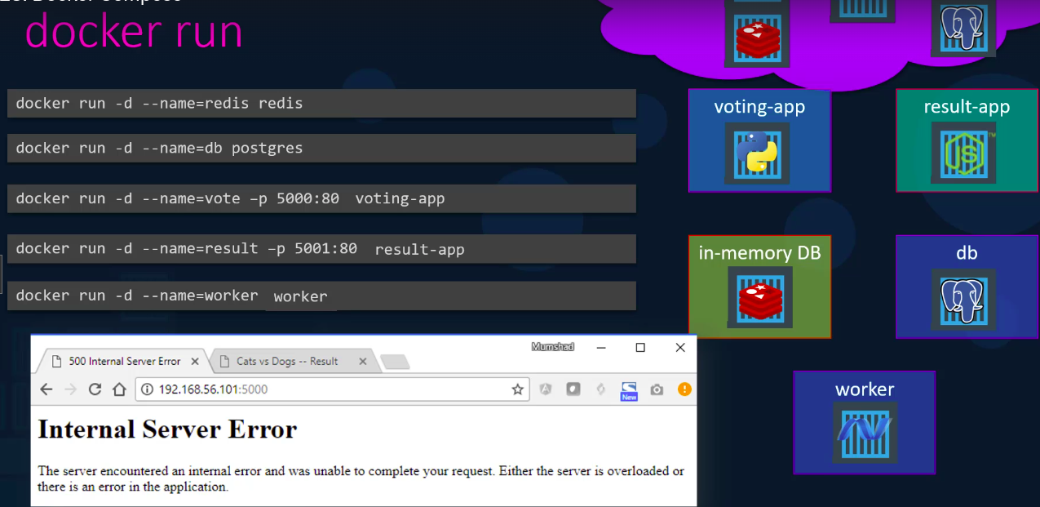
Lets Assume that we had creted all this 5 imges.

Now, want to run voting-app to result-app .
Run all this images conatainer in detached mode.
docker run -d –name=redis redis
docker run -d –name=db postgres
docker run -d –name=vote -p 5000:80 voting-app -- so we can give vote on browser.
docker run -d –name=result -p 5001:80 result-app – so we can see the result on result-app on browser.

docker run -d –name=worker worker

You run all this container in background detached mode . So, why did you got this error ?

Bcz, we just create Image, run Image, container only.

In This image all 5 images/container all linked to gether.
Ex. Input of user votes is stores into redis databse from voting-app – linked
Worker will take output of redis database votes given by user & update postgresql database table to update votes count for cat & dog. -- linked
postgresql db will send the updated table result on result-app – linked.

In our case we just run the container & mapped with port 80 to acces them.

So, we have to linked all this 5 conatainer together for further updations.
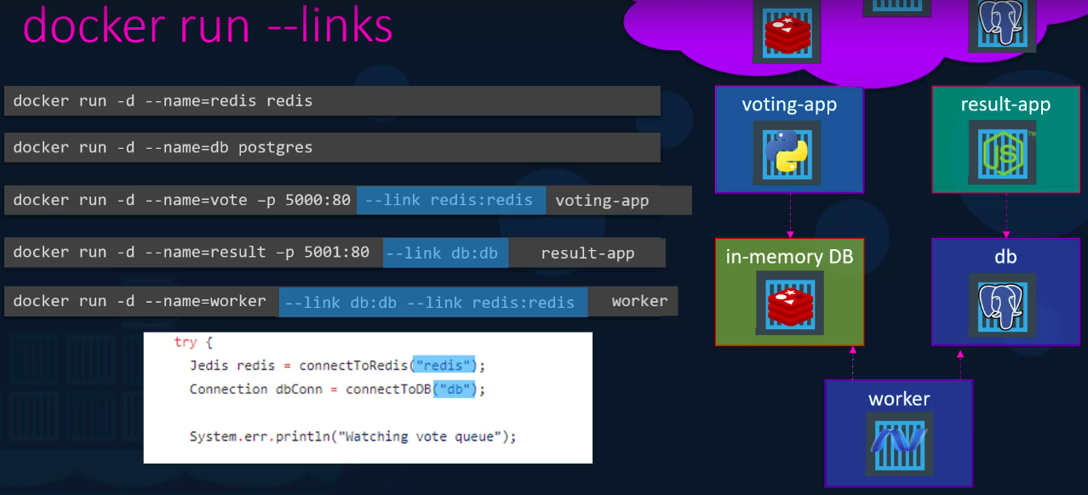

To link between container to make communucates.
Add --link redis:redis
Add --link db:db

docker run -d –name=vote -p 5000:80 --link redis:redis voting-app
docker run -d –name=result -p 5001:80 --link db:db result-app

for worker we have to linke worker between redis db and psql db.
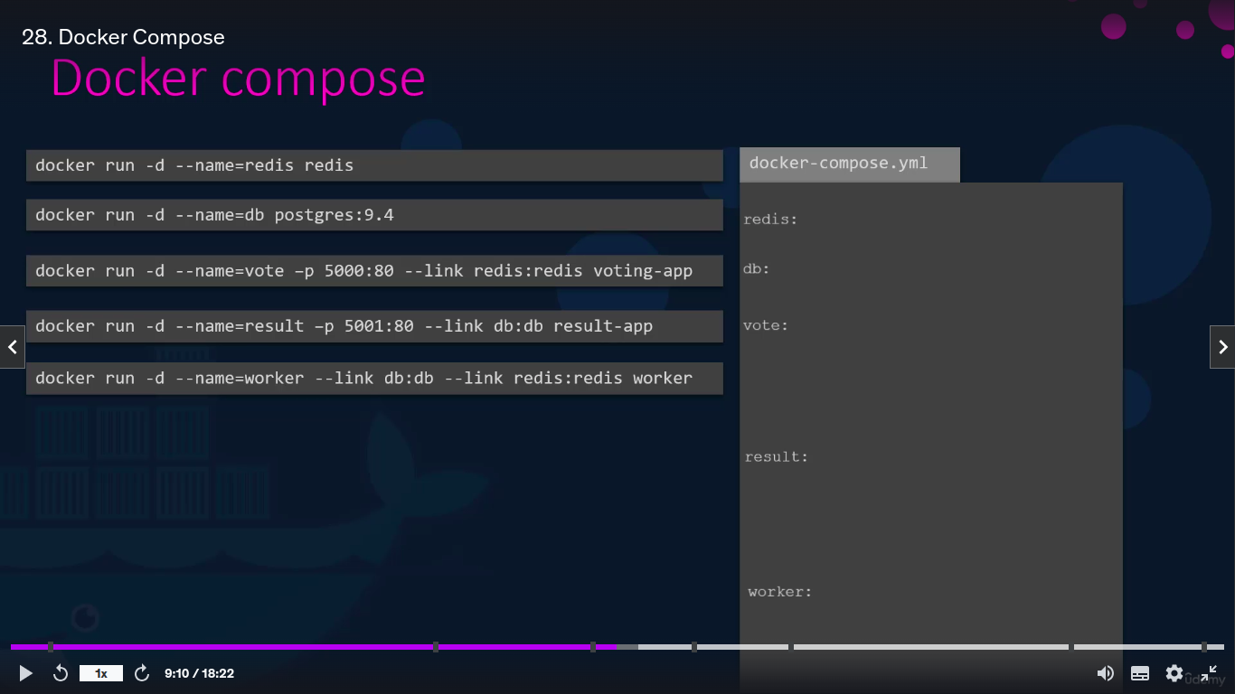
Docker run -d –name=worker

so, this will make entry in /etc/hosts file --link db:db --link redis:redis worker.

Now, you have to make Docker Compose file.
Step 1. Take Key

Step 2. Take Image value Step 3. Take Ports Step 4. Take links
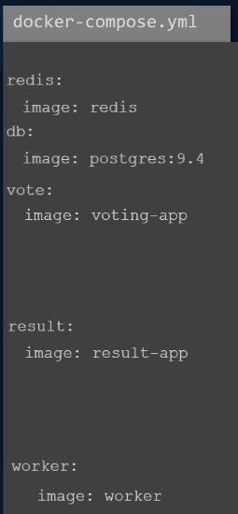
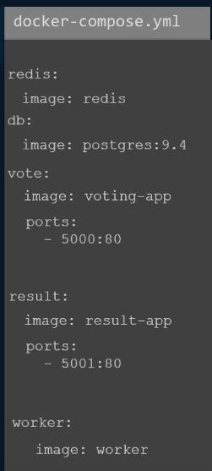
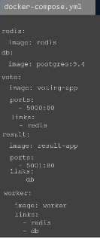

Now, run,
docker-compose up

Docker – Compose – Build – link the contaier
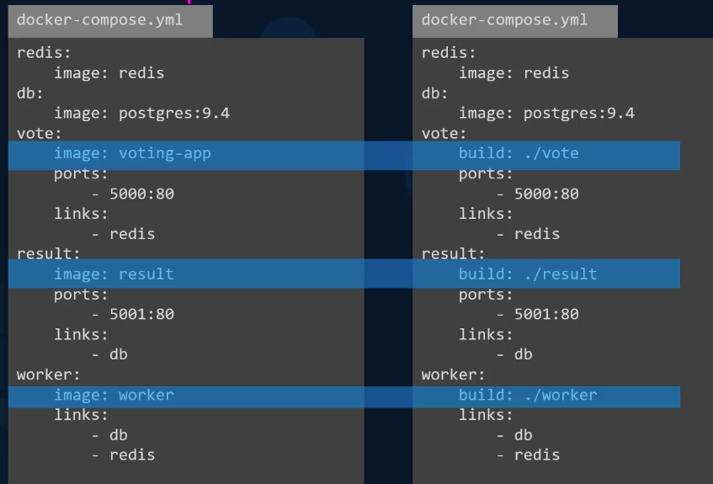
links instructs Docker to link containers over a network.

When we link containers, Docker creates environment variables and adds containers to the known hosts list so they can discover each other.

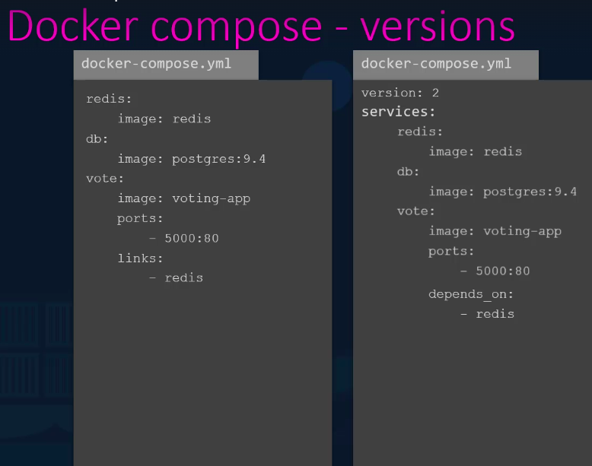
You want to modify the dodker-comose file , you can manage by keep it versions by,
version: 2 , versoin: 4

After link the cotainer , we have to make communucation between the containers.
Using –link we are abel to do links/joints the container together only. And Not communications happens between them.
To make communications between containers we have to use network:
This will discover the service of conatainer like bluetooth, we on bluetooth we can see all enabled bluetooth device in dicover.
To make connection between bluetooth device we have to select bluetooth service of oposite device.
Like that we have to use network: to discover & make connection between them.
