Demo: Docker Create Image
ge name
Go to git repo https://github.com/mmumshad/simple-webapp-flask.git.

To create image for run application on your docker, see all steps & perfome it manually.

Run docker run -it ubuntu bash
root@’container_id’# apt-get install -y python3
root@’container_id’# python3
root@’container_id’# apt-get update && apt-get upgrade -y

root@’container_id’# apt-get install python3-pip
root@’container_id’# pip3 install flask – is a dependencies

root@’container_id’# rm /usr/lib/python3.*/EXTERNALLY-MANAGED
root@’container_id’# pip3 install flask-mysql

copy code from git repo app.py into your docker path /opt/app.py

cd /opt/ & run FLASK_APP=app.py flask run –host=0.0.0.0
type https://ip_of_your_localhost:5000

here, my ip is http://172.17.0.3:5000/
output:- Welcome!

http://172.17.0.3:5000/how are you
output:- I am good, how about you?
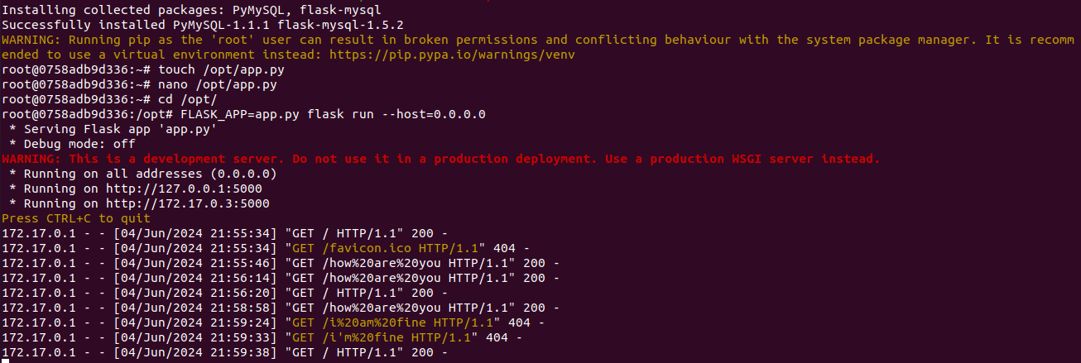

This is we done by manually but we want to do this by containerized means create image.

Make Dockerfile in text editior & write each steps which we performed by manually.
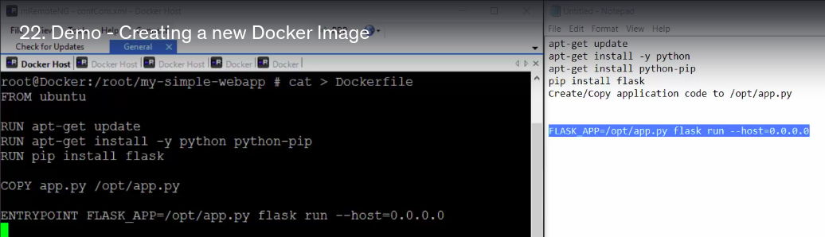
Now make directory where this Dockerfile will save & also image will create

mkdir my-simple-webapp , cd my-simple-webapp.
Create Dockerfile.
vi Dockerfile
Add all steps in Dockerfile

FROM ubuntu

RUN apt-get updat && apt-get upgrade -y
RUN apt-get install -y python3 python3-pip
RUN rm /usr/lib/python3.*/EXTERNALLY-MANAGED
RUN pip3 install flask
RUN pip3 install flask-mysql

COPY app.py /opt/app.py

ENTRYPOINT FLASK_APP=/opt/app.py flask run –host=0.0.0.0

To Perform Tasks COPY app.py /opt/app.py
create app.py or copy app.py file into your local where directory my-simple-webapp.

Now, build image by,
docker build . -t ‘my-simple-webapp’
Here, -t for give Image Name is ‘my-simple-webapp’

If you define FROM ubuntu you dont need to give image name in docker build . -t ‘my-simple-webapp’

so, i will run,
docker build .

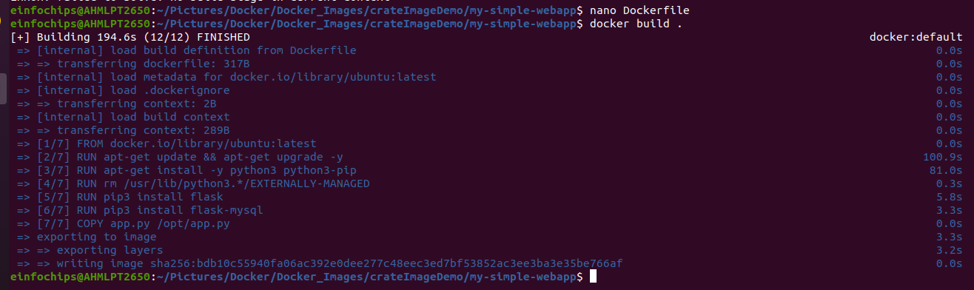
Check your owne image was created in your local by, docker images
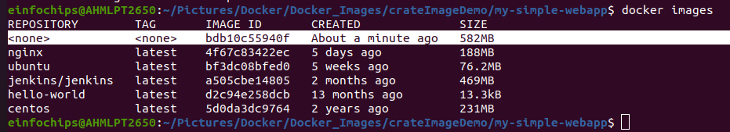
But, here your images dont have Name / Tag . So give it name ‘my-simple-webapp’

docker build . -t my-simple-webapp
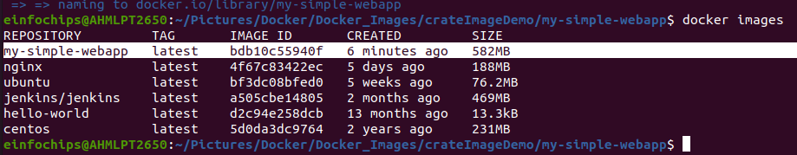

docker run my-simple-webapp
search https://localhost:5000

Push your this image on docker hub by,
docker push my-simple-webapp

but, it will give error that requests denied to push image into docker.io/library/my-simple-webapp.

Bcz, your image will be push into this docker.io/library. & not everybody doesnt access to push image in this library.

You have to make your account in docker hub then give your account name while push image.
docker build . -t bhavin/my-simple-webapp
docker push bhavin/my-simple-webapp

If this doesnt work , create account on docker hub.
Run command,
docker login
give your credentials
docker push bhavin/my-simple-webapp
