Docker Images

How to create my own Image ?

Ex. I want to run application on my host.
Steps i will follow,
1. OS- Ubuntu
2. Update apt repo by sudo apt-get update && apt-get upgrade -y
3. Install dependencies using apt for your application
4. Install python dependencies using pip – pip install “package name”
5. Copy source code to /opt/‘folder_name’
6. Run the web server using ‘flask’ command

To deploy & run web from docker, i have to

1. craete docker file named Dockerfile

Dockerfile
FROM Ubuntu
Run apt-get update && apt-get -y install python
RUN pip install flask flask-mysql
COPY . /opt/source-code
ENTRYPOINT FLASK_APP=/opt/source-code/app.py flask run

after create this Dockerfile , build image using docker build command and specify this Dockerfile as input by -f Dockerfile and as well as a tag name for this build image by -t “your_custome_image_name”

docker build . -f Dockerfile -t mmumshad/my-custom-app

Now, you build your image in your local & image also only available on you localhost.
To Make it available on the Public Docker Hub Registry Run,

docker push “your_custome_image_name” that you created.
docker push mmumshad/my-custom-app

To
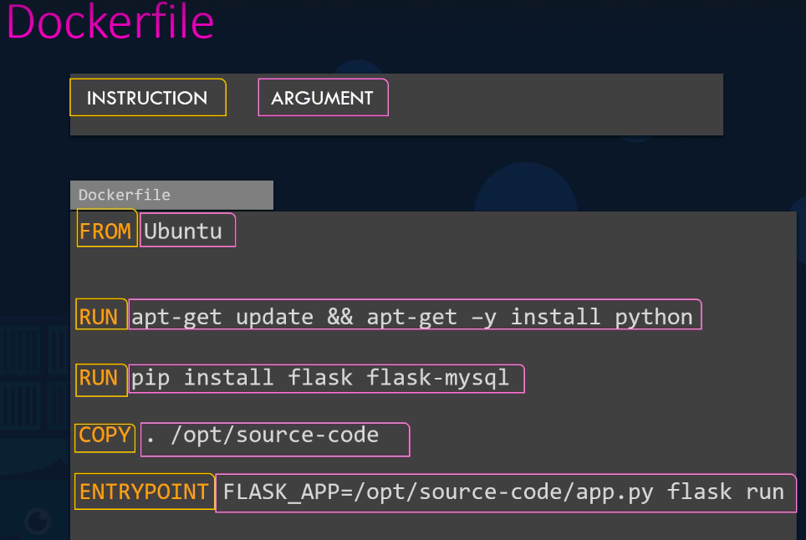
Each of these Instruction – docker to perform a specific action while creating the image-name

Everything on the right is an argument to those instructions.

This all 5 steps in Dockerfile will execute by ENTRYPOINT ,
This will follows layers means, if layer 1 FROM Ubuntu will pass then it will go to layer 2 RUN apt-get update && apt-get -y install python & make cache of previous layer, & follow like this till end.

So, ex. if layer 3 is failed, you modify the Dockerfile step 3 & rerun the contaier image , at this time, docker will not run Dockerfile form starting, Docker will run image from where your last layer was failed that is layer 3 .
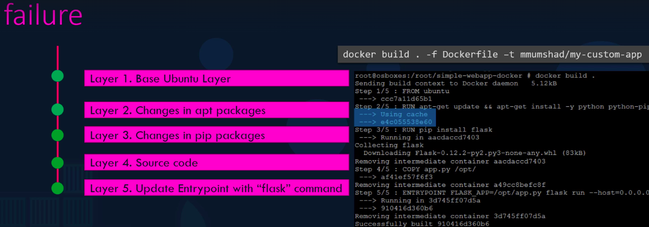
This will save your time .

