Environment Variabel in Docker
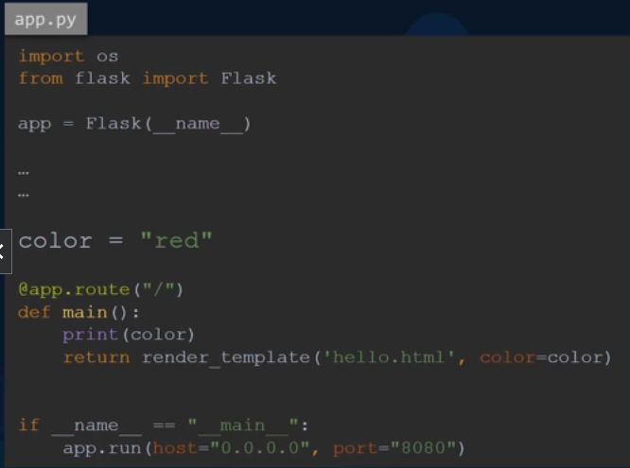
Ex. here in app.py script file when you create image using Dockerfile & this app.py, when you search localhost:port in your browser, the browser’s background colour will be red. Bcz, in this app.py the variable called color = “red” is given.
If you want to change color into “blue”. You have to modifry this scrip mannally then build . -t ‘image_name’ again at every time.

So, Its not good approach.

Use Environment Variabel & set it to your custom colour whenever you need.

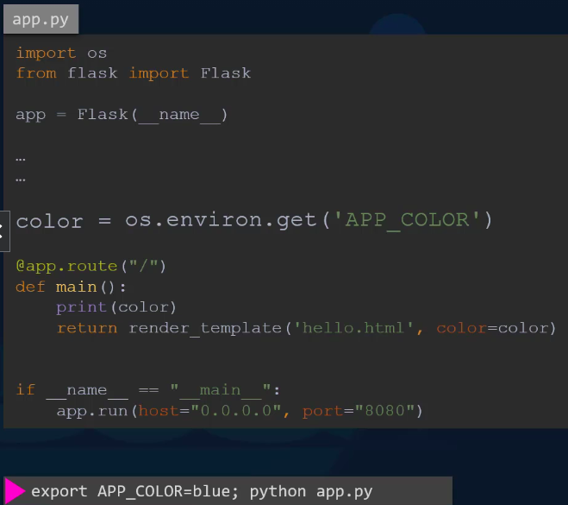
So, use color = os.environ.get(‘APP_COLOR’) in your this app.py script.

Then, set environment variable is blue with mapping app.py script to use app.py script for use environment variable.

Export APP_COLOR=blue; python app.py in your local.

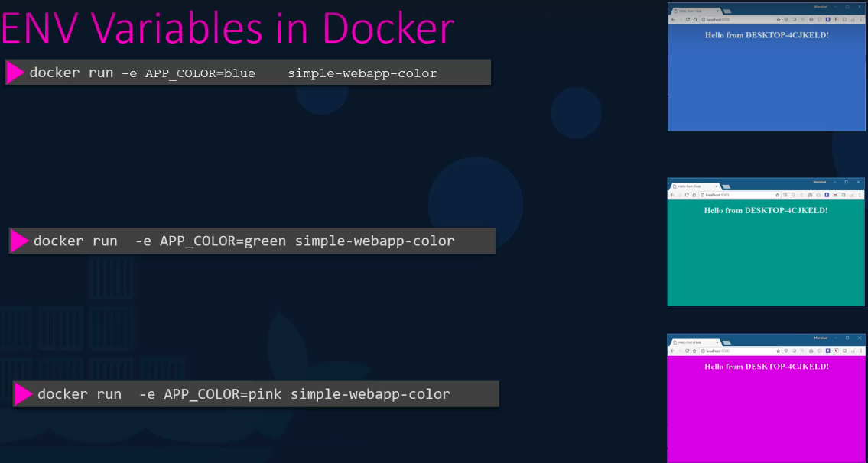
To set web’s background color during run the container , you have to pass environment variable using -e .

docker run -e APP_COLOR=blue simple-webapp-color

NOTE:
Give container name
docker run -d –name ‘custom_contaier_name’ ‘image_name’

Give image name during build
docker build . -t ‘custom_image_name’

Give Tag to image during build
docker build . -t my-simples-webapp:local

Give container name & imagename and tag during run the conatainer
docker run -d --name <container_name> <image_name>:<tag_name>

docker run -d --name bhavin-build my-simples-webapp:local

