Commands VS Entrypoint

CMD – command
to run command after build image,

for ngixn for mysql
CMD [“nginx”] CMD[“mysqld”]
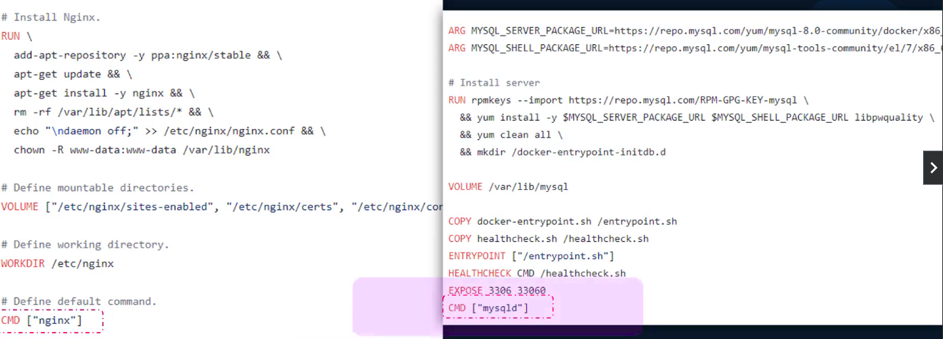
To see the container’s terminal during build image
CMD[“bash”] – so , when you run contaier your cotainer will not be exited bcz, in Dockerfile you specify the command CMD[“bash”]

so, that means you directly entered in containers terminal means you are run the process into container . Thatsfor container will not be exited.

Different commands to start/run the conatainer.
1. append
docker run ubuntu “command”
docker run ubuntu “sleep 10”

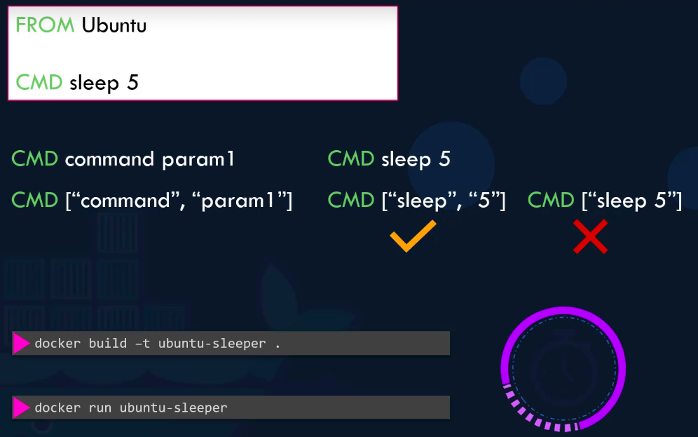
This will override the CMD[“bash”] or CMD[“nginx”] whatever you defined in image Dockerfile.

2. Define command within Image Dockerfile

You can write command 2 ways.
1. CMD sleep 5
2. Json Formate
2. Json formate – CMD [“executable command”, “parameters/value”]
CMD [“sleep”, “5”]

so , whenever you run conatainer , your contaier will be automatically go in sleep mode for 5 sec & then conatainer will be exited

docker build -t ubuntu-sleeper . -- image build
docker run ubuntu-sleeper – sleep mode for 5 sec & then exited.

3. Entrypoint
You specify CMD sleep 10 in dockerfile – so during run docker it will go sleep for 10 sec.

You want to sleep 20 or sleep 5 during run container & want to override hardcoded command in Dockerfile CMD sleep 10

you can do by,
docker run ubuntu-sleeper sleep 20
But, this is not good approach

so, you have to only pass the command valude like 20 sec only
docker run ubuntu-sleeper 20

Here, comes ENTRYPOINT in picture,
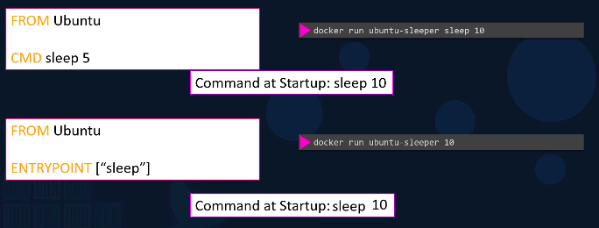

You have to specify ENTRYPOINT in Dockerfile like this,
ENTRYPOINT[“sleep”]
So, when you pass parameters/value for command sleep

docker run ubuntu-sleeper 20
ENTRYPOINT[“sleep”] will take 20 sec as input , and run container for 20 sec.

4. Without pass paramters/value for set default sleep 10 .
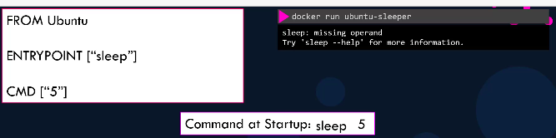
Specify both CMD & ENTRYPOINT in Dockefile like this.
docker run ubuntu-sleeper – it will sleep for 5 sec when you run contaier.

5. If you want to modify ENTRYPOINT during run time run container
specify –enntrypint sleep 20 & override ENTRYPOINT sleep 5 sec in Dockefile.

docker run –entrypoint sleep 20 ubuntu-sleeper

