Docker Networking

When you install docker, it creates 3 networks automatically,
1. Bridge 2. None 3. Host

1. Bridge – is the default network a container gets attached to.
While you create / Run container , it will get attached to this Bridge Network.
docker run ubuntu – attached to Bridge Network.

If you want to attache any other networks to your container, Specify networks by,
docker run ubuntu --network=none
docker run ubuntu --network=host
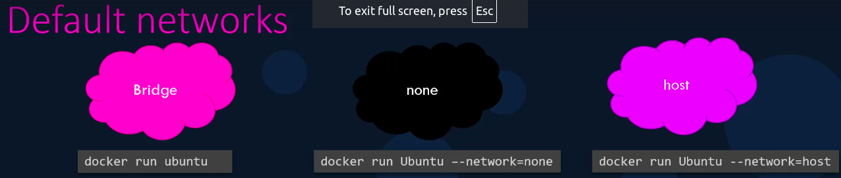
1. Bridge Network – Is a Private Internal Network created by docker on the host.
All containers attached to this network by default & they get an INTERNAL IP address with range “172.17” series.
The containers can access each other using this internal ip if required.
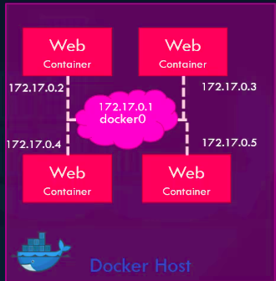
To access any of these container from the outside of docker host. You have to port this containers to docker host(Your host).

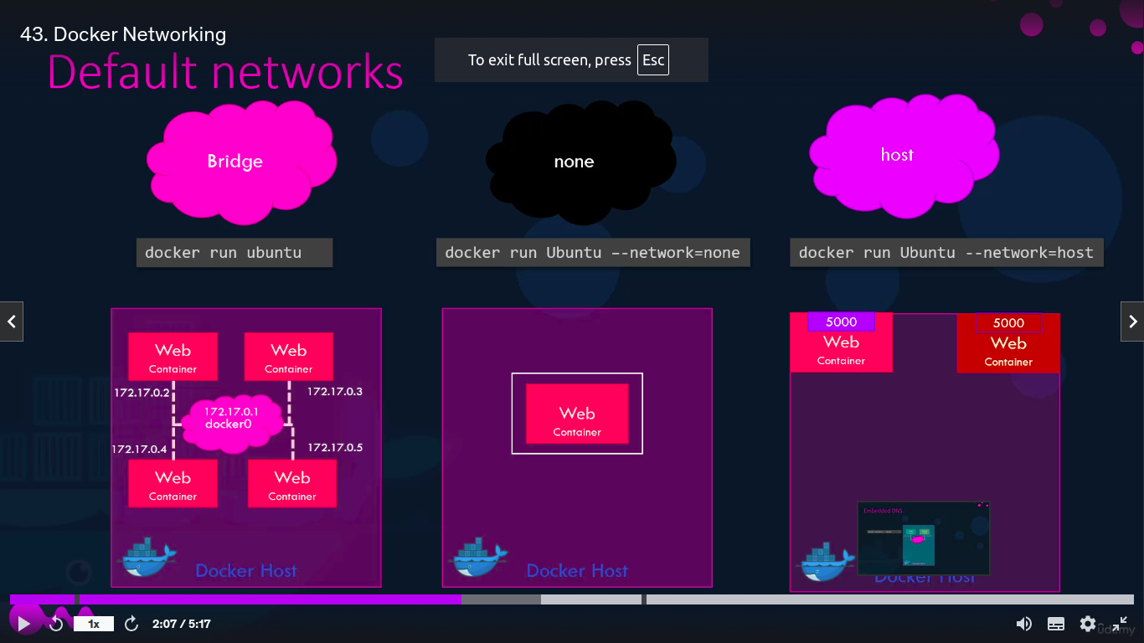
2nd method is ( host ): Associate the containers to the host network.
Means associate the container with my localhost network.

Means, when you run , docker run ubuntu or docker run -d ubuntu , This will run on your localhost.
After that whatever container will you run, it will run on your localhost bydefault. Here, you dont need to port mapping.

3rd method ( none ):- The containers are not attached to any network and doesn’t have any access to the external networks or other containers.
They run in an ISOLATED networks.

User Defined Network – Custom Network instead of Bridge Network (Bydefault)

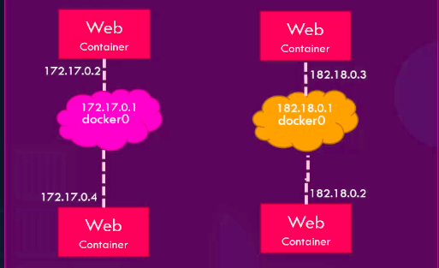
If you run container , it will attached to host network by default.

Internal IP – Private IP.. 172.17 range fo docker

If you want to make your own network & attech 2 container to this own network.
You have to create the network by,
docker network create \
-- driver bridge \
-- subnet “your custom ip range” – 182.18.8.0/16
custom-isolated-network

To lists all networks docker network ls
How to see networks settings and the IP Address of existing container ?
docker inspect “container_IP/name”
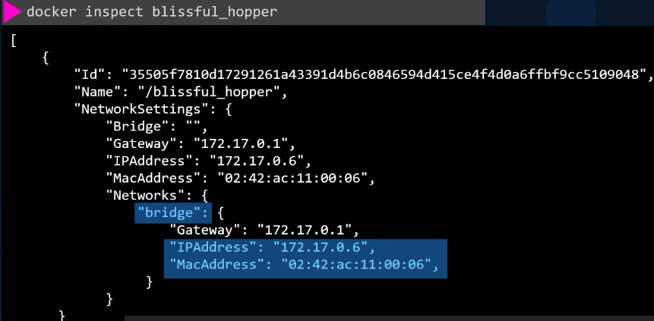

If i have one container having MySQL database & web-app like wordpress, sonarqube running on different container.

How can i connect to web-app from MySQL database ?
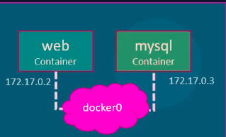
Internal IP of web-app is 172.17.0.2
Internal IP of mysql is 172.17.0.3

I will connect to web-app by entering web-app Internal IP.
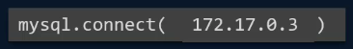

But This is not good approach , bcz , IP of myslq container will be changed after reboot the system.
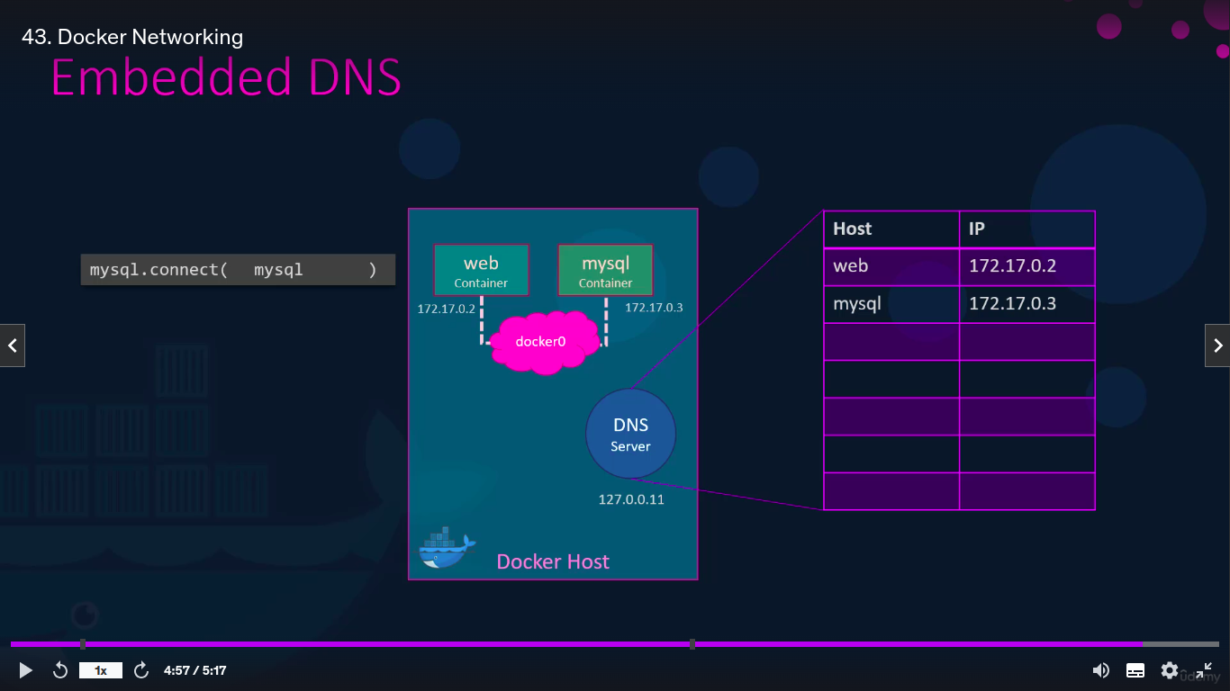
Use Container Name instead of container ip.
Bcz, all containers in a docker host can resolve each other with the container name
Docker has built in DNS Server that helps the containers to resolve each other using teh container name.

Built in DNS Server always runs at 127.0.0.11

