Demo: Advanced Docker Run Feature

docker run ubuntu – It will pull latest(Tag_name) image & run it.
docker run ubuntu cat /etc/*release* -- It will give version of ubuntu image is running in container.

What happen if you want to run specific version of ubuntu image
docker run ubuntu:17.10
This will not show the version of ubuntu image

To show version of ubuntu image
docker run ubuntu:17.10 cat /etc/*release*

Attach & Detach

In Attach mode
docker run ubuntu sleep 20 – It run container for process sleep 20 sec.
After 20 sec This contaier will be exited.

But, till complete this sleep 20 sec process we cann’t to able to do anything like we normally do in our terminal like run a command , view file etc.

In Detach mode
docker run -d ubuntu sleep 20
This will run a container in a background so we can able to do anything like we do in our terminal . But for only process run for 20 sec. After 20 sec this containder will exited.

docker run -d ubuntu sleep 20
root@docker#: cat /etc/*release
root@docker#: ls -ltr

This is now a detached mode,

To go back to Attach mode,
docker attach “contaier_id”

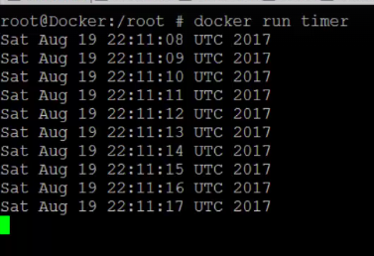
Print Current time on scrren
docker run timer
This will print current time continuously, not stop.
This is running in attach mode

To run it in background – Detached mode
docker run -d timer

To go back to foreground mode, Attach mode
docker attach “contaier_id”
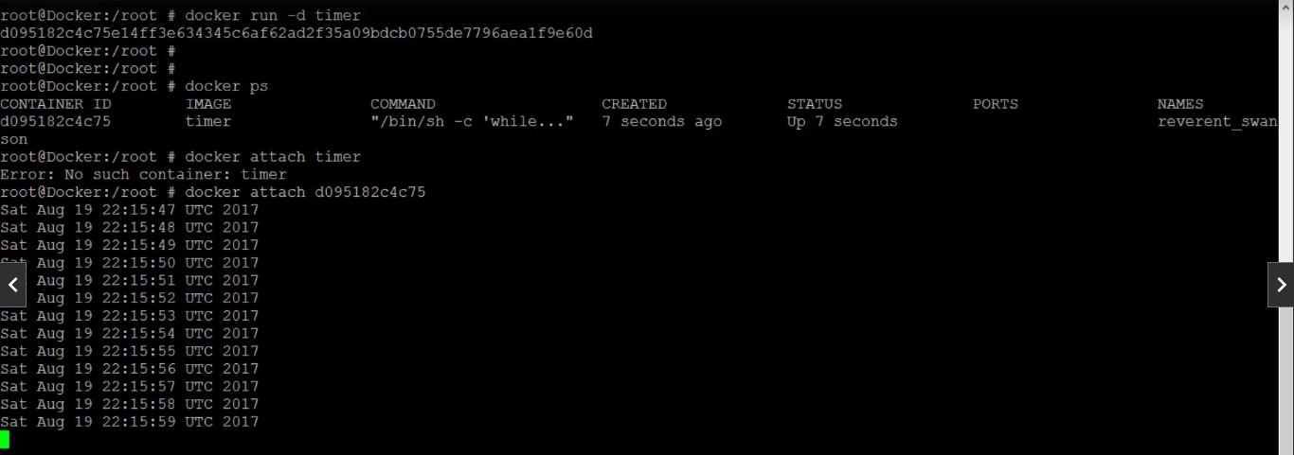

Jenkins Run on docker

docker run jenkins
docker run port -p 8080:8080 – mapping to port 8080 to jenkins port 8080.
to see a internal ip of jenkins image,
docker inspect “contaier_id”
find IPAddress: 192.168.2.4 -- 192.168.2.4:8080 – jenkins will run

docker run -p 8080:8080 -v “your_custom_path”:“jenkins-Path” “image-name”

docker run -p 8080:8080 -v /root/my-jenkins-data:/var/jenkins-home jenkins

docker run -p 8080:8080 -v /root/my-jenkins-data:/var/jenkins-home -u root jenkins

