Docker Run
What is Docker Tag ?
To pull specific version of image we give tags is seperated by “:”
docker run redis:4.0 – It will pull only version 4.0 of redis image.

Docker run redis – It will use default tags named “latest”

Run – PORT mapping

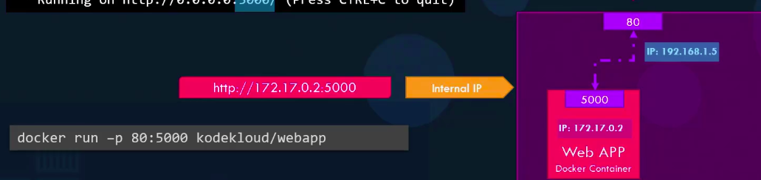
Here, kodekloud/webapp is application within the docker host.
Ip is 172.17.0.2 is internal ip. User outside of docker host cann’t accessible it.
To Access this application outside of Docker Host with port 80.
you have to map port 80 to port 5000 .
docker run -p 80:5000 kodekloud/webapp
-p for port mapping from 80 to port 5000.

docker host ip for port 80 is 192.168.1.5
so after port mapping 80:5000 , user will able to access this application by ,
https://192.168.1.5:80 ----
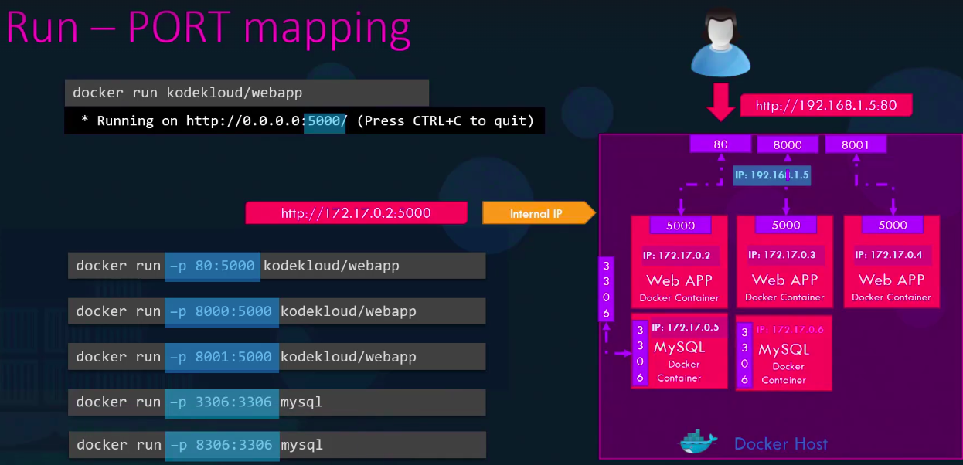

Here, you can port your mysql db to your custom port.
docker run -p 3306:3306 mysql ---- https://172.17.0.5:3306

docker run -p 8306:3306 mysql ---- https://172.17.0.6:8306

Run – Volume Mapping

Why we need to Volume Mapping like port mapping ?
In port mapping you user can access your application from anywhere by mapping user port 80 to your application port 5000 from outside of docker host.

Like that to access your database, storage under container .
All data of your records, applications of mysql db is stores in directory ​/var/lib/mysql.

If you delete this mysql container , your all data under /var/lib/mysql are permanantly gone/ deleted by ,
docker stop mysql
docker rm mysql

If you store data inside container It will deleted after remove the container.
If you want to Prevent the data from deleted, do not use it inside the container, use it outside of container.

You have to need a Volume Mapping.
You have to map your directory(outside of container) with /var/lib/mysql(inside directory – where data stores) by,

docker run -v “directory outside of container”:”directory inside of container” “container_name”

docker run -v /opt/datadir:/var/lib/mysql “mysql”
/opt/datadir – is directory outside of container ( your working directory )
/var/lib/mysql – is directory inside of container ( your mysql container directory )

TO GET MORE DETAILS ABOUT THE CONTAINER.
docker inspect “container_name/id”

It will give you all detailed information about the container with JSON Format.

Container Logs
How do we see the logs of a container we run in the background ?

docker logs “container_name/id”

