Lab: Docker Run Commands

Q-1 How many containers are running on this host ?
A-1 docker ps –1

Q-2 What is the image used by the container ?
A-2 nginx:alpine

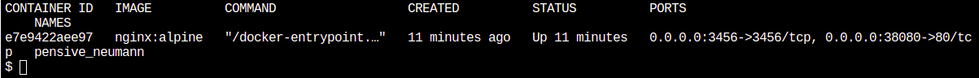
Q-3 How many ports are published on this container ?
A-3 container e7e9422aee97 Image nginx:alpine
Q-4 how many ports are exposed ?
A-4 docker ps 3456 & 80
0.0.0.0:3456->3456/tcp ->3456/tcp is container ports on side of docker hub
0.0.0.0.:3456 – on localhost has assign mapping ports from localhost to port 3456 to docker hub container port to access web from port 3456.
same for 0.0.0.0:38080->80/tcp

Q-5 Which of the below ports are published on host ?
A-5 Ports on the left(before ->) are published on the host.
3456 & 38080

Q-6 Run an instance of kodekloud/simple-webapp with a tag blue and map port 8080 on the container to 38282 on the host.
A-6 docker run -p 8080:38282 kodekloud/simple-webapp:blue

