Docker Storage

How the docker stores data on the local file system ?
When you install Docker on a system, It creates this folder structure at /var/lib/docker.

Under this directory docker stores auts/ containers/ image/ volumes/
all the files related to containers are stored under the containers/ folder,
all the files related to images are stored under the image/ folder
Any volumes created by the docker containers are created under the volumes/ folder.

Lets Understand Docker’s Layered Architecture
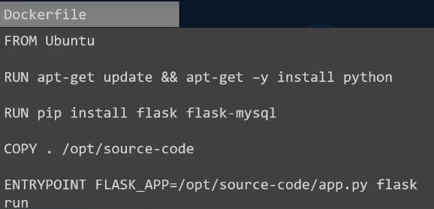
When you build image, Each line of Dockerfile will creates a new layer in the Docker image with just the changes from the previous layer.

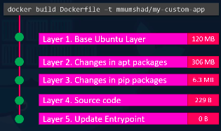
Ex. 1st Layer – Base Ubuntu OS followed by
2nd Instruction that create a 2nd layer which iubstall all the apt packages.
3rd Instruction creates 3rd layer with the python packages followed by,
4th Layer that copies the source code over.
5th Layer will update the entry point of the image

Each Layer only stroes the what changes happens form the previous layer & it will reflected in size.

Advantages of Layer Architecture
Ex. 1 Ex. 2
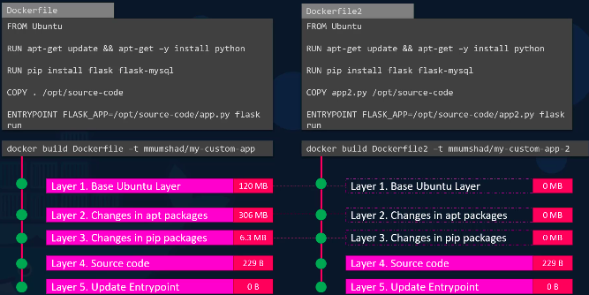
Here, 2 Dockerfile for 2 different application.

Docker will create Image of ubuntu base for ex.1
It will creates all 5 layer of each line.
This each layer will have cache of that tasks defined in that line.

For Ex.2
First 3 line are same for ex.1 & ex.2
OS = ubuntu
update packages & install python
install flask dependencies
Copy source code at diff place with diff script file is app2.py
Update Entrypoint is diff from ex.1

Means it will change/update that line which is diff from ex.1
And Keep layer 1 to layer 3 same & not perform that tasks bcz, layer 1 to layer 3 have cache of that line tasks.

So, your time & data size will save.
Docker will reuse that layer 1 to layer 3 from the cache of it.

When we run the docker container It will create Layer 6. Container Layer.
This Laye 6. Containe Layer is writable layer on top of the imgae layer(Layer1 to Layer 5).
This writable layer 6. container layer is used to stores the data created by the container . Stroes the data like logs file, tmp files, file modified by user.
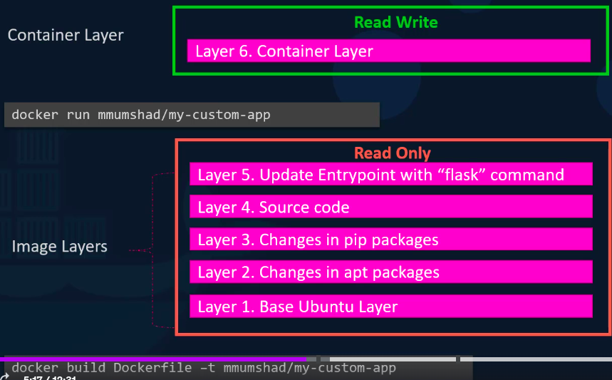
This Layer 6. contaienr layer will only alive till that container is alive.

When contaeinr will delete this layer 6 also be deleted.

In container layer – It is Read & Writable layer. So, after created image – image will create a file from that image layer ex. app.py . So, this app.py will first created in image layer. Which is only readable & not writable.
After create imgae , docker will automatically copy this app.py from image layer to contaeiner layer.
Now, you can modify this app.py file form Layer 6. contaeiner layer only.

If you want to modify file app.py in Image just you created, you cann’t do that directly.
You have to rebuild that image after modified docker file with updated app.py file.

When you delete the container , your all data under layer 6. contaeiner layer will also be deleted permanantly.
How to preserved / secure your data ?

You have to create a volume by, docker volume create your_volume_name
It will create the volume under /var/lib/docker/your_volume_name
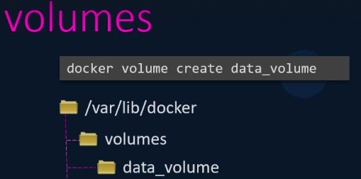

docker run -v data_volume:var/lib/mysql mysql
This will create volume “mysq” inside the contaeiner path /var/lib/mysql .
And also attach/link your contaeiner volume /var/lib/myslq with your localhost volume directory data_volume.

Whatever all data you will write , modified in your contaienr /var/lib/mysql , it will also update your localhost volume ‘data_volume’ like git pull .

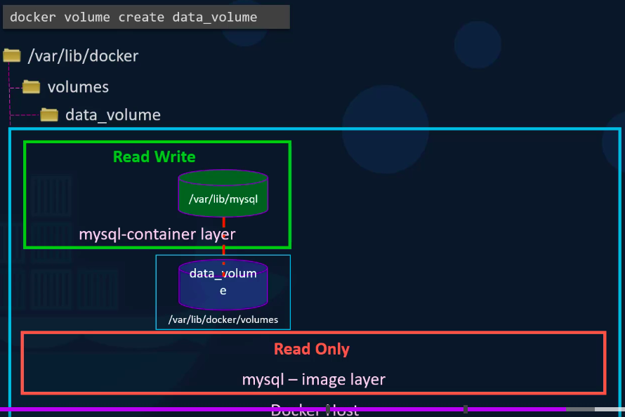
Even if you delete your container , still your all data will be presisted / saved / secured in your localhost volume path.

If you did not created volume by docker volume create ..
you can also do that by, mounting the volume.

docker run -v /data/mysql:/var/lib/mysql mysql
This is called bind mounting.

There are 2 types of mounting
1. Volume mounting, -- mount a volume from the volume directory.
2. Bind mounting – mounts a directory from any location on the docker host.

Another way to mount a volume not using -v .
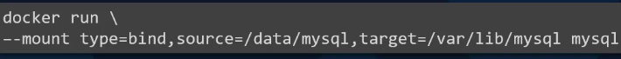
source – my localhost directory ,
target – my contaeiner volume directory
type – bind , volume

Who is responsible to do and maintain all of these like manage image layer, container layer, create file, modify file, copy file, send file over image layer, container layer, create volume inside container , on docker host(localhost) ?
Docker is using storage dirvers to enable layered architecture.

Types of storage drivers.
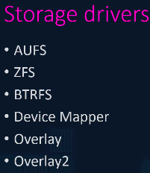
How to select storage drivers ?
Based on the underlying OS – which os will you use in Dockerfile,

