Docker Swarm

I have 4 container in my docker host.
If i make group for this 4 container & Keep it in this group is called node.

If i have no. of nodes where each nodes will have no. of container. And these all are runing on a machine like vm, your localhost, remote server is called pode.

What docker swarm , you could combine multiple Docker machines together into a single cluster.
docker swarm will take care of distributing your services or your applications instances into sepearate hosts for high availability and for load balancing across different systems and hardware to set up a docker swarm.
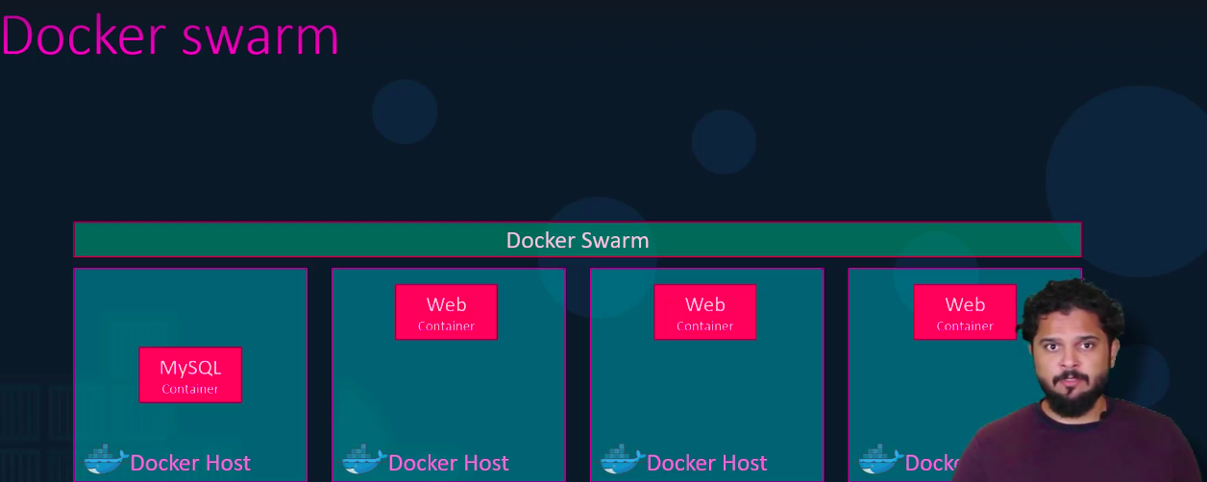
If i have 10 pc & each pc have installed docker & running lot of container.
I have to manage this all container in each pc for high availability, load balancing , i can use docker swarm.

Define Swarm Manager/Master Node from 10 pcs. And remains all are as worker/ remote server.

Define swarm manager by go to that docker host/node and type,
docker swarm init
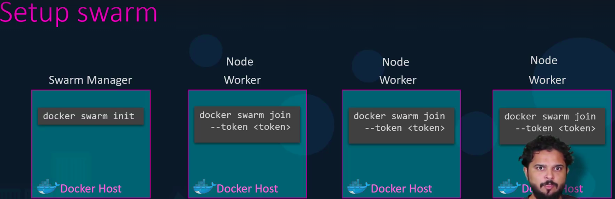

Now, Remaining node, pc, docker worker , have to join your main node – Swarm Manager by,
docker swarm join in each worker node.
But it is not good idea , bcz, ex. i have 1000 nodes , i couldn’t go to each nodes and join each worker node to my swarm manager.

Thatsdfor i will use docker service ,
docker service create –replica=3 ‘my-web-server’
Run this on only swarm manager.

docker service is similar to docker run command.
We can user & pass environment variable -e using docker service
