Kubernetes Introductions

In docker cli, you can run container / server by,
docker run my-web-server but at one time only once container will runs.

In Kubernetes,
you can run , deploy, scale up , scale down, update apt-get packages on 1000, 2000 server / nodes whatever you want by single command.
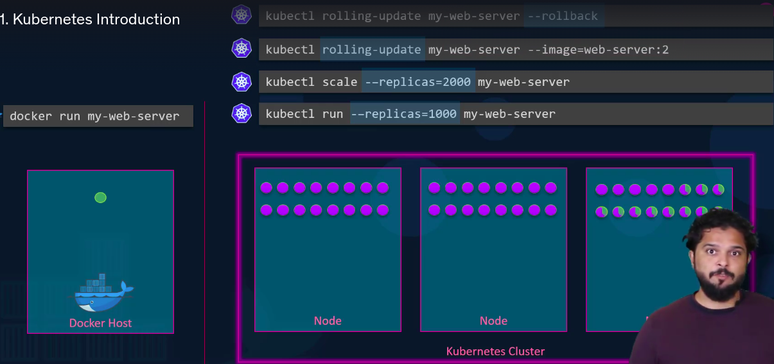
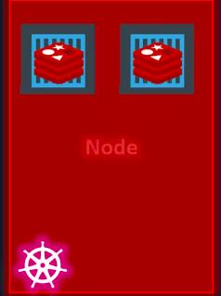
Nodes – is a machine may be physical or virtual machine.
In Nodes your softwares / applications are running.

What happens if your nodes goes to failed ?
Your softwares / applications will also goes failed If you have only single node.

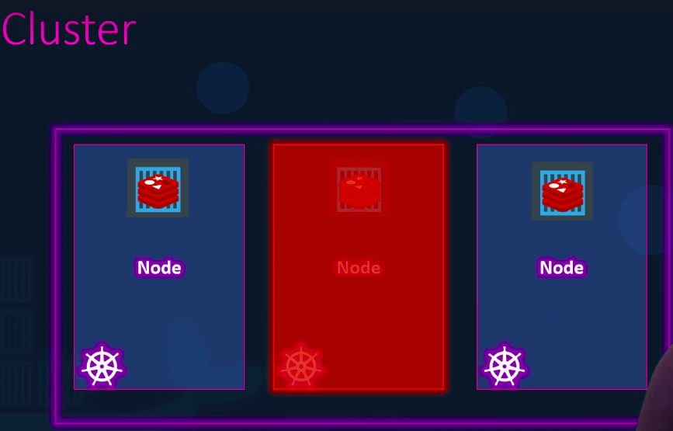

You should have to use more then 1 nodes.

Cluster – Is a set of nodes / group of nodes.
If one nodes fails you have your application still accessible from the other nodes.

Who are responsible for managing this cluster ?

Whereas the information about the members of the cluster is stored ?
How are the nodes monitored when a node fails ?
How do you move the workload of the falied nodes to another worker node ?

Here, Master comes .

Master – is a node with the kubernets control plane components installed.
Master watches over the nodes in the cluster and is responsible for the actual orchestration of containers on the worker nodes.

When you install kubernetes on a system , you’re actually installing the following components ..
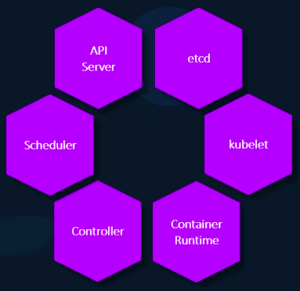
API server
etcd server
kubelet
Container Runtime
Controller
Scheduler

API Server – acts as front end for kubernetes the users, management devices, cli these all talk to the API Server to interact with component cluster.

etcd – Is a distribute reliable key value store used by kubernetes to store all data used to manage the cluster think of it this way when you have multiple nodes and multiple masters in your cluster.. etcd will stores all that informations on all the nodes in the cluster in a distributed manner.

etcd is responsible for implementing logs within the cluster to ensure there are no conflicts between the masters.

Scheduler is responsible for distributing work or container across multiple nodes. It looks for newly created containers and assigns them to nodes the

Controllers are the brain behind orchestration they’re responsible for noticing and responding when nodes container endpoints closed down.

The controllers makes decisions to bring up new container in such cases the container runtime is the underlying softwares that is used to run containers.
Kubelet – is the agent that runs on each node in the cluster.
The agent is responsible for making sure that the containers are running on the nodes as expected.

kubectl – is a kubernetes cli which is used to deploy and manage applications on a kubernetes cluster to get cluster related information to get the status of the nodes in the cluster and many other things

kubectl run hello-minik – to deploy an application on the cluster
kubectl cluster-info – to view info about the cluster
kubectl get nodes – lists all the nodes part of the cluster.

To run 1000+ instances of your applications across 1000+ of nodes all i need is a single kubernetes command like this.

