Deployment: Update and RollBack

when you deploy , it will create a deployment, deployment will create replicaset, & pods , containers etc.

This is called revision 1.

when you launch a new versions of you web by this deployment, is called revision 2.
ex. web version from v1.2 to v2.2

now, some reason your version updation get failed, in a few instance from 1000+ instnaces.
You want to go back to version v1.2 is called roll back to a privious versions.

Deployment is support to this version upgraes & Roll Back.

Rollout Command:-

kubectl rollout status deployment/myapp-deployment -- to see status

kubectl rollout history deployment/myapp-deployment – to see histroy
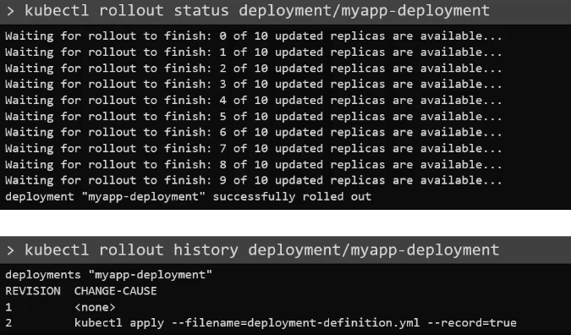

Deployment Strategy
1. Recreate strategy
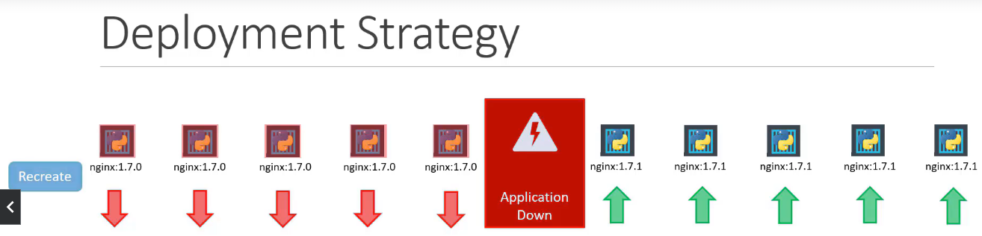
You have 5 app instances/pod, & want to upgrades its all instnaces version.
This strategy will delete all this 5 instances/pods of your app, then recreate 5 new instnaces/pods within a new version.

This will create a issue – your users can not accessible your app during this 5 app instances/pods.

2. Rolling Update Strategy
we will not delete all 5 instances at once.
We will delete 1st instance & create new instance with new version.
This will do one by one till 5 instnces.

This way your app / web will never goes down, & running up completley, seamlessly.
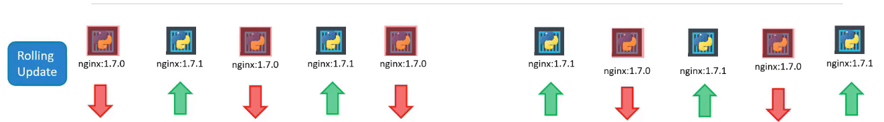
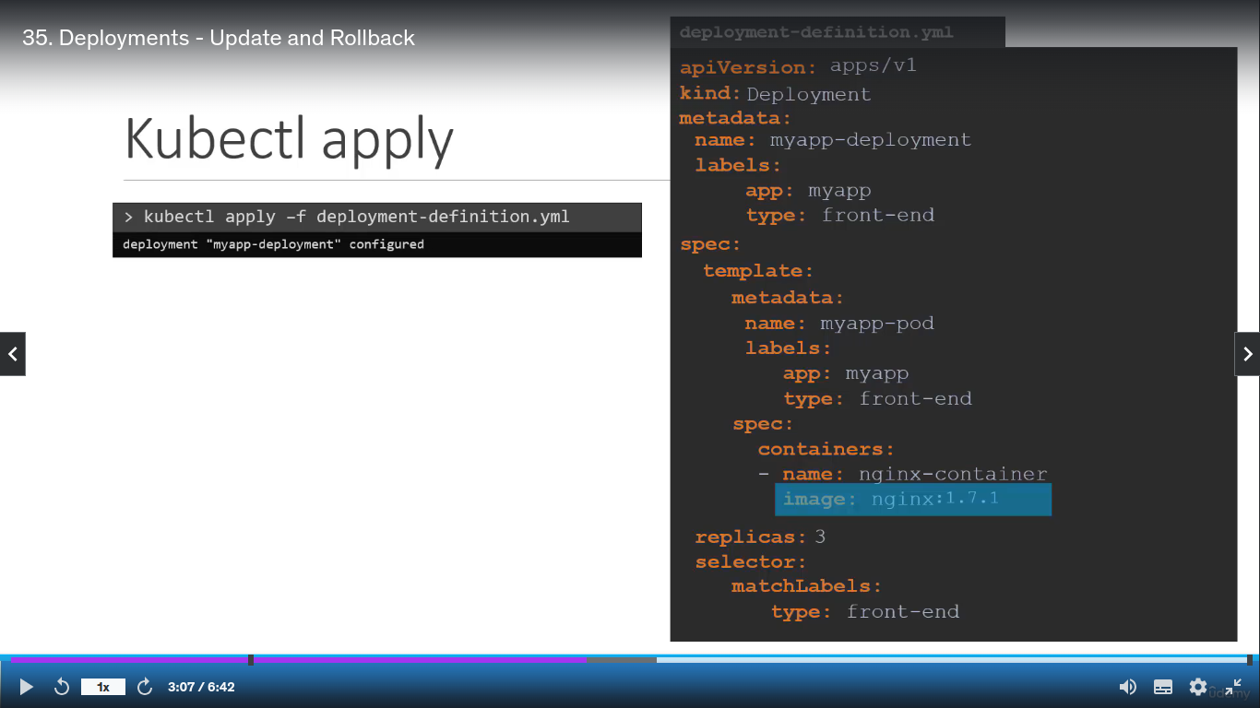
You just made changes in web version by, its labels,
docker image version etc.
Ex. upgrade docker image version by,
image: nginx to imgae: nginx:1.7.1
see in yml file

To made changes in all your instances which are running now, run command,

At this time a rollback will created/triggered.

2nd way to upgrade your web by runnign set command.
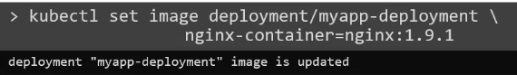

Understand How Rolling Update Stategy Works ?
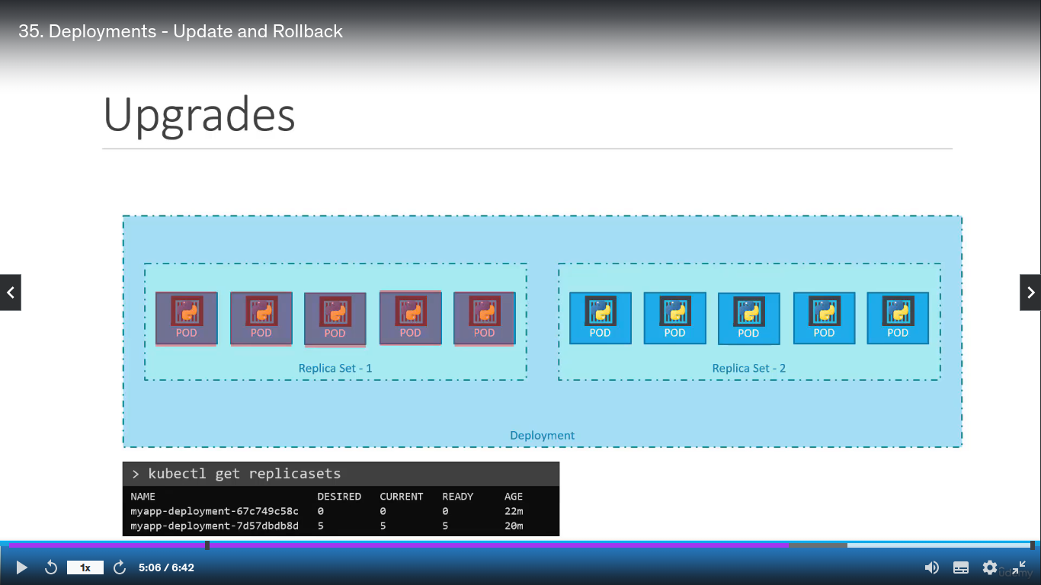
When you apply for upgradation to your web versions,
It creates Replicaset within a version – replica-set-2 but one by one pods created.
When 1st pod created, here, replicaset-1 (older), one pods deleted, and one by one this will upgrades your all pods, replicaset.

You can see , how many replicas, deleted & new created with new versions.

Suppose, some thing is wrong with your replica-set, pods, during upgrade .
You want to undo this process of upgrade to roll back of your previous version of replica-set.

You can do this by,
