PODS
A containers are upload / store to an small object called pods.
A pods is the smallest object that you can create in kubernetes.

Ex. You have a single node kubernetes cluster with a single instance of your application running in a single docker container in a POD.

If your users increased daily , also load on your application will increase.
So, you need to another instance of your applications for high availability.

Should you upload your application in same pod ?
No. bcz, if this single pods will crash , your all instances under this single pods also crash.

You have to create a new pods with a new instances of your applications.
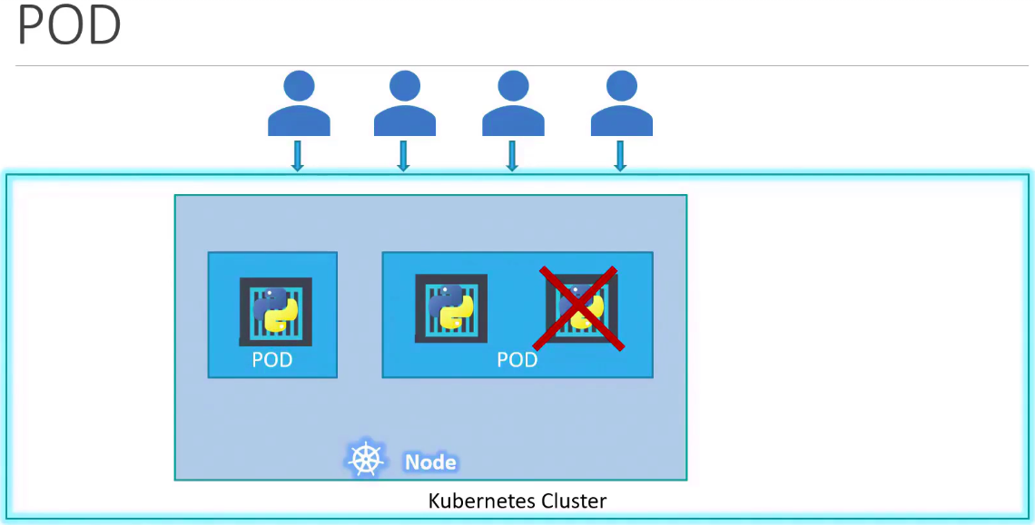

What if users are further increasing and your current node has no sufficient capacity ?
You have to deploy additional diff/separated PODs on a new node in a cluster.
You have a new node added to the cluster to expand the cluster’s physical capacity.
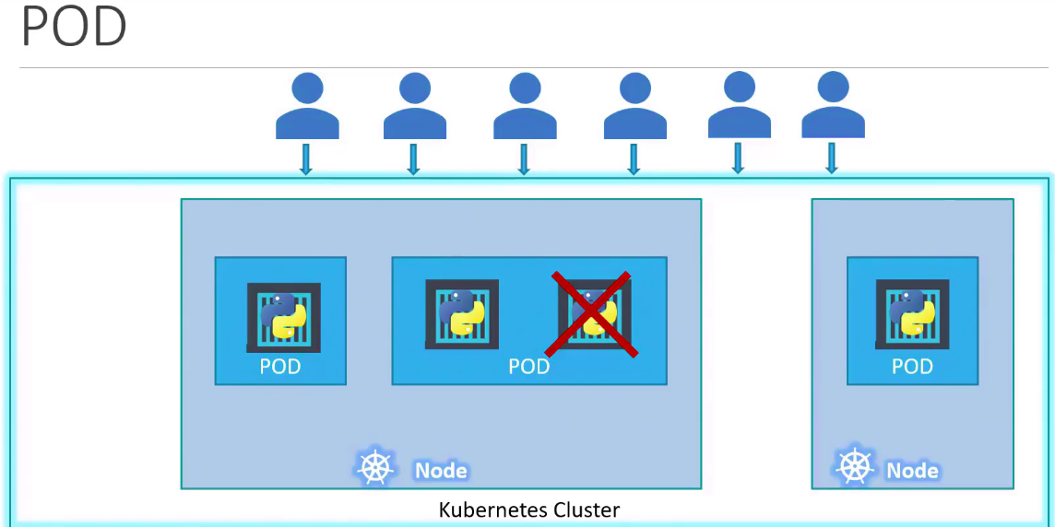

Multi-Container PODs
When you create a container in a pods, kubernetes also create a helper container to supports our worker container like, process a file, process a data etc.
When you delete a container, this helper container also dies bcz, it is part of same PODs.
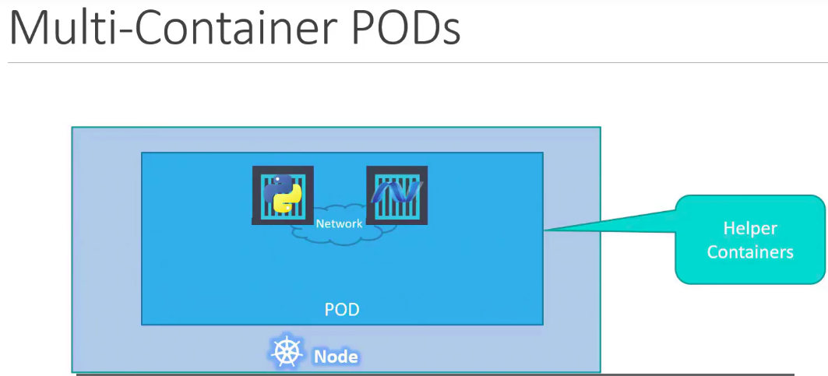
2 Containers can also communicate with each other directly by reffering to each other as local hosts.
Since, they share the same Network Space.
Also, they can easily share the same storage space as well.

Kubernetes commands

kubectl run nginx
creates a pod automatically and deploys an instance of Nginx Docker image.

This command will create a pod named “nginx” like a container name in docker.
Still you created only a PODs name , not use of image to run your applications.

But, where does it get the application image from ?

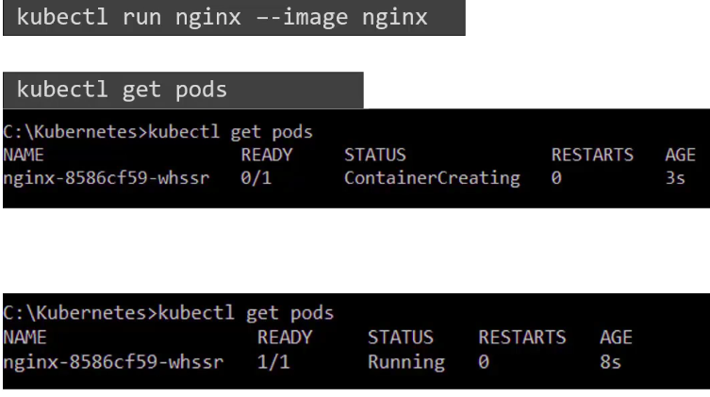
Use, --image “image_name”
kubectl run nginx --image nginx

See lists of pods are available.
kubectl get pods

To open a kubernetes in your browser
minikube dashboard

Try to deployment
kubectl create deployment hello-minikube –image=kicbase/echo-server:1.0
kubectl expose deployment hello-minikube --type=NodePort –port=1212

kubectl get deployment

To Delete deployment
kubectl delete service hello-minikube

