Deployments

You want to deploy your web server in a production environments.

You need to lot of / 1000+ instances of your web server should running.

Whenever newer versions of application builds become available on the docker registry, you would like to upgrade your docker instances seamlessly.

If you upgrade all instances at once time, this will affect your websites running and user will see a impact.
So, you have to upgrade all instances one by one.

This kind of upgrade is known as “Rolling Updates”.

Suppose, one of the upgrades you performed resulted in an unexpected error and you’re asked to undo the recent change, & paush deployment/changes.
you would like to be able to roll back the changes.

This all capabilities are available with the kubernetes deployments.

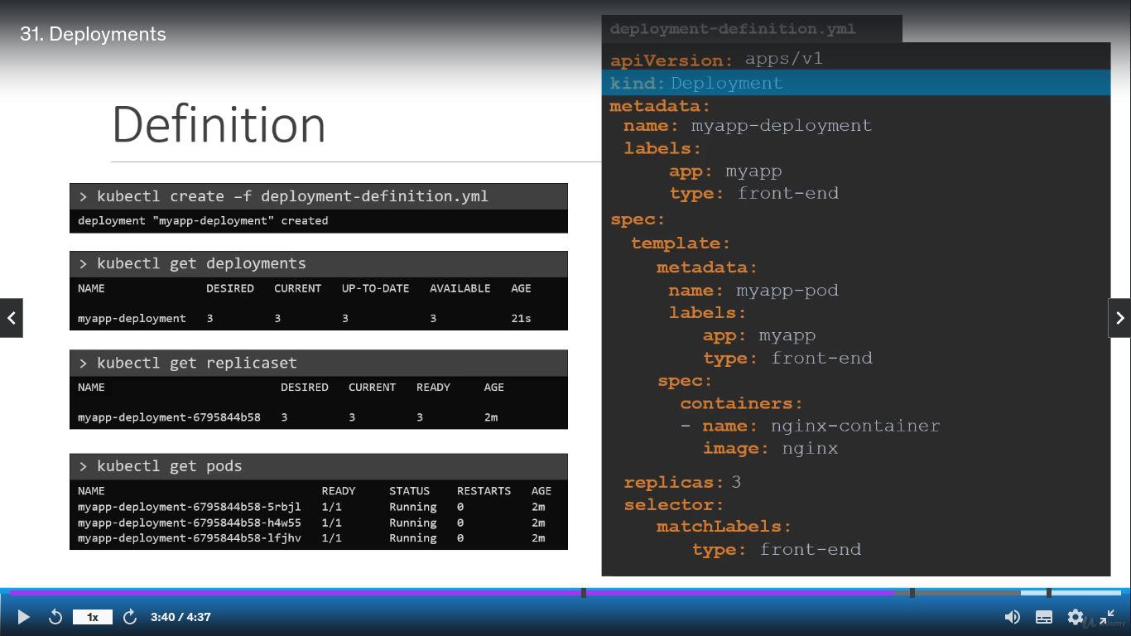
How to create deployments ?

All are same in ReplicaSet.yml file, but, only changed in kind: Deployment instead of kind: ReplicaSet.

This Deployment will creates ReplicaSet, Pods, Nodes etc & manage upgrade seamlessly.

Here, is a single command to crate all this things like, Deployment, ReplicaSet, Pods, Nodes.
Kubectl get all
