PODs With YAML
Kubernetes uses YAML files to as input for the creation of objects such as PODs, replicas, deployment services etc.
All of these follows similar structure.

Kubernetes definition file always contains 4 top level fields.
1. apiVersion, 2. kind, 3. metadata, 4. spec

1. apiVersion: is the version of the kubernetes API you are using to create the objects.
2. kind: is the what kind of you creates a objects ? Like, Pods, Service, ReplcaSet, Deployment.
3. metadata: is data about the object like its name, labels etc.
4. spec: have lisy/arrY OF NO. OF containers.
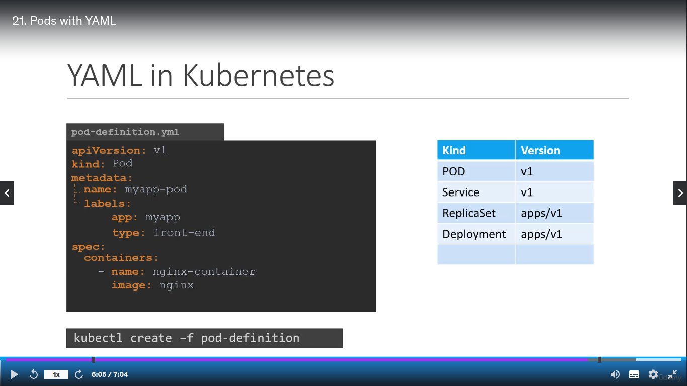

After create yaml file, to create pods using yaml file.
kubectl create -f pod-definition(yaml file name)

