Replication Controller and ReplicaSets

What is Replica ?

If you have one pod , which have one or more containers are running state.
Some reason, this our single pod is crashd, obviously our all containers under this pods also get crashed & resulted in our website will not be run.
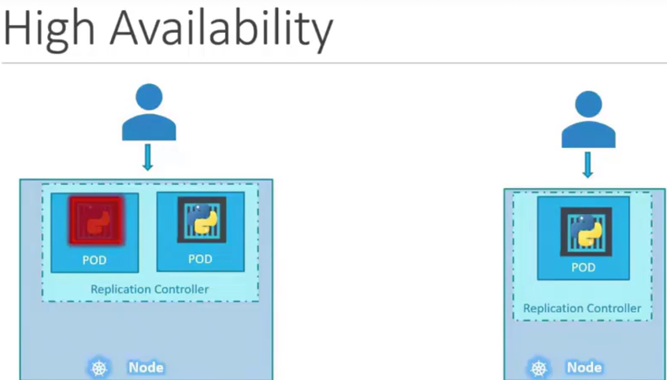
Resulted in our users will not be able to usr our websites.

To avoid this, we have to go for high availability by, keep multiple pods.

The Replication Controller helps us run multiple instances of a single pod in the kubernetes cluster. Which provides high availability.

This Repliction Controller will work for high availability.
If our single pods get crashed, this replication controller will automatically bring a new one pods ,so our application will run continuously.

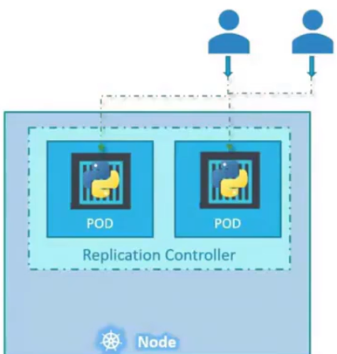
Replication Controller will ensure that you specified the no. of pods are running at all times.

Another reason for we nned replication controller is to create multiple pods to share the workloads across them ( just like load balancer ).

If we have only one / single pods, and no. of users are increase, load on single pods will increase & getting crash.
So, we will deploy additional PODs to balance the load acrosss the 2 PODs.

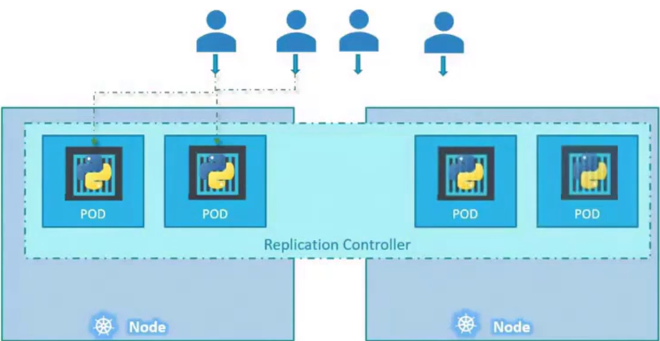
If the demand further increases and if we are running out of resources on the 1st node, we could deploy additional parts across the other nodes in the cluster.

Mean, if we don’t have enough resurces like out of Storage, out of VCPUs, out of Memory etc. Then we can make use of another nodes in our cluster of 1st nodes.

By Replication Controller.

Replication Controller is older technology which is replaced by ReplicaSets.
Both are use for same purpose of replications.

How to create our Replication Controller ?

We write a pod.yml file to create a pod within a multiple containers.
We wrtie a kind: Pod to create a Pods.
So, we can write kind: ReplicationController to create ReplicaSets/ReplicationController.

And, copy whole containts of pod.yml into this replicacontroller yml file like this.
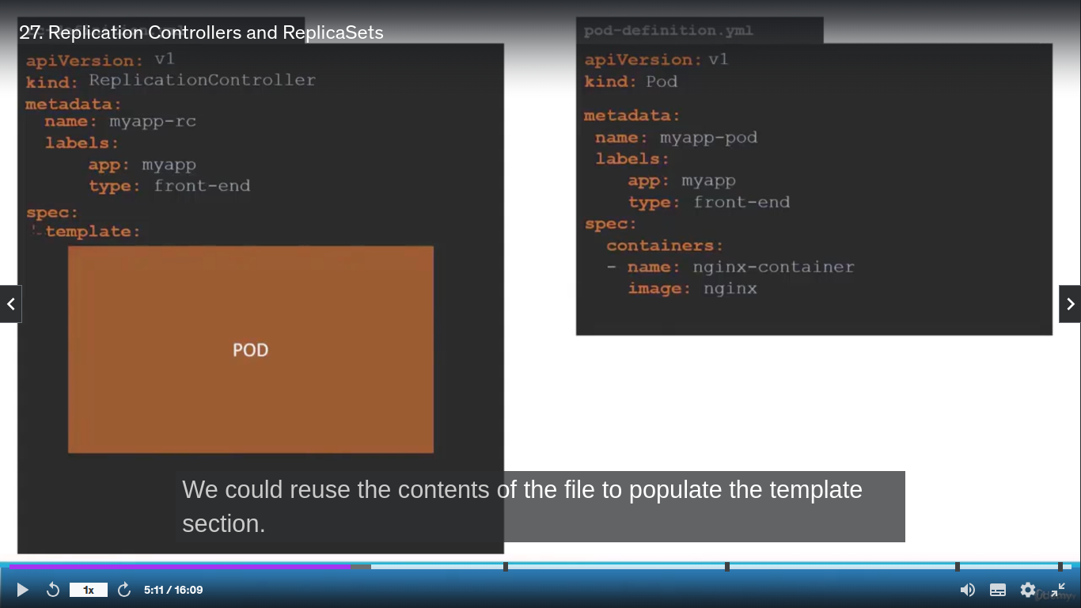

Use template: to use of whole containts of pod.yml file
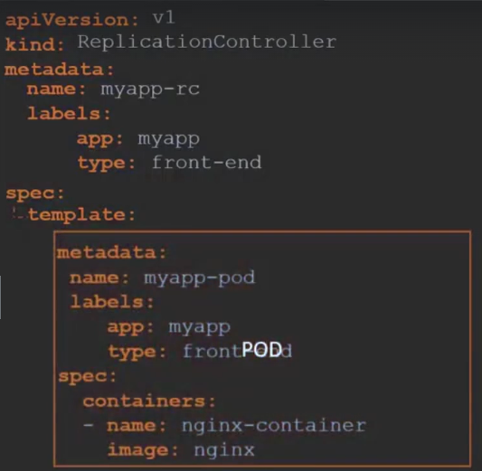
But, here we missed how much replicas we need to create.
Add , replicas: 3 as array list under spec:
- replicas: 3
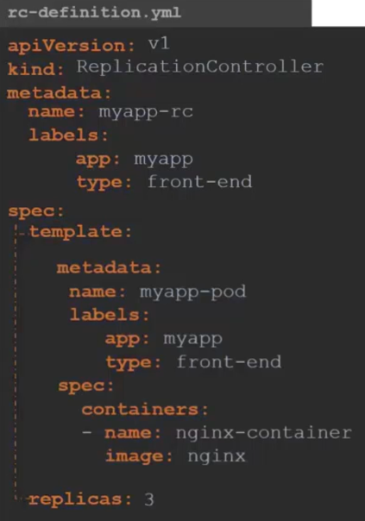

To create this replicas,
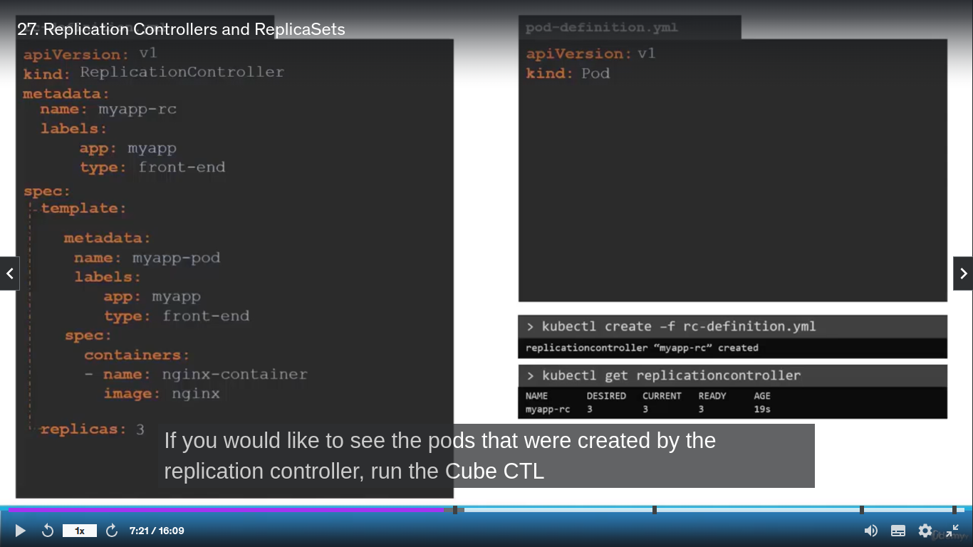

To see how much replicas created,

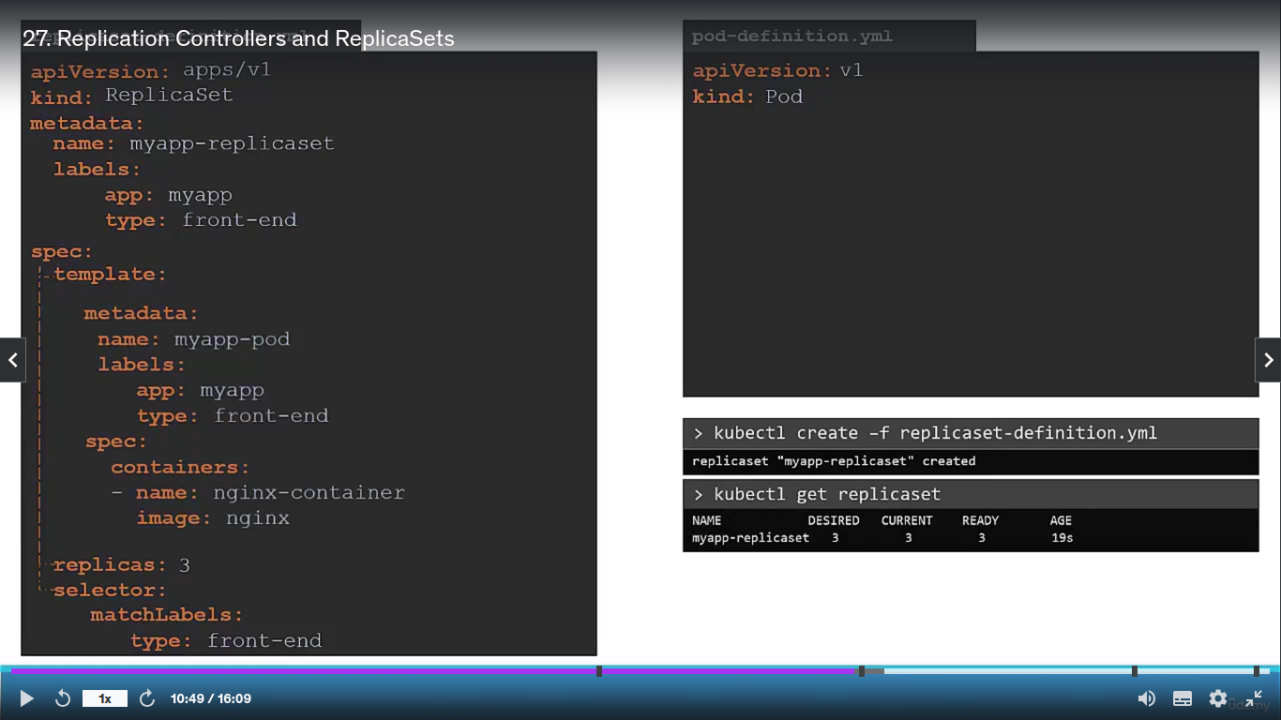
For ReplicaSets
Similar to Replication Controller but, ReplicaSets is diff from the ReplicaSets by,
selector: & matchLables:

This matchLables: front-end , this front-end we give in pod.yml file in metadata section, as tag.

So, this replicas: 3 will created only for tag, front-end pods.

Why we need selector & matchLables ?

We deployed 3 instances of our front-end web applications as 3 pods.
We would like to create a replication controller or replicaset to ensure that we have 3 active parts/pods at any time.

If any one of these 3 replicas got fails, ReplicaSets will replece them with new one pods by replications.
But, for that , ReplicaSets should know which parts/pods it should monitor.
But, ReplicaSets how will know that ? Bcz, there are multiple / lot of pods in same cluster.

Here, labeling will work for our pods during creation of new replicas.
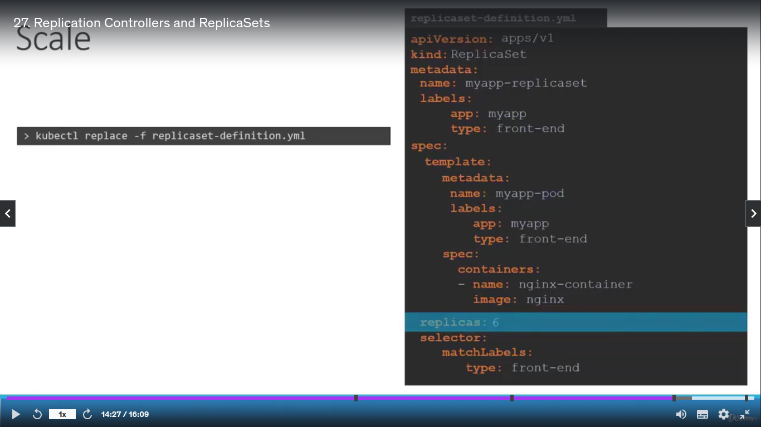
How to Scale ReplicaSets from replicas: 3 to replicas: 6 in future ?

1st Way:-
1. update replicas: 6 in replica.yml file .
2. run command to update replica.yml file.

2nd Way:-
1. Run kubectl scale command,
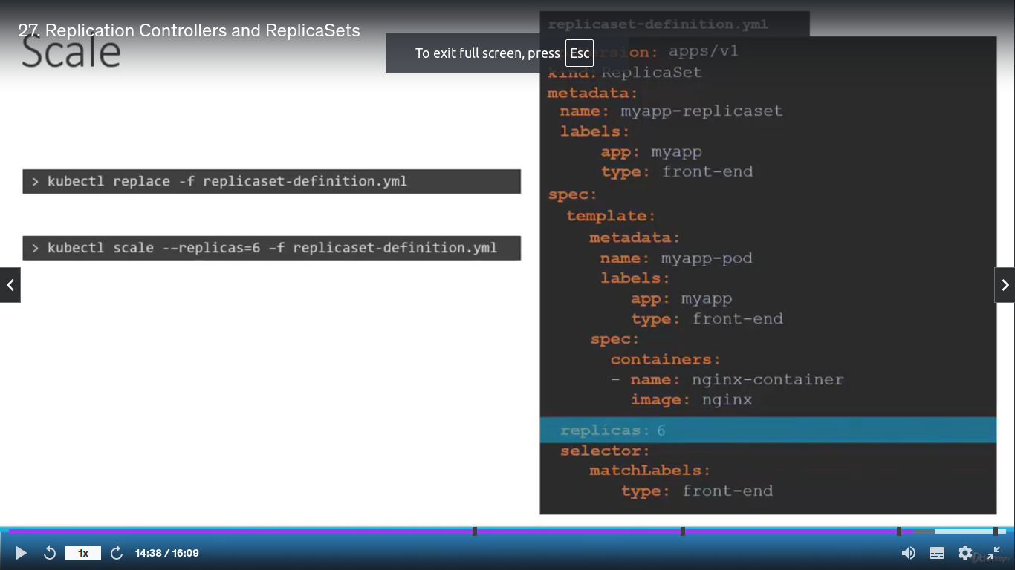

--replicas=6 – added new 3 replicas.
Replicaset-definition.yml is a repliaca file.

But, this 2nd way command will not recommended.
Bcz, this will not update replicas: 6 in replicaset-definition.yml file.
In replicaset-definition.yml still replicas: 3 & not be changed to replicas: 6.

Commands:-
kubectl create -f replicaset-definition.yml
use to create a replicaset or basically any object , depending on the file we are porviding as input.

Kubectl get replicaset
Use to see a list of replicasets created.

kubectl delete replicaset “replica_name”
To delete replicaset & also deletes all underlying PODs.

kubectl replace -f replicaset-definition.yml
To replace / update the replicaset

kubectl scale –replicas=6 replicaset-definition.yml
To scale replicaset simply from the cli withou having to modify the file.

