Flow Charts
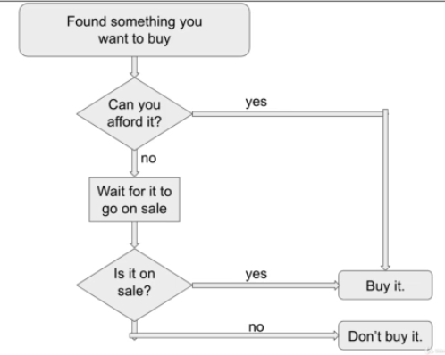
A flow chart is a type of diagram which has a starting point & have multiple endpoints.

Flow Charts is a good analog to how your code will execute.

In flow charts we uses rules/condition to perform a tasks when meet a conditions.

To make conditions yes or no, we hava to use 6 comparision operators,
1. <, 2. <=, 3. >, 4. >=,
5. != -- not equal to,
6. == -- equal to.

It result in value Boolean true or false,

print(4 > 2) – True
print(1 > 3) – False

print(5.79 < 6) – True
print(3 < 3) – False

print(9 >= 9) – True
print(1 <= 2) – True

print(10 != 100) – True
print(10 != 10) – False

print(10 == 100) – False
print(10 == 10) – True

Compair String using == & != operators

print(“hello” == “hello”) – True
print(“hello” != “world”) – True

Case latter comparisions

print(“Hello” == “hello”) – False

Floats & Integer equivalent Comparisions

print(4.0 >= 4) – True
print(4.0 <= 4) – True
print(4.0 == 4) – True

When any of one or both conditions not meet conditions means, Both conditions are false, it return FALSE.
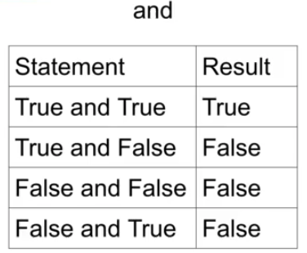
Boolean Operators
1. and, 2. or, 3. not

1. and
When Left & Right conditions meets it return TRUE.

2. OR

If any one of or both condition are meets true, it return TRUE.

If any one of or both condition are meets false, it return FALSE.
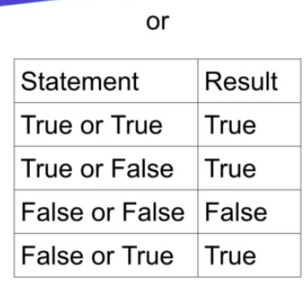

3. not
If your output is true , not operators will do its opposite – False
If your output is false, not operators will do its opposite – True

