Nested If else Statement

If your conditon has more sub condition is called nested if else statements, means, if condition 1 is TRUE, look for other condition 2 , 3 if this condition 2 , 3 TRUE then get output.
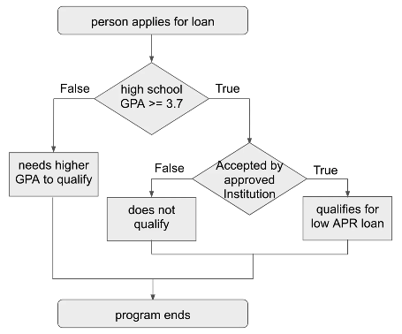

Make Python script for above flow chart.

# Ask to user for input gpa
gpa = float(input("What was the applicant's gpa ?"))

# Ask for input as yes or no for Accepted by approved institutions ?
institute = input("Is the student going to be educated at an approved instsitutions ?")

# write if statement for check gpa >= 3.7
if gpa >= 3.7:

# If gpa >= 3.7 then, check approved institute is qualified or not by yes or no.
# If Institute is qualified mean yes,
if institute == "yes":
print("The applicant qualifies for a low APR student Loan.")

# If institute not qualified means no.
else:
print("THe applicant doesn't qualify so, they aren't accepted into an approved institutions.")

# If gpa is not >= 3.7 or < 3.7 gpa then , print "Applicant did not have enough gpa to qualify."
else:
print("The applicant did not have enough gpa to qualify")

