If Statement
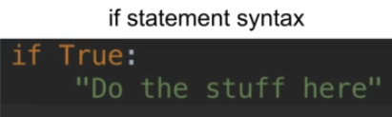
True is a condition,
if True: here, : called if condition meets, then execute if statements.

Ex.
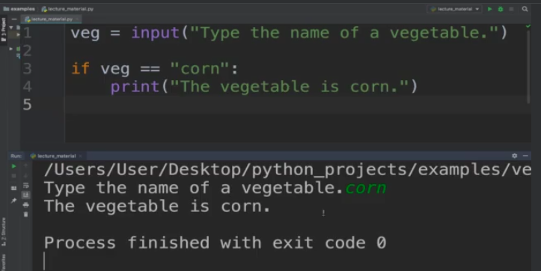
veg is a variable ,
taks input from user to enter a veg name.

If input == “corn”, print “The veg is corn”

output will, “The veg is corn”

If you enter other veg name , it will not give you output & program run with exited code 0.

Here, Flow Chart for this code
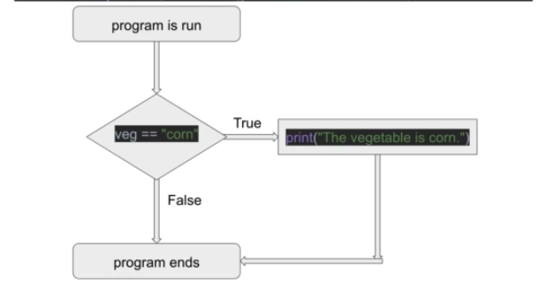

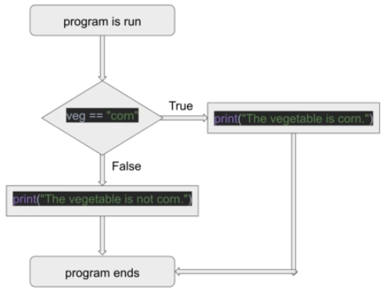

Else Statement

Syntax

else:
“your code”
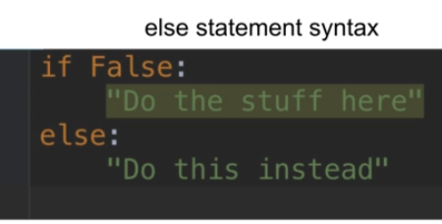

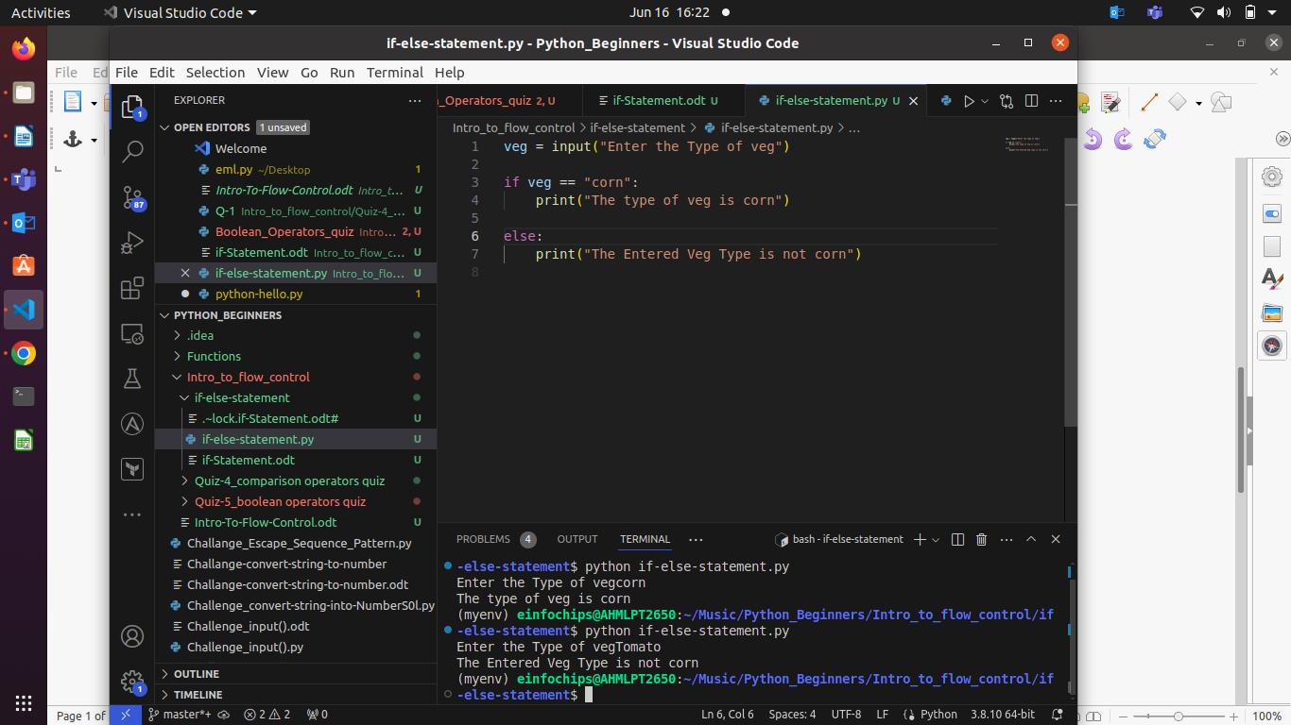

OutPut

