Truthy and Falsy value for the Stings
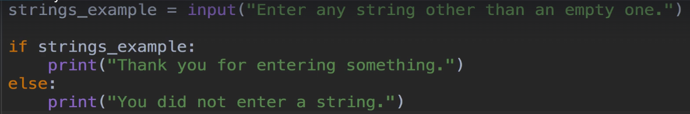
Here, Truthy means, if user will enter somthing , It means its Truthy.
if user did not enter anything, or keep empty, it means its Falsy.

Here, if has assign user’s output from variable named “strings_example”
means, if user will give any input , it will store in this vars.

This vars is assign to if statements means, if user will give any input then print,
“Thank you for entering somthing.”

If user did not give any input by entering blank enter, it will stores in vars “strings_example”

and print, “You did not enter a string” in a else statements.

With conditions
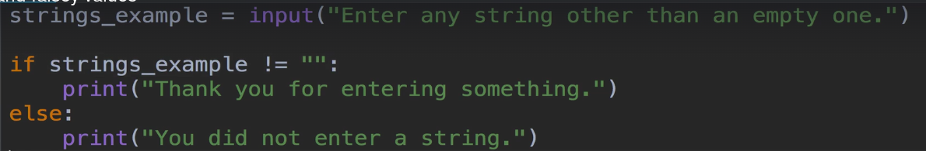
Here, strings_example != “”: -- means if vars stings_example did not has input of blank or means, vars strings_examole does not has any “blank input” , it will print

“Thank you for entering somthing.”

else, it print
“You did not enter a string”
