If statment run for single time for sigle line,
while statment run for continuously till condition meets.

Ex.
counter = 0

while counter < 3:
print("something")
counter +=1

OutPUT:-
something
something
something

counter vars is 0
counter +=1 -- it add 1 in vars counter at each iteration/flow/loops.

while counter < 3:
if counter vars value 0 t0 2 not meets it runt iteration till meet to counter vars value is 2
and print string "something" till meets this conditions.

If we use if statment for this loops

counter = 0

if counter < 3:
print("something")

This will print string "something" for sigle time.

Infinite loops – never ends
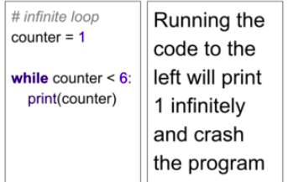
Here, you did not given counter += 1.
which add 1 at each iteration in vars counter = 1 to 5
.

if you did not given counter += 1.
counter = 1 will always have a value 1 & not been changed form 1 to 5.

since, its infinite loops.

