CONVERT STRING TO NUMBER USING INT() & FLOAT()

user_int = int(input(“Please Enter your number”)
print(user_int)
print(type(user_int))

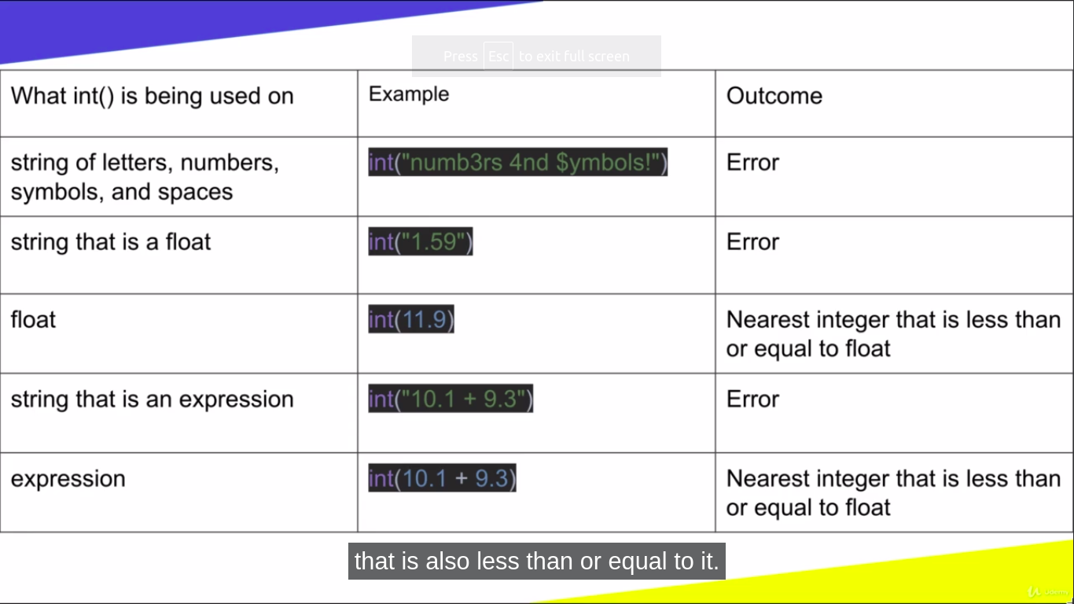
Please Enter your number 10
10
<clasee ‘int’>

