AWS ACCESS

There are 2 types of aws access
1. AWS GUI Access – you can make role and attach with user or group.
You can make your own IAM Policy and attach with user , group by AWS IAM console.

2. Programmatic Access
By Making use of Access Key & Secret Key using AWS CLI – allows to interact with AWS Services

By Making use of AWS CLI for programmatic access , you need to make a profile and aws configure in your linux shell.

STEP 1. Install AWS CLI -- sudo apt install aws cli
STEP 2 Configure your AWS Account with AWS CLI to programmatic access
aws configure

It will ask for Enter your credentials like Accesss Key , Secret Key
It will ask for in which region you want to configure – Enter Default Region
For Output Format – choose csv, xlsx, table, text etc.

This Credential is stored in path of ~/.aws/config & ~/.aws/credentials

MAKING USE OF AWS CLI COMMAND SYNTAX

aws <command> <subcommand> [options and parameters]

aws iam create-user --user-name lucy
aws -- base command
iam – command
create-user – subcommand
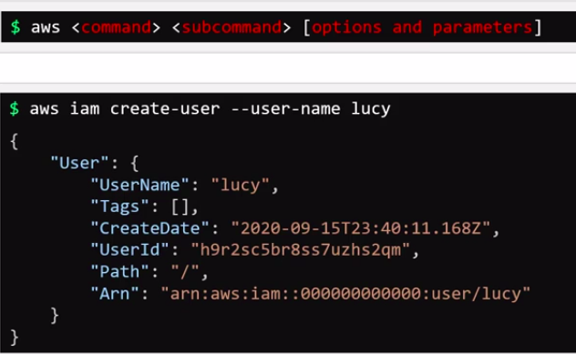
--user-name – options
lucy – parameters

Once, you run this command , the details for creating iam user will be display on your screens.

To Know AWS Specific Command
aws iam help – iam is command

aws iam create-user help

LAB: AWS CLI & IAM

Q-1 From this lab onwards, we will be working with aws services! In this lab, we will learn how to make use of aws cli to explore and deploy IAM resources that we learnt in the previous lecture.
As explained in the Lab Demonstration video, we are making use of localstack as the mocking framework to work with AWS.

This framework is exposed at http://aws:4566. Hence, throughout this lab, we will be making use of the command option and parameter like this: --endpoint http://aws:4566

A-1 OK
Q-2
First, let's explore the AWS CLI configuration.
What is the exact version of the CLI installed on the iac-server?
A-2 2.13.12
aws –version
Output is aws-cli/2.13.12 Python/3.11.4 Linux/5.4.0-1106-gcp exe/x86_64.ubuntu.22 prompt/off
Q-3
Which command should be used to interact with Identity and Access Management in AWS using the CLI?
If unsure, use the CLI help by running: aws <command> help
A-3
aws iam
Q-4
Which subcommand with iam can be used to list all the users created in aws?
If unsure, use the CLI help by running: aws iam <subcommand> help
A-4 Do aws iam help
find for list-user
o list-ssh-public-keys
o list-user-policies
o list-user-tags
o list-users
Q-5
Now, let's learn how to make use of the mocking framework used in the labs.
Run: aws iam list-users
Does it work?
A-5 No.
❯ aws iam list-users
An error occurred (InvalidClientTokenId) when calling the ListUsers operation: The security token included in the request is invalid.
Q-6
This is because, we have not provided the –endpoint option.
Now, run the same command but with the --endpoint http://aws:4566 as the option, like this:
aws --endpoint http://aws:4566 iam list-users
OUTPUT
{
"Users": [
{
"Path": "/",
"UserName": "jill",
"UserId": "1am68xtfdakud21vkk3o",
"Arn": "arn:aws:iam::000000000000:user/jil
l",
"CreateDate": "2024-05-11T09:06:46.416000+
00:00"
},
{
"Path": "/",
"UserName": "jack",
"UserId": "gx4fha1s5fioxniwpsz9",
"Arn": "arn:aws:iam::000000000000:user/jac
k",
"CreateDate": "2024-05-11T09:06:47.245000+
00:00"
}
]
}
Q-7
How many IAM Users do you see listed now ?
A-7 2 ,Jill & Jack
Q-8
Now let's add a few more users! To add more users, we need to make use of the create-user sub-command.
However, we also need to pass in a mandatory option with this command for it to work?
Which option should we use ?
A-8
--user-name
Q-9
Create a new user called mary using the AWS CLI.
Make sure to use the --endpoint http://aws:4566 option with the command.
A-9
❯ aws --endpoint http://aws:4566 iam create-user --user-name mary

Q-10
Now, inspect the newly created user mary and find out its ARN (Amazon Resource Name).
A-10 “Arn”: “arn:aws:iam:: 000000000000:user/mary”
{
"User": {
"Path": "/",
"UserName": "mary",
"UserId": "fq3vppwoprylu9eorxm6",
"Arn": "arn:aws:iam::000000000000:user/mary",
Q-11
What is the default region that has been configured for use with the AWS CLI ?
A-11
Do cat ~/.aws/config
us-east-1
Q-12
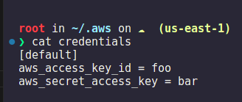
What is the aws_access_key_id used in the configuration ?
A-12
cat ~/.aws/credentials
aws_access_key_id = foo
Q-13
What is the value of aws_secret_access_key used ?
A-13 aws_secret_access_key = bar
Q-14 Now that we have a few users created, let's grant them privileges.
Let's start with mary, grant her full administrator access by making use of the policy called AdministratorAccess.
Make use of the subcommand attach-user-policy.
The ARN of the AdministratorAccess policy is arn:aws:iam::aws:policy/AdministratorAccess.

A-14
Use the subcommand attach-user-policy.
Run: aws --endpoint http://aws:4566 iam attach-user-policy --user-name mary --policy-arn arn:aws:iam::aws:policy/AdministratorAccess

Q-15
jack and jill are developers and are part of a project called project-sapphire.
Create a new IAM Group called project-sapphire-developers.
Use the subcommand create-group to create the group.
A-15
aws --endpoint http://aws:4566 iam create-group --group-name project-sapphire-developers
{
"Group": {
"Path": "/",
"GroupName": "project-sapphire-developers",
"GroupId": "vs4yi3dft2yqd8rw49qs",
"Arn": "arn:aws:iam::000000000000:group/project-sapphire-developers",
"CreateDate": "2024-05-11T10:19:44.430000+00:00"
}
}
Q-16
Add the IAM users called jack and jill, who are developers to the new IAM Group called project-sapphire-developers.
Use the subcommand add-user-to-group to add users into the group.
A-16
Do aws iam help & look for add group something
o add-client-id-to-open-id-connect-provider
o add-role-to-instance-profile
o add-user-to-group
o attach-group-policy
Here, add-user-to-group is perfect sub-command
Now, Do this,
aws --endpoint http://aws:4566 iam add-user-to-group –user-name jack-jill

aws --endpoint http://aws:4566 iam add-user-to-group --group-name project-sapphire-developers --user-name jack
and
aws –endpoint http://4566 iam add-user-to-group –group-name project-sapphire-developers –user-name jill
Q-17 What privileges are granted for jack and jill who are part of the group project-sapphire-developers?

Check for their permissions individually and the ones granted to the group.
A-17 None.
Check Policies attached to the group by running: aws --endpoint http://aws:4566 iam list-attached-group-policies --group-name project-sapphire-developers and for individuals by running aws --endpoint http://aws:4566 iam list-attached-user-policies --user-name jack (use user-name as jill to check her permissions)

Q-18
Both jack and jill need complete access to the EC2 service.

Attach the AmazonEC2FullAccess policy with the ARN: arn:aws:iam::aws:policy/AmazonEC2FullAccess to the group project-sapphire-developers.

A-18
Run:
aws --endpoint http://aws:4566 iam attach-group-policy --group-name project-sapphire-developers --policy-arn arn:aws:iam::aws:policy/AmazonEC2FullAccess

