AWS IAM WITH TERRAFORM
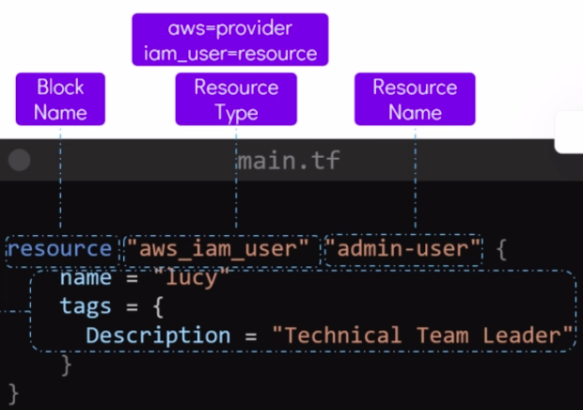

Here, we created IAM User by assign provider – aws
resources_tupe – iam_user
resources_name – admin-user &
USER NAME – lucy.
Now, we can give taggs to this IAM User – lucy by,
tags = {
Description = “ Tech. Team Leader”
}

Now, if you run terraform init , terraform plan, it will not Execute & give you error,
Bcz, Terraform doesn’t know this IAM User will be created on which REGION on AWS.

It will prompt you for Enter Region: us-east-1 -- Mumbai.
Also, Terraform doesn’t know in which aws account your IAM User will be created.

To fix this issues,

Give Provider Blocks in your main.tf files
Give Access key & Secret key in Provider Blocks.
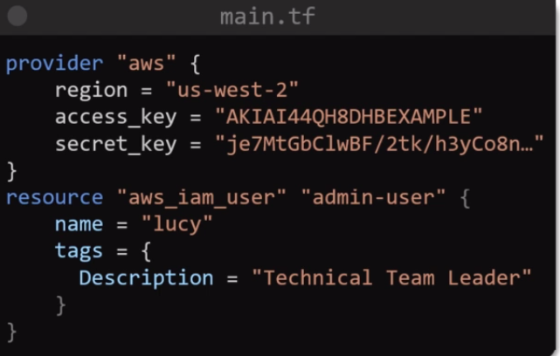

Refer registry.terraform.io documents.

Ways for passing credentials by terraform
1 way -- We had hardcoded the credentials with main.tf files.
This is not a recommended approach.
We have to use Version Control System.

2 way – configure aws cli where we have installed terraform.
3 way – Use Environment Variable
Use export command

