Data Sources

Terraform is a tool for Infrastructure as code where we can provision our infrastructures.

There are other tools for provision infrastructures as code, like Puppt, CloudFormations, SaltStack, Ansible etc.

Assume, You provision Database Instance manually in AWS Cloud.
Terraform does not manage this resource.
Terraform can read Attribute such as the Database Name, Host Address, DB User. And use this Attribute to provision an application resource which is managed by Terraform.

Example
You made a resource called local_file , File Name is Pets.txt & content is “We love Pets !”. This resource is created by Terraform. So, Terraform is incharge of this file, terraform.tfstate , state file, resource attributes & real resource in real world infrastructures like in aws etc.
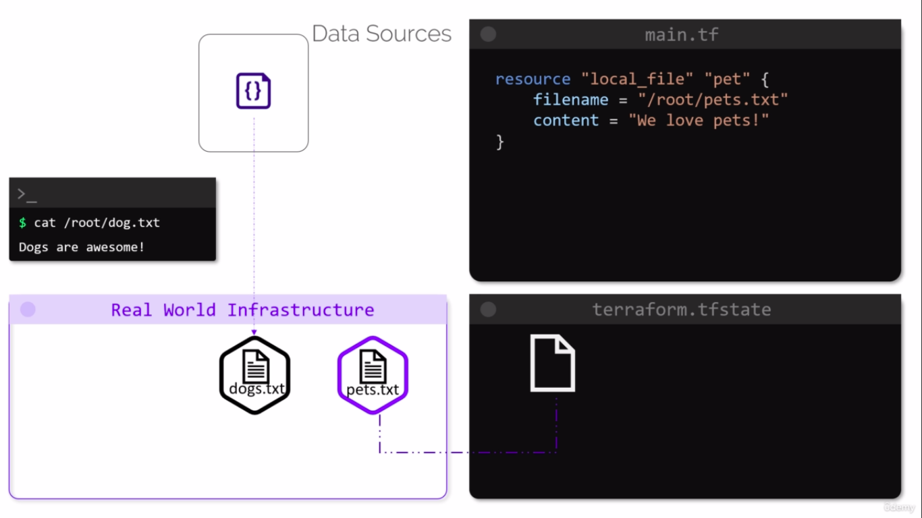
So, when you made any changes in crated resource or its, config file, terraform will update this resource.

If you have a new resource called dogs.txt in Real World Infrastructure means OUTSIDE OF TERRAFORM like AWS, Azure etc. This file has content of Dogs are Awsome !.

Terraform doesn’t have Access / Incharge of this dogs.txt resource.
Bcz, it is OutSide of Terraform & don’t created by Terraform.

Here,
Terraform can read Attribure of this dogs.txt file only.

To Read the attributes form the local file called dogs.txt
We can define a data block within the config file , like this.

Add data block of which file content, attributes you want to access , print , read etc.
Main.tf

resource “local_file” “pet” {
filename = “/root/pets.txt”
content = “We love petws!”
}

data “local_file” “dog” {
filename = “/root/dog.txt”
}

Logical Resource Name
Attribute of resource will be read.

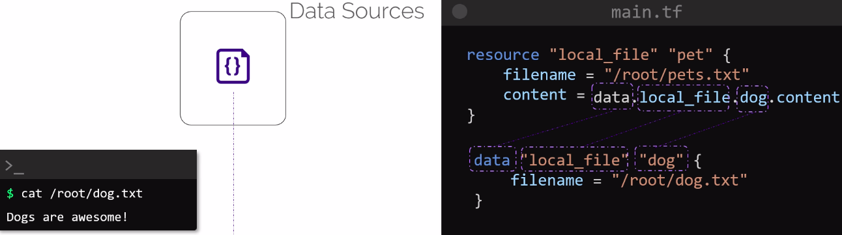

Add reference of dogs.txt ( which is outside of Terraform ) into resource block.

Difference Between Resource & Data Source

Resource
-- defined by resource block in config file
-- We can create , updates, Destroys infrastructures
-- Also called Managed Resources

Data Source
-- Defined by data block in config file
-- We can only reads attributed of infrastructures.
-- Also called Data Resources.

