Meta-Arguments

We looked for create loal file, EC2 Instance, Random Pet resource, Datasources etc.
But that was only single resources which we had created.

If you want to create multiple resources like 4 local file or 2 instance create in same directory.
It is possible by use of specific meta argument in terraform.
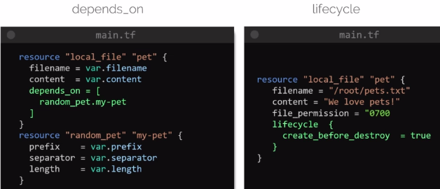
Meta-Arguments can be used within any resouces block to change the behavior of resouces.

We had seen 2 types of Meta-Arguments till yet.
That is , Depenency – Depends_on & Lifecycle rule

New Meta-Arguments we will look like Loops.

1. Count Meta-Arguments

You can create multiple resources within single config file with single resouces block.
We will see for create 3 file.
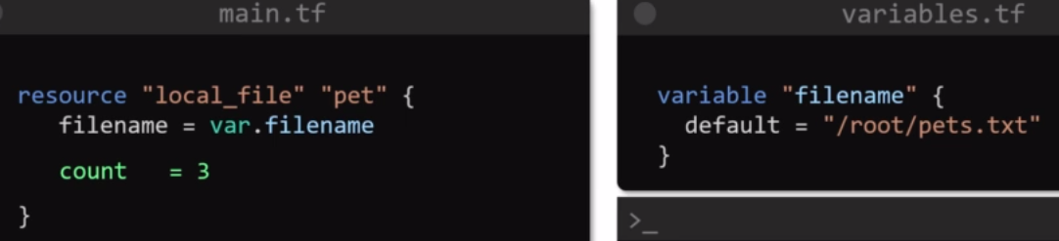
Now, it will craete 3 new empt file name called pets[1].txt, pets[2].txt, pets[3].txt in same directory of /root/.

2nd Way
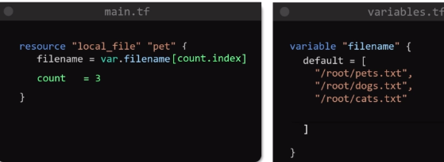
Which will make different name of file given in variable.tf file.

Count =3
so 3 files will be created.
3rd Way
Here, only 3 files variables given in variabels.tf file, But, what happens if you add 2 new other files in variabels.tf files ?
Bcz, count = 3 & total file = old 3 files + 2 new files = 5 files
so if count = 3 , so only 3 files will be creaed not 5 files.

To automatically fetch the how many files are defined in variabels.tf files & add it’s values is 5 in count = 5 instead of count = 3 automatically count.

Use Length Functions for defined variabels in variabels.tf files.
Std . Syntax is – count = length(var.“variables_name”)
count = length(var.filename)
