Terraform Commands

terraform validat4 – To check syntax of configuration file
If your configuration file doesn’t have syntax mistake or anything like not given variable , or dependency etc then it will give you success msg.
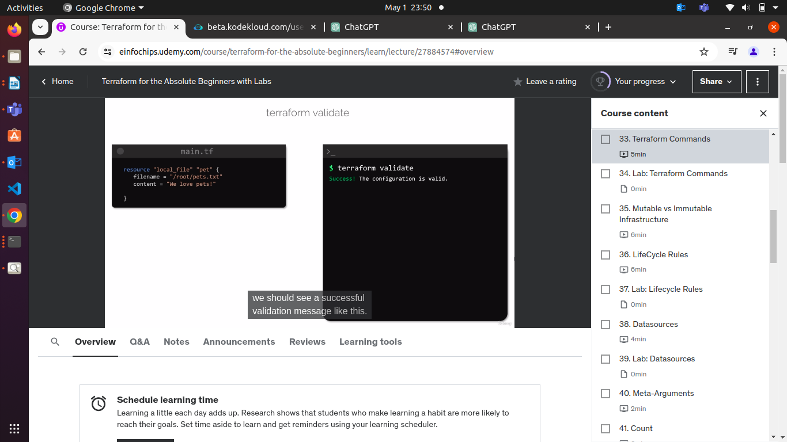

If you did mistake in your configuration file or variable.tfvars or .tf files.
It will show you line which cause the error where you did mistake.
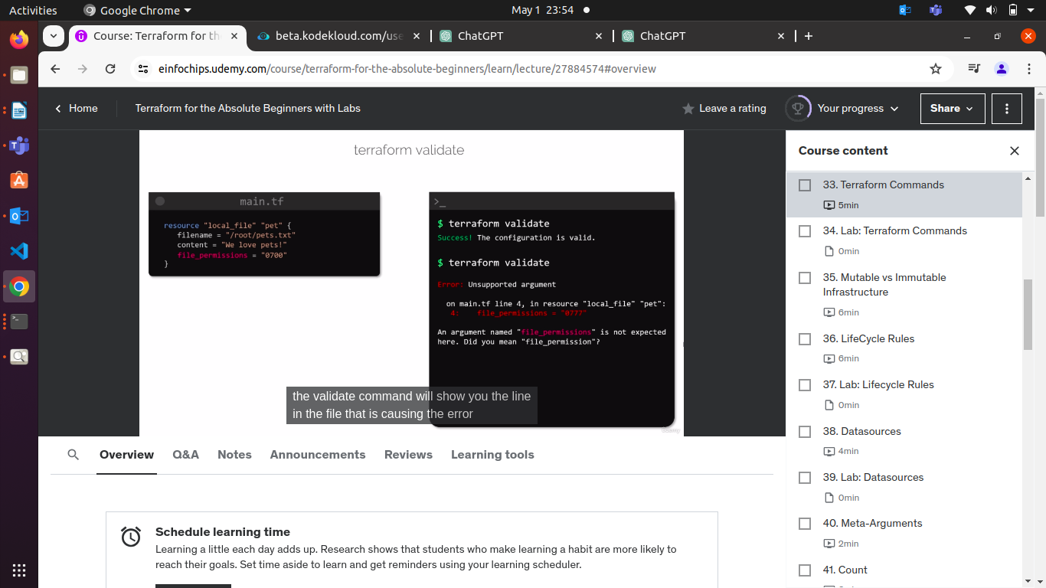

Here, file_permissions is incorrect.
It should be file_permission = “0700”

2. terraform fmt – Format
This command will scan configuration file and directory & format the code into a canonical format.

To Improve readability of the configuration file.
BEFORE AFTER
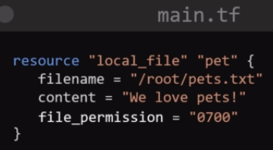
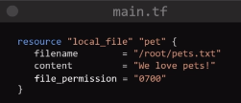

after run terraform fmt , it will change format of configuration file into std. format and it will display on the screens.

To see a list of all providers used in the configuration directory.
Use terraform providers commands.
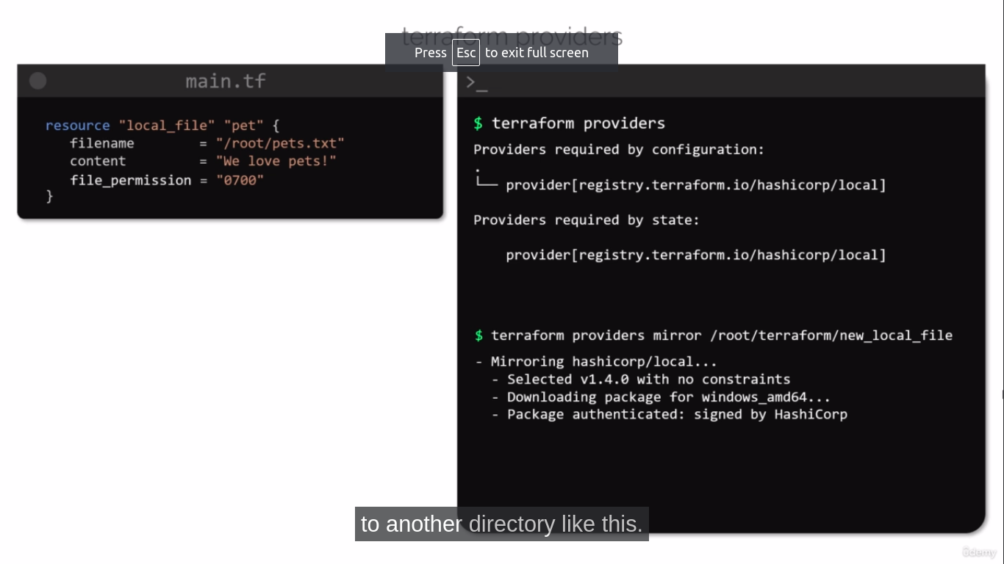

To mirror/copy of providers , plugins into another directory.
Use , terraform providers mirror “path/of/directory”

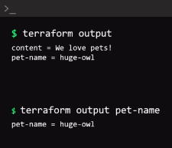
To Print all output variable in the configuration directory,
Use terraform output commands.

To print the value of a specific variable
Use terraform output “variable name”

To sync the terraform.
Use terraform refrash

terraform graph
To create visual representations of the dependency and terraform configuration or execution plans.

This command will show you dependency like terraform.tfstate file & it is graph generated in format called “DOT”

To show as a graph formate of your dependency, install graphviz software

apt install graphviz -y
terraform graph | dot -lsvg > graph.svg
It will show you graph of dependency of resource on your browser.

