Versoin Constraints

Whenevet we initiate terraform by terraform init, it will download letest version of providers.
Providers are plugin type architectures.
But, Every time we don’t requires letest versions of providers.
At that time we customize our providers.

To add customize provider versions,
Go to Terraform Registry by typing terraform docs providers versions
Search providers name – local
click on provider
click on version tab & choose your customize Providers version – version 2.5.0
Click on Use Provider tab
Copy code & paste it into your resource block.
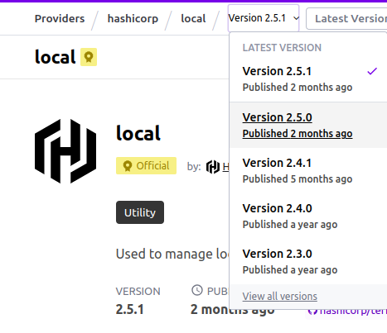
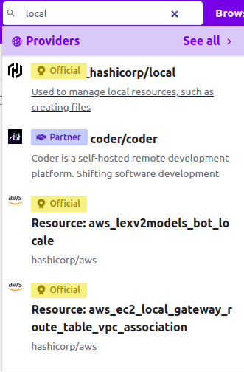
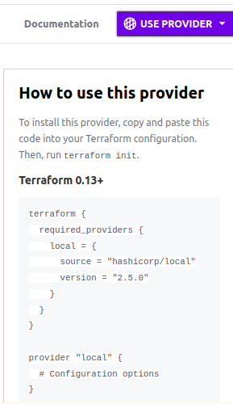

Specify this code of providers in your resourcre block.
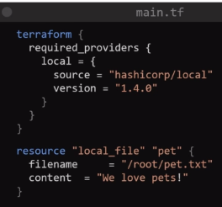
This allows terraform to find and download this exact version of the local providers.

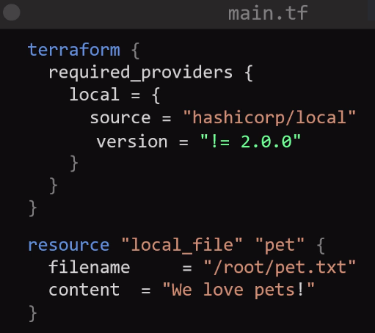
If you type version = “! = 2.0.0”
That means, not use version 2.0.0
so, terraform will never use this version of providers , but use previous versions of 2.0.0 like it will use 1.8.0

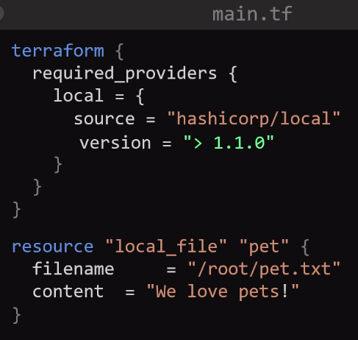

To use less then you specified versions
type, version = “< 1.8.0”

To use greater then you specified versions
type, version = “> 2.0.0”

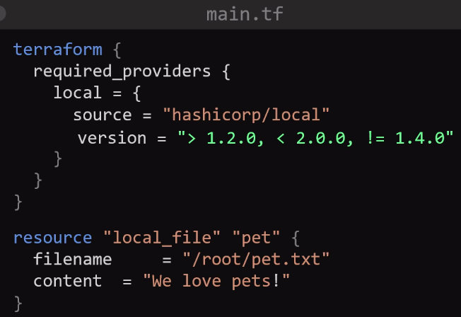
To use Between Range you specified
type, “> 2.0.0 , < 1.2.0”

Between Range with not equal to,
type,
vresion = “> 2.0.0, < 1.2.0, !=1.4.8”

