HOW TO CREATE POLICY & ATTACH TO USER & RESOURCES
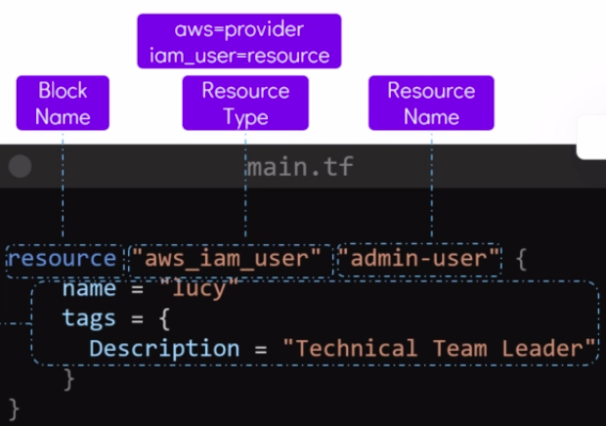

We Had created IAM User “lucy”.
We didn’t give priviledges to this user.
We have to make IAM Policy & attach to this user.
We have to creaet IAM Policy by “iam_policy” Provider.

We have to write & mentions JSON file of policy.

We can mentions Policy in JSON file by using heredoc which allows us to pass multiple lines into a command.
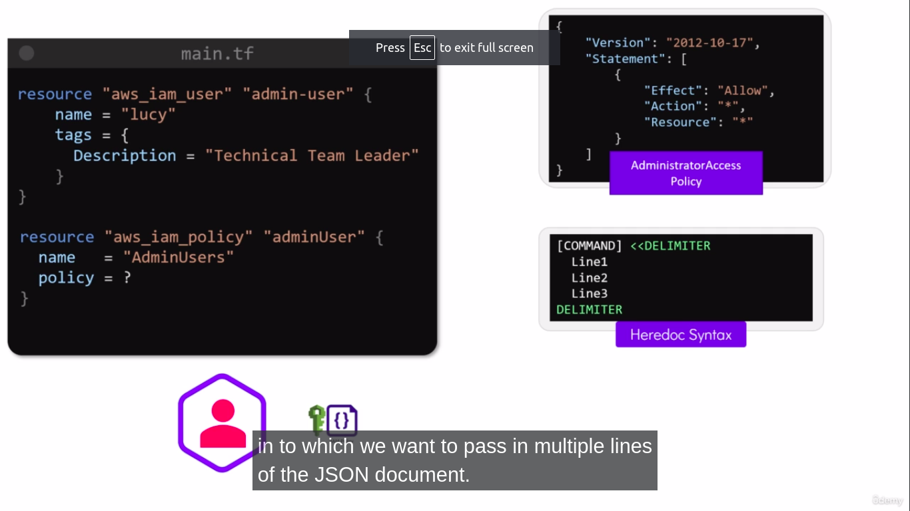

Here, in this case the multiple lines we have to pass in JSON file using Herecoc Syntax

Here, redirection sumbol is <<DELIMITERin Heredoc
The Delimiter can be any string, but the most commanly used string is EOF – End Of File.
We can make use of the same Delimiter to CLOSE THE FILE is EOF

command <<DELIMITER
line1
line2
DELIMITER

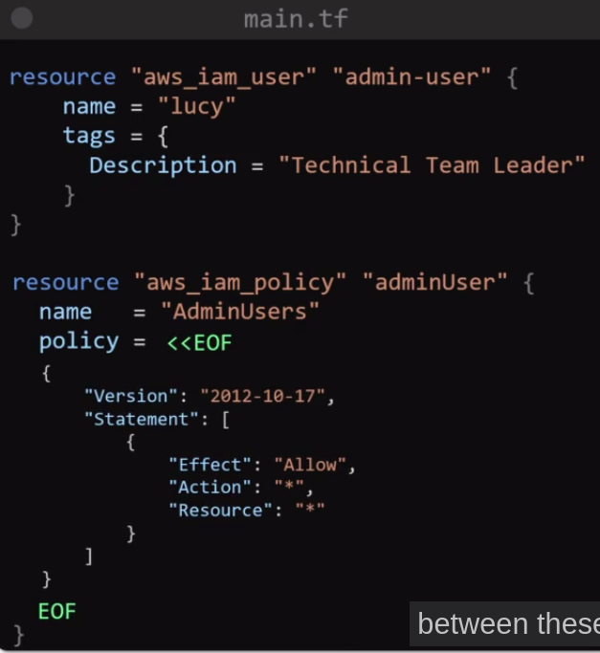
Between the Delimiters we can pass in any number of lines that we want to pass in to the command.

In our case, we want to write entire JSON file in between Delimiters
Policy = <<EOF

-- your lines in JSON files
-- your lines in JSON files

EOF

Here, Policy is a command.

We created successfully IAM Policy, but it is not attached to the user “lucy”

TO ATTACH THIS POLICY TO USER LUCY

ADD NEW RESOURCE BLOCK & WRITE
“aws_iam_user_policy_attachment” & refernce of IAM User Name & IAM Policy ARN.
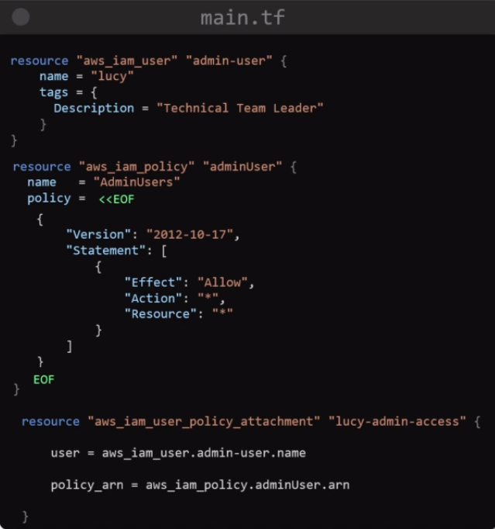

In Above case we defined JSON file in same resources files, main.tf files
Which is hardcoded, but you can make JOSN files within the same directory & call or read that JSON files in this resource block.

Step 1 – Create JSON files – admin-policy.json
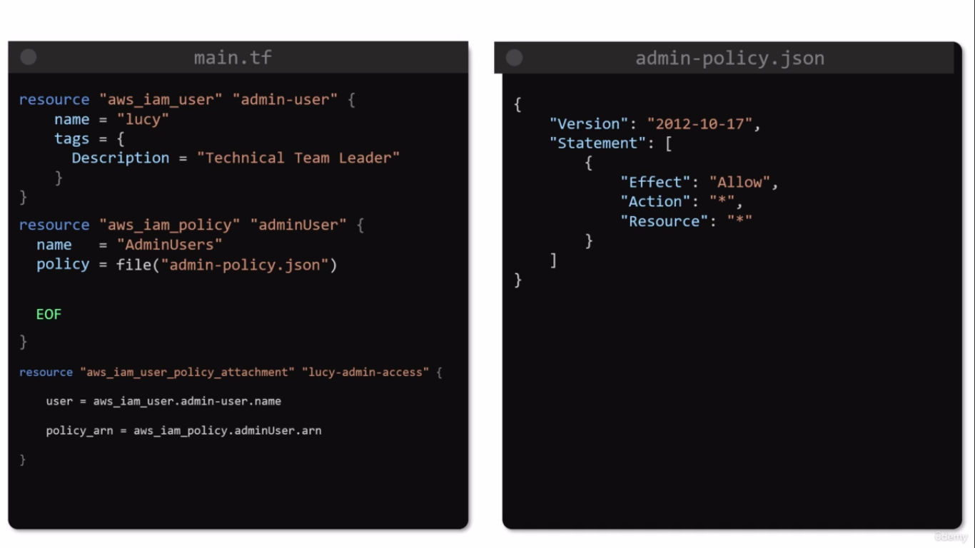
Step 2 – remove JSON content from main.tf in policy = << EOF & Write
policy = file(“your_json_file_name”)

policy = file(“admin-policy.json”)
this will call your .json file in current directory.

