S3 WITH TERRAFORM

Create S3 Bucket with terraform.
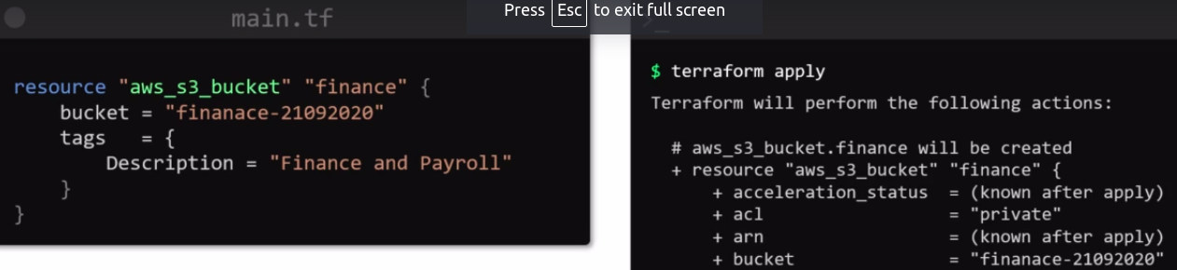
Resource “aws_s3_bucket” “finance” {
bucket = “finance-21092198” # bucket name. If you not provide bucket name , Terraform will use a random unique name.
tags = {
Description = “Finance & Payroll”
}
}
To Upload Doc on this S3 Bucket using Terraform.
Add another Resource Type “aws_s3_bucket_object”
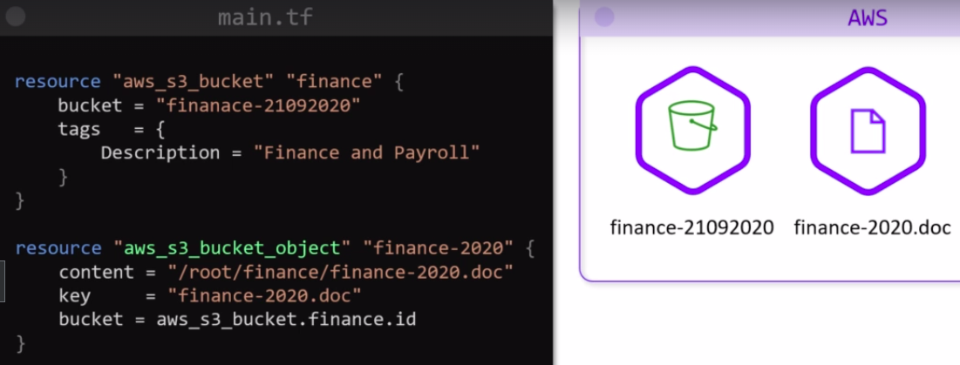
content – path of your file in your local

key – file name / object name.

Who can access this bucket ?
We have to make use of bucket policy
Assume, we have IAM Group “finance group” which was created manually in aws account.
This group needs access to the finance bucket that we created with terraform.

That means, bucket “finance-21092020” is created by terraform, so it’s entry in .tfstate file , so terraform knows this s3 bucket.

But, IAM Group “finance group” doesn’t created by terraform , it is outside of terraform.

And we have to use this IAM Group in terraform, so we will need to create a “Data Source” to read resource Iam Group.
We have to use ARN of IAM Group within bucket_policy
