for_each Meta-Arguments

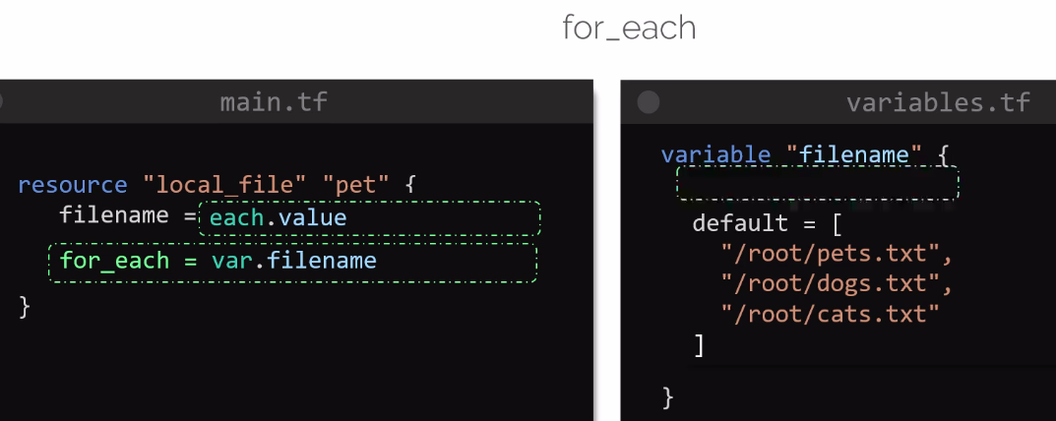
Instead of count = 3 or count = length(var.filename)
you can use for_each = var.filename
So you have to reference of how many files are in variabels.tf files using for_each loops,

Think like for loop using in shell scripting,
for dogs in house , here all values are stored in house varaible & one by one values are come in dogs variable and check whether is it available in house variable.

Here, all values are stored in var.filenme & come to each.value & check whether is it available in var.filename ?

And each filename varibles are come in each.value & create a new file .
If you have 5 files , so all 5 files will be counted & created.
IT CAN CREATES SAME FILENAME.

SET Meta-Arguments

To Prevent from creation, duplications of same filename, resource etc
DO NOT CREATES SAME OR DUPLICATE FILES & RESOURCES.
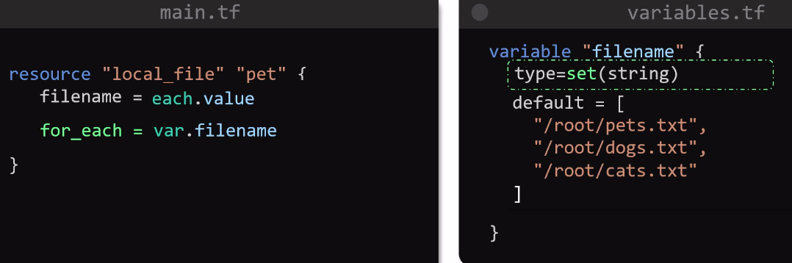
Write type=set(string) in variabels.tf files.
To prevent from creation of same files , resource.

Toset Meta-Arguments to convert a list into sets.
