Lab 8: Output Variables

Q-1 Navigate to the directory called /root/terraform-projects/data. We have used the configuration files created in this directory to create some resources. Inspect them.
A-1 done
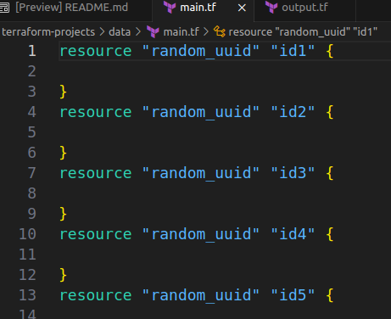
Q-2 Which provider is used by the configuration files in this directory?
A-2 random providers

Q-3 Which two resource types are configured in the configuration files?
A-3 1. “random_uuid” 2. “random_integer”
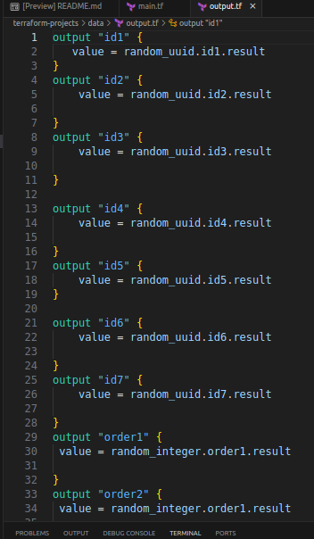
Q-4 We also defined a few output variables in the output.tf file in this configuration directory. Inspect them.
A-4 done.

Q-5 Run terraform init, plan and applyto create these resources.

A-5 ❯ terraform plan

Terraform used the selected providers to generate the
following execution plan. Resource actions are
indicated with the following symbols:
+ create

Terraform will perform the following actions:

# random_integer.order1 will be created
+ resource "random_integer" "order1" {
+ id = (known after apply)
+ max = 99999
+ min = 1
+ result = (known after apply)
}

# random_integer.order2 will be created
+ resource "random_integer" "order2" {
+ id = (known after apply)
+ max = 222222
+ min = 1
+ result = (known after apply)
}

# random_uuid.id1 will be created
+ resource "random_uuid" "id1" {
+ id = (known after apply)
+ result = (known after apply)
}

# random_uuid.id2 will be created
+ resource "random_uuid" "id2" {
+ id = (known after apply)
+ result = (known after apply)
}

# random_uuid.id3 will be created
+ resource "random_uuid" "id3" {
+ id = (known after apply)
+ result = (known after apply)
}

# random_uuid.id4 will be created
+ resource "random_uuid" "id4" {
+ id = (known after apply)
+ result = (known after apply)
}

# random_uuid.id5 will be created
+ resource "random_uuid" "id5" {
+ id = (known after apply)
+ result = (known after apply)
}

# random_uuid.id6 will be created
+ resource "random_uuid" "id6" {
+ id = (known after apply)
+ result = (known after apply)
}

# random_uuid.id7 will be created
+ resource "random_uuid" "id7" {
+ id = (known after apply)
+ result = (known after apply)
}

Plan: 9 to add, 0 to change, 0 to destroy.

Changes to Outputs:
+ id1 = (known after apply)
+ id2 = (known after apply)
+ id3 = (known after apply)
+ id4 = (known after apply)
+ id5 = (known after apply)
+ id6 = (known after apply)
+ id7 = (known after apply)
+ order1 = (known after apply)
+ order2 = (known after apply)

──────────────────────────────────────────────────────

Note: You didn't use the -out option to save this
plan, so Terraform can't guarantee to take exactly
these actions if you run "terraform apply" now.

root in ~/terraform-projects/data via 💠 default on ☁️ (us-east-1)
❯ terraform init

Initializing the backend...

Initializing provider plugins...
- Reusing previous version of hashicorp/random from the dependency lock file
- Using previously-installed hashicorp/random v3.6.1

Terraform has been successfully initialized!

You may now begin working with Terraform. Try running "terraform plan" to see
any changes that are required for your infrastructure. All Terraform commands
should now work.

If you ever set or change modules or backend configuration for Terraform,
rerun this command to reinitialize your working directory. If you forget, other
commands will detect it and remind you to do so if necessary.

root in ~/terraform-projects/data via 💠 default on ☁️ (us-east-1)
❯ terraform plan

Terraform used the selected providers to
generate the following execution plan.
Resource actions are indicated with the
following symbols:
+ create

Terraform will perform the following actions:

# random_integer.order1 will be created
+ resource "random_integer" "order1" {
+ id = (known after apply)
+ max = 99999
+ min = 1
+ result = (known after apply)
}

# random_integer.order2 will be created
+ resource "random_integer" "order2" {
+ id = (known after apply)
+ max = 222222
+ min = 1
+ result = (known after apply)
}

# random_uuid.id1 will be created
+ resource "random_uuid" "id1" {
+ id = (known after apply)
+ result = (known after apply)
}

# random_uuid.id2 will be created
+ resource "random_uuid" "id2" {
+ id = (known after apply)
+ result = (known after apply)
}

# random_uuid.id3 will be created
+ resource "random_uuid" "id3" {
+ id = (known after apply)
+ result = (known after apply)
}

# random_uuid.id4 will be created
+ resource "random_uuid" "id4" {
+ id = (known after apply)
+ result = (known after apply)
}

# random_uuid.id5 will be created
+ resource "random_uuid" "id5" {
+ id = (known after apply)
+ result = (known after apply)
}

# random_uuid.id6 will be created
+ resource "random_uuid" "id6" {
+ id = (known after apply)
+ result = (known after apply)
}

# random_uuid.id7 will be created
+ resource "random_uuid" "id7" {
+ id = (known after apply)
+ result = (known after apply)
}

Plan: 9 to add, 0 to change, 0 to destroy.

Changes to Outputs:
+ id1 = (known after apply)
+ id2 = (known after apply)
+ id3 = (known after apply)
+ id4 = (known after apply)
+ id5 = (known after apply)
+ id6 = (known after apply)
+ id7 = (known after apply)
+ order1 = (known after apply)
+ order2 = (known after apply)

─────────────────────────────────────────

Note: You didn't use the -out option to
save this plan, so Terraform can't
guarantee to take exactly these actions
if you run "terraform apply" now.

root in ~/terraform-projects/data via 💠 default on ☁️ (us-east-1)
❯ terraform appl
Terraform has no command named "appl". Did you mean "apply"?

To see all of Terraform's top-level commands, run:
terraform -help

root in ~/terraform-projects/data via 💠 default on ☁️ (us-east-1)
❯ terraform apply

Terraform used the selected providers to
generate the following execution plan.
Resource actions are indicated with the
following symbols:
+ create

Terraform will perform the following actions:

# random_integer.order1 will be created
+ resource "random_integer" "order1" {
+ id = (known after apply)
+ max = 99999
+ min = 1
+ result = (known after apply)
}

# random_integer.order2 will be created
+ resource "random_integer" "order2" {
+ id = (known after apply)
+ max = 222222
+ min = 1
+ result = (known after apply)
}

# random_uuid.id1 will be created
+ resource "random_uuid" "id1" {
+ id = (known after apply)
+ result = (known after apply)
}

# random_uuid.id2 will be created
+ resource "random_uuid" "id2" {
+ id = (known after apply)
+ result = (known after apply)
}

# random_uuid.id3 will be created
+ resource "random_uuid" "id3" {
+ id = (known after apply)
+ result = (known after apply)
}

# random_uuid.id4 will be created
+ resource "random_uuid" "id4" {
+ id = (known after apply)
+ result = (known after apply)
}

# random_uuid.id5 will be created
+ resource "random_uuid" "id5" {
+ id = (known after apply)
+ result = (known after apply)
}

# random_uuid.id6 will be created
+ resource "random_uuid" "id6" {
+ id = (known after apply)
+ result = (known after apply)
}

# random_uuid.id7 will be created
+ resource "random_uuid" "id7" {
+ id = (known after apply)
+ result = (known after apply)
}

Plan: 9 to add, 0 to change, 0 to destroy.

Changes to Outputs:
+ id1 = (known after apply)
+ id2 = (known after apply)
+ id3 = (known after apply)
+ id4 = (known after apply)
+ id5 = (known after apply)
+ id6 = (known after apply)
+ id7 = (known after apply)
+ order1 = (known after apply)
+ order2 = (known after apply)

Do you want to perform these actions?
Terraform will perform the actions described above.
Only 'yes' will be accepted to approve.

Enter a value: yes

random_uuid.id2: Creating...
random_uuid.id3: Creating...
random_uuid.id1: Creating...
random_uuid.id7: Creating...
random_uuid.id5: Creating...
random_uuid.id6: Creating...
random_uuid.id1: Creation complete after 0s [id=e0e972f3-cb7d-60b2-269c-452a7878a684]
random_uuid.id4: Creating...
random_integer.order1: Creating...
random_uuid.id4: Creation complete after 0s [id=09537f5b-d8de-1399-3e93-9d2ba7b8f8c0]
random_integer.order2: Creating...
random_uuid.id2: Creation complete after 0s [id=26a266b5-d2de-e95b-3fcd-03526c597503]
random_uuid.id7: Creation complete after 0s [id=35748731-938a-0ee9-e7da-a94bf90264da]
random_uuid.id6: Creation complete after 0s [id=a70203e3-1e8e-d740-e1cd-e4b954f4a76a]
random_uuid.id3: Creation complete after 0s [id=71243943-52b5-60d5-0b74-a53f7ca69cb0]
random_integer.order1: Creation complete after 0s [id=35090]
random_uuid.id5: Creation complete after 0s [id=487cfc3e-a340-a997-6625-5bde506a4c0e]
random_integer.order2: Creation complete after 0s [id=5286]

Apply complete! Resources: 9 added, 0 changed, 0 destroyed.

Outputs:

id1 = "e0e972f3-cb7d-60b2-269c-452a7878a684"
id2 = "26a266b5-d2de-e95b-3fcd-03526c597503"
id3 = "71243943-52b5-60d5-0b74-a53f7ca69cb0"
id4 = "09537f5b-d8de-1399-3e93-9d2ba7b8f8c0"
id5 = "487cfc3e-a340-a997-6625-5bde506a4c0e"
id6 = "a70203e3-1e8e-d740-e1cd-e4b954f4a76a"
id7 = "35748731-938a-0ee9-e7da-a94bf90264da"
order1 = 35090
order2 = 35090

root in ~/terraform-projects/data via 💠 default on ☁️ (us-east-1) took 2s
❯ terraform show
# random_integer.order1:
resource "random_integer" "order1" {
id = "35090"
max = 99999
min = 1
result = 35090
}

# random_integer.order2:
resource "random_integer" "order2" {
id = "5286"
max = 222222
min = 1
result = 5286
}

# random_uuid.id1:
resource "random_uuid" "id1" {
id = "e0e972f3-cb7d-60b2-269c-452a7878a684"
result = "e0e972f3-cb7d-60b2-269c-452a7878a684"
}

# random_uuid.id2:
resource "random_uuid" "id2" {
id = "26a266b5-d2de-e95b-3fcd-03526c597503"
result = "26a266b5-d2de-e95b-3fcd-03526c597503"
}

# random_uuid.id3:
resource "random_uuid" "id3" {
id = "71243943-52b5-60d5-0b74-a53f7ca69cb0"
result = "71243943-52b5-60d5-0b74-a53f7ca69cb0"
}

# random_uuid.id4:
resource "random_uuid" "id4" {
id = "09537f5b-d8de-1399-3e93-9d2ba7b8f8c0"
result = "09537f5b-d8de-1399-3e93-9d2ba7b8f8c0"
}

# random_uuid.id5:
resource "random_uuid" "id5" {
id = "487cfc3e-a340-a997-6625-5bde506a4c0e"
result = "487cfc3e-a340-a997-6625-5bde506a4c0e"
}

# random_uuid.id6:
resource "random_uuid" "id6" {
id = "a70203e3-1e8e-d740-e1cd-e4b954f4a76a"
result = "a70203e3-1e8e-d740-e1cd-e4b954f4a76a"
}

# random_uuid.id7:
resource "random_uuid" "id7" {
id = "35748731-938a-0ee9-e7da-a94bf90264da"
result = "35748731-938a-0ee9-e7da-a94bf90264da"
}

Outputs:

id1 = "e0e972f3-cb7d-60b2-269c-452a7878a684"
id2 = "26a266b5-d2de-e95b-3fcd-03526c597503"
id3 = "71243943-52b5-60d5-0b74-a53f7ca69cb0"
id4 = "09537f5b-d8de-1399-3e93-9d2ba7b8f8c0"
id5 = "487cfc3e-a340-a997-6625-5bde506a4c0e"
id6 = "a70203e3-1e8e-d740-e1cd-e4b954f4a76a"
id7 = "35748731-938a-0ee9-e7da-a94bf90264da"
order1 = 35090
order2 = 35090

Q-6 What is the value of the output variable called id2 ?
Use the terraform output command.
A-6 id2 = "26a266b5-d2de-e95b-3fcd-03526c597503"
Q-7 What is the value of the output variable called order1 ?
Use the terraform output command.

A-7 order1 = 35090

Q-8 We have a new configuration directory located at the path /root/terraform-projects/output. Inspect the configuration files that are created in this directory.
What is the value of the output variable pet-name ?
Use the terraform output command within the new configuration directory.
A-8 terraform init to terraform apply.
terraform output
swan – pet-name.

Q-9
We have just updated the main.tf file in this directory with a new resource block.
Add a new output variable with the following specifications:
Output Variable Name: welcome_message
Value: content of the resource called welcome
When ready, run terraform init, plan and apply

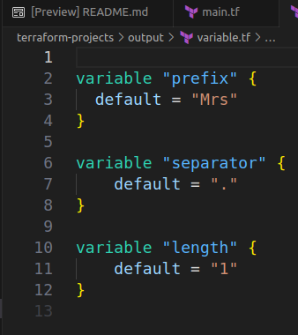
A-9
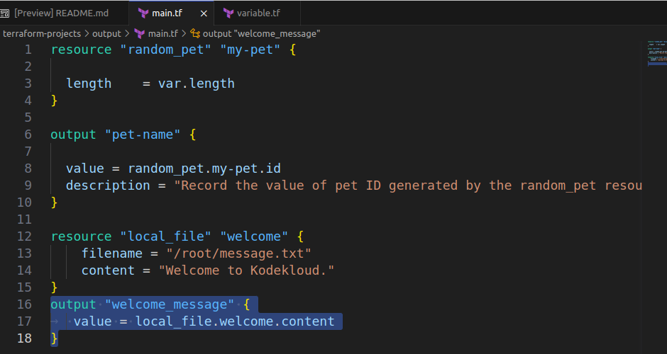

OUTPUT
