 

Integrated Development Project Report





**Elaborated by:**

Emira Obba

Ibrahim Boubaker

Mariem Ben Wahma

Mariem Khalfa

Mohamed Amine Smida

Sabrine Gmati

University year: 2018 - 2019 4 ERP-BI 3

**Index**

Introduction

I-Project Presentation

II-Market Study

II.1- Examples of the existing

II.2- Critic of the existing

II.3-Proposed solution

III-Functional Analysis

III.1-Functional requirements

III.2-Non-Functional Requirements

IV-Conception

IV.1-USE CASE DIAGRAM

IV.2-Class diagram

IV.3-System sequence diagram

IV.4-Gantt chart

V-Architectures

V.1-Logical Architecture

V.2-Physical Architecture

VI-Mock-up Designs

Conclusion

**List of Figures**

**Figure 1**: PeoplePerHour website

**Figure 2**: Upwork website

**Figure 3**: Use case diagram for the “Applicant”, “Resource” and “Customer “

**Figure 4**: Use case diagram for the “Recruitment manager “

**Figure 5**: Use case diagram for the “Admin “

**Figure 6**: Class diagram

**Figure 7**: Sequence diagram of the “Assign resource to mandate” case

**Figure 8**: Sequence diagram of the “Add resource” case

**Figure 9**: Gantt chart

**Figure 10**: Logical architecture

**Figure 11**:Physical architecture

**Figure 12**:Login view

**Figure 13**:Current mandates view

**Figure 14**:Add project view

**Introduction**

As part of our fourth year academic program, and in order to put into practice what we have learned through the first semester and the years before, we’ve been asked to develop a web application for a renowned Canadian company “Levio”.

Levio is a consulting company working in the field of information technology. He specialized in providing solutions and advice, among other services, to organizations supporting a digital transformation.

To do this, Levio brings together the best information technology (IT) specialists who apply their experience, knowledge, creativity and dedication to meet the needs of their customers and deliver the desired benefits.

This project, titled “MAP”, as in “Mandate, Assignation,Project”, aims to provide the company with the most effective tool to better manage its day to day work.

It consists in implementing an application for Levio, which will not only facilitate and organize the workflow in the company, but also allow the responsible to have an overall view on relevant information about the resources, clients, project …

II-Market Study

II.1- Examples of the existing

In this part, we will be studying the existent, which means, what already exists on the Market. a web applications dedicated for freelancers are available for users all around the world on the Internet. We chose three of them to talk about and describe. Let’s start with the first one:

Une image contenant capture d’écran, texte

Description générée avec un niveau de confiance très élevé

**Figure 1**: PeoplePerHour website

PeoplePerHour is a marketplace connecting small businesses and freelancers all over the world in a trusted environment where they buy and sell services to each other.

Une image contenant homme, personne, capture d’écran, assis

Description générée avec un niveau de confiance très élevé

**Figure 2**: Upwork website

Upwork is the world’s largest freelancing website and makes it easier for the world’s best businesses and independent professionals to find each other without the traditional barriers of set time and place.

II.2- Critic of the existing

The problems of the previously mentioned platforms are :

* Employee assignation to a project lacks security
* The platforms are not easy to use for a first-time user
* They are very time-consuming for the project owner as well as the employee when it comes to search for an opportunity (lots of fake/non-serious profiles, huge searching-result lists. . .)

II.3-Proposed solution

In order to meet our needs, we have decided to design and propose a flexible, high-performance and feature-rich solution through the implementation of a web application which is MAP .

It will use some of the positive aspects of the existing platforms:

* the freelancers’ management by their type of work, the skills management (add online tests)
* improve over security, usability
* time-management by automating most of the time-consuming process, like searching (by the use of intelligent and user-specific suggestions for both the project owner/client and the employee)
* administrative papers and mails will be filled and sent automatically, as well as the deadlines and the contract fees calculation

III-Functional Analysis

III.1-Functional requirements

III.2-Non-Functional Requirements

This phase is the operational viewpoint of the solution. To ensure the satisfaction of our users, our application must consider a set of non-functional requirements including:

* **Performance:**

Very fast response and processing time.

* **Capacity:**

Since our application is designed for a large community, it should be able thousands even millions of simple user and pro-users.

* **Availability:**

The software must be available all the time; users can edit or send information at any time.

* **Usability:**

The application has to be easy to use, with standard looking interfaces and with clear and beautiful visual style.

* **Maintainability :**

If any maintainability is needed, the software must be maintainable very fast so the enterprise business could not be on hold

IV-Conception

This part concerns the solutions that we have proposed for our web application. That’s why we will be presenting our different diagrams as well as some explanations.

IV.1-USE CASE DIAGRAM

A use Case diagram captures user's requirements by focusing on who (we mean the actor) wants to do what (use case), and also identifies functional requirements through users' scenario development. Here, we are going to present our global use case diagram for this, which means, it will contain all of our use cases for the entire application.

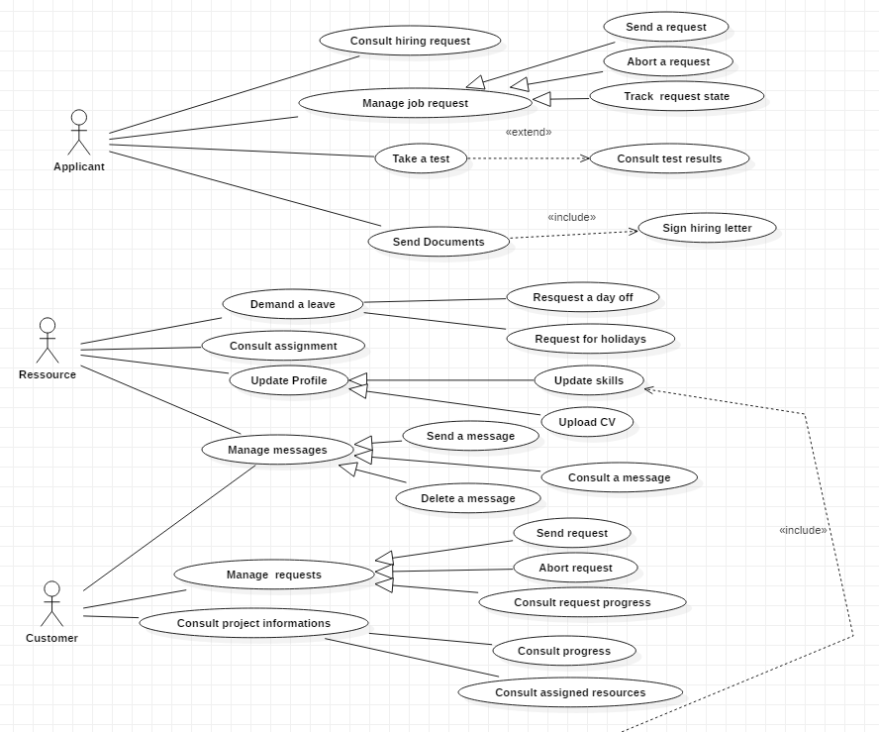

**Figure 3**: Use case diagram for the “Applicant”, “Resource” and “Customer “

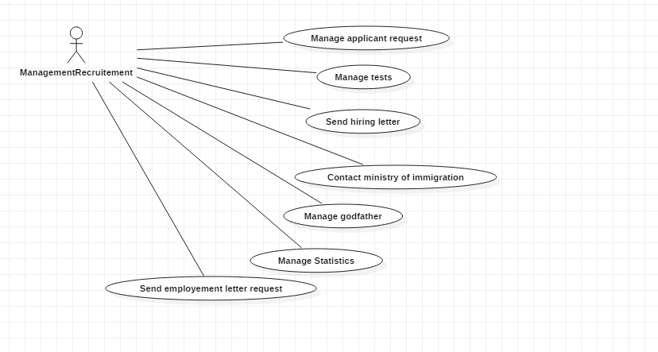

**Figure 4**: Use case diagram for the “Recruitment manager “

###### 

**Figure 5**: Use case diagram for the “Admin “

IV.2-Class diagram

The class diagram is a static diagram that represents the static view of an application. It does not only describe and document different aspects of a system by showing the system's classes, their attributes, operations (or methods), and the relationships among objects, but also for helps construct executable code of the software application. Here is our class diagram.

**Figure 6**: Class diagram

IV.3-System sequence diagrams

We are using the sequence diagram to show how objects operate and interact with one another in a specific time and order.

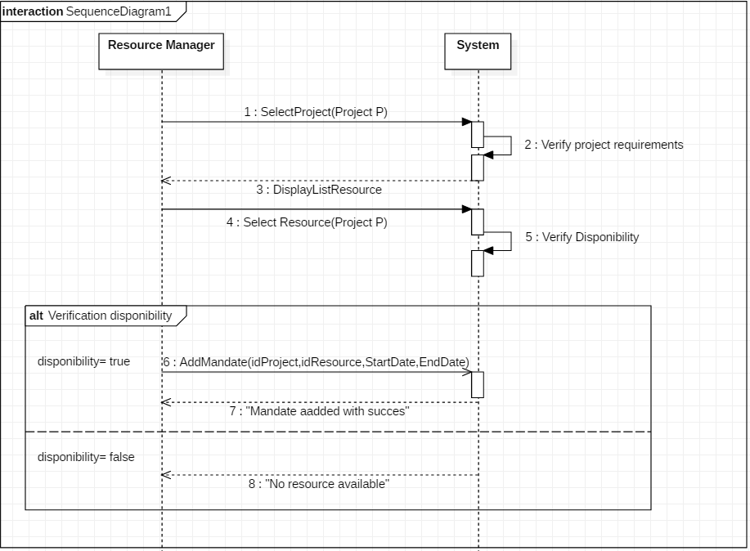

**Figure 7**: Sequence diagram of the “Assign resource to mandate” case

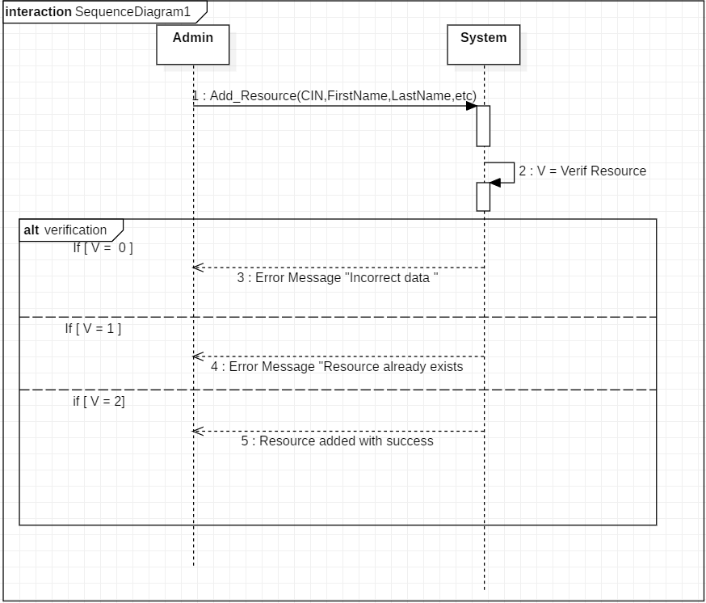

**Figure 8**: Sequence diagram of the “Add resource” case

IV.4-Gantt chart

To plan our work during Phase 1, we made the Gantt chart which is a project planning tool that allows us to visualize all the tasks and team members' deadlines, and where each task is assigned to a member of the team with its start and end dates.

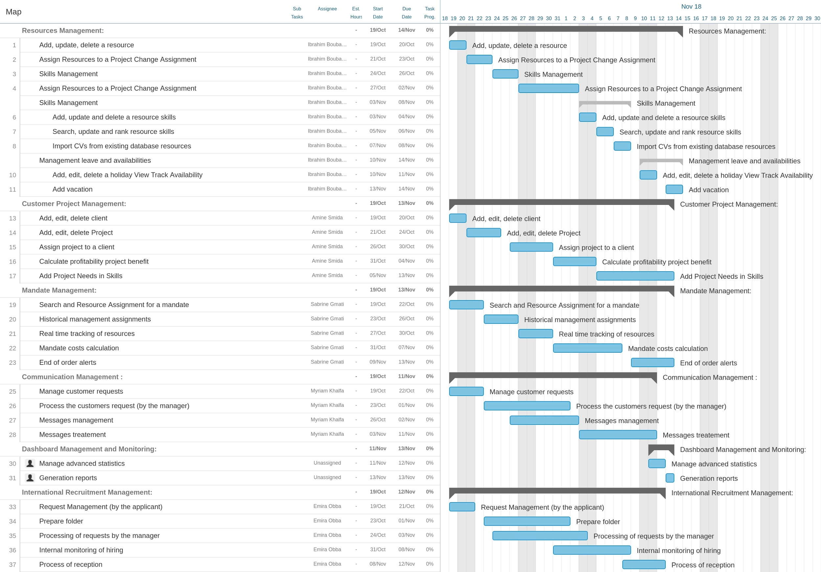

**Figure 9**: Gantt chart

VI-Architectures

V.1-Logical Architecture

Logical Architecture Model Development may be used as a task of the activity "Develop candidate architectures models and views", or a sub-process of the System Architecture Definition process. Its purpose is to elaborate models and views of the functionality and behavior of the future engineered system as it should operate, while in service.

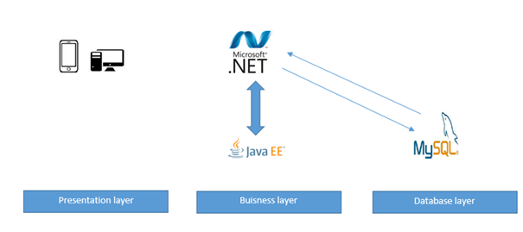

**Figure 10**: Logical architecture

**Presentation layer:** Responsible for presenting information to the user via graphical user interface.

**Business Layer:** consists of components that provide the business logic for an application. Business logic is code that provides functionality to a particular business domain, in a properly designed enterprise application, the core functionality exists in the business tier components.

**Data layer:** (Data persistence): represent the enterprise information system tier that handles EIS software and includes enterprise infrastructure systems, such as enterprise resource planning (ERP), mainframe transaction processing, database systems, and other legacy information systems.

V.2-Physical Architecture

The physical architecture is the physical layout of a system and its components in a schema. It refers to some representation of the structure or organization of the physical elements of the system. The physical architecture should be part of the Allocated and Product Baselines.

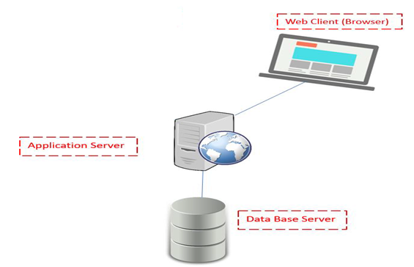

**Figure 11**:Physical architecture

**Client-Side:** Consist of physical personal computers or desktop computer stations. These use connections to make demands on servers.

**Server-Side:** Contains applications or operations are done within the hardware structures that are serving the requests of clients.

VI-Mock-up Designs

In this last part, we propose some mockups that will help to better visualize the future views of the application, in another word, our perception of the future application.

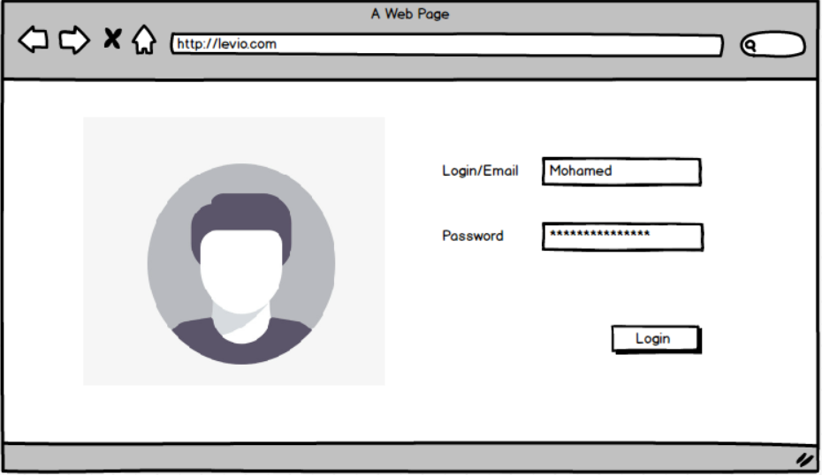

**Figure 12**:Login view

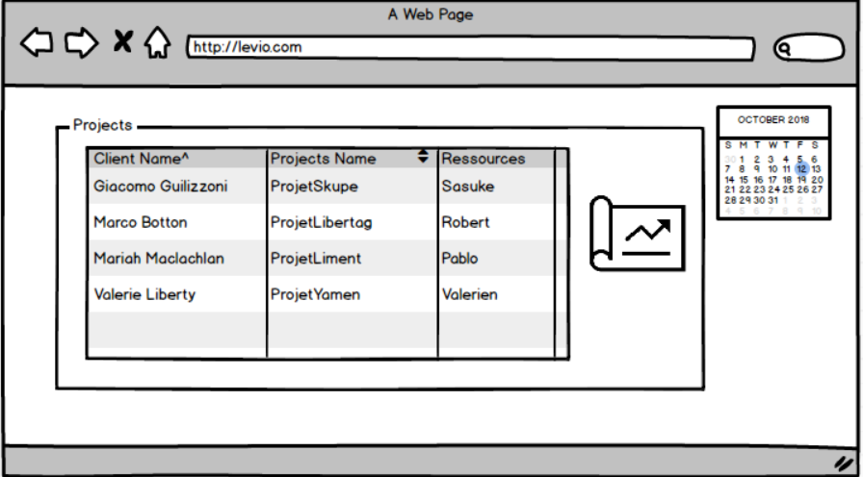

**Figure 13**:Current mandates view

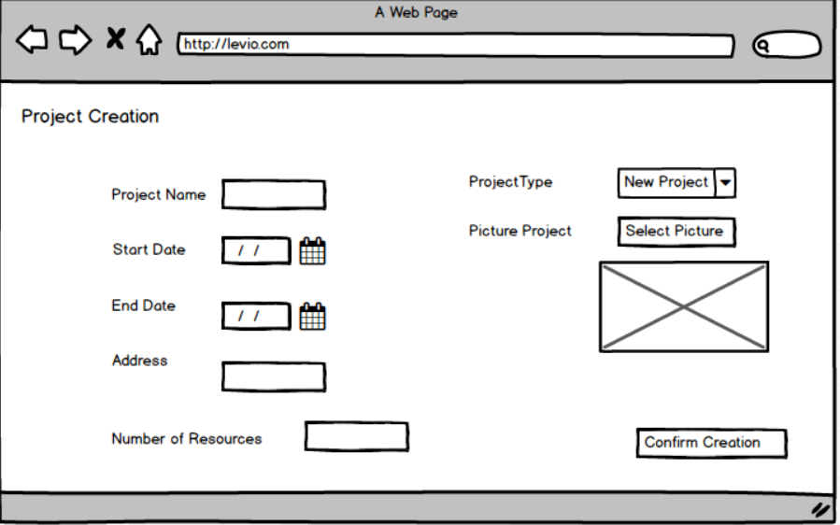

**Figure 14**:Add project view

Conclusion