Technical Solution Description
T-Systems Verification Work
MMS

Likhandristov A.V.
a.likhandristov@gmail.com

Saint Petersburg 2017

Content

Content 2
1. Introduction 3
2. Goals 3
2.1 Selling online 3
2.2 Automate customer service 3
3. Technologies 4
4. Additional features 5
5. Database schema 6
6. Database overview 7
7. User interface 8
8. Business logic 10
9. DAO 13
10. Tests 14
11. Build and deploy 15
12. Logging 15
13. Security checks 15
14. Statistics 16
15. Next releases features 17

1. Introduction

In today's online shopping obsessed culture, consumers and businesses alike are learning that simply delivering goods and services are becoming increasingly obsolete. That said, we can see why store is important part of web and internet.

2. Goals

2.1 Selling online

Main goal of Internet Store project is selling online. The most well known goal for Online Businesses where you're looking for an extra channel to push your products whether it's make-up, clothes, shoes, pet products etc.

2.2 Automate customer service

Are you spending a large part of your day getting interrupted by customer care phone calls instead of working on your business? You need an Online Business to be automating some of that for you.

3. Technologies

In project I have been using numbers of technologies, all of them you can observe in the list below:
— IDE Intellij Idea;
— Wildfly 10.1;
— DB – MySQL 5.7;
— Maven;
— JPA 2.1;
— Hibernate 5.2.9;
— Slf4J with logback 1.1.7;
— JUnit 4.12;
— Spring Framework 4.3.5 (core, test, mvc, forms, aop, security);
— JSP;
— PrimeFaces Push;
— Java EE 7;
— Apache Tiles;
— EJB 3.2;
— JSF 2.2;
— Apache Artemis MQ;
— JQuery;
— WebServices (SOAP).

4. Additional features

There are some features implemented which are not in the main task:
— Deleting products;
— Remember me check-box;
— Autofill forms;
— Upload images;
— Date picker;
— Asynchronous push to front-end in advertising stand.

5. Database schema

For a quick reference, see the database diagram below:

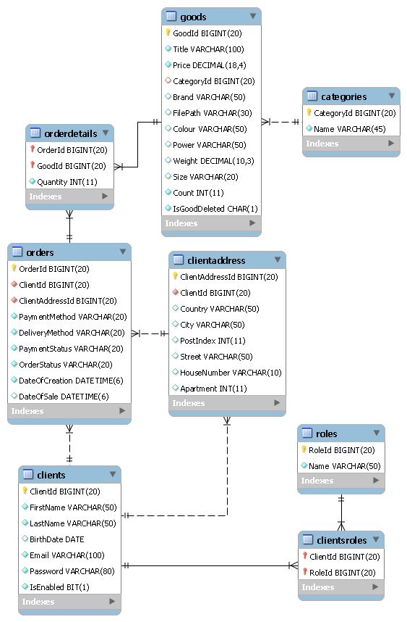
6. Database overview

In this section, we will step through the types of tables in database and what their purposes are:

— Categories stores category information;
— Goods stores information about products;
— OrderDetails identifies quantity of item bought in the order;
— Orders stores all information about orders;
— ClientAddress stores addresses of clients;
— Clients store password, logging information and all user-related information;
— ClientRoles identifies what roles belong to user;
— Roles store role information.
As we can observe there are relations around orders, clients and addresses. That is due to the fact we should have many addresses relates to client (work, home, etc) and one-to-one relation between address and order (actual address of delivery).
Furthermore, client can participate in application as many roles. Whether he could be admin or user at the same time.
Third, there is one-to-many relation between categories and goods. That is because product can only be one type category, hierarchical categories have not been supported yet.
The interesting part is goods and orders relation. This as we can see passes through orderdetails which is used to store quantity of items bought.

7. User interface

User interface developed using JSP contains jstl, spring security tags, apache tiles. Main page template stored in /WEB-INF/jsps/tiles/default.jsp. Template contains header and content Dynamic elements of views are using js and ajax.
JQuery UI library is used for spinner, search element. Css provides fade in animation in products page.

Main page:
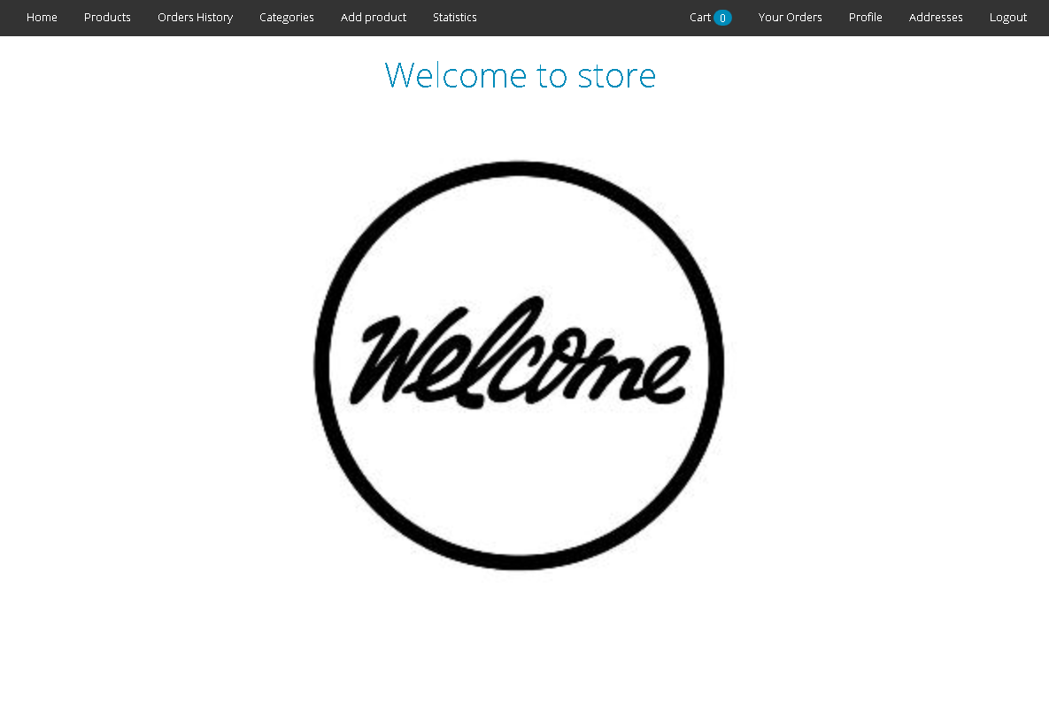

Profile page:
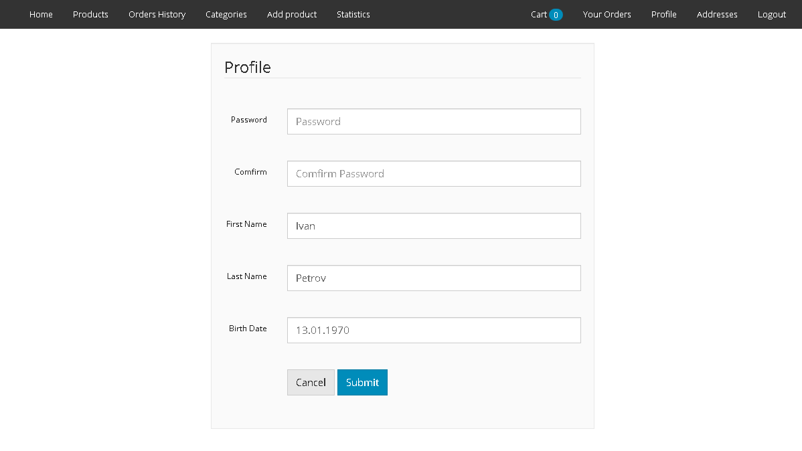
Catalogue:
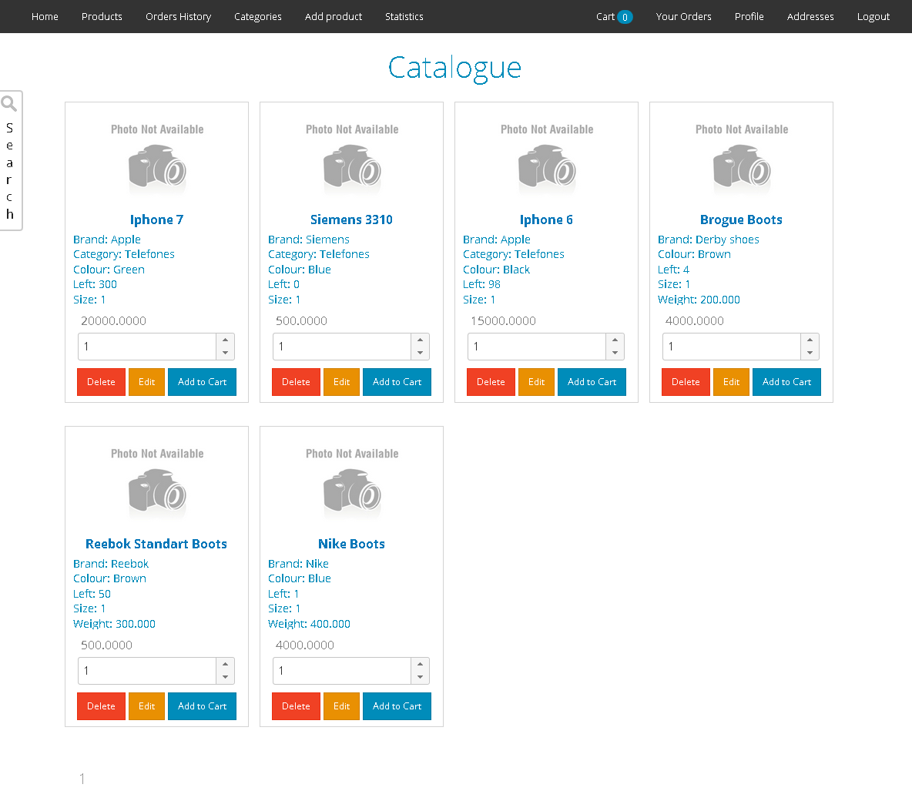

8. Business logic

Service layer consists of GenericService and its implementation. Each of the service implementation classes is annotated with a @Service annotation. Transactions are declared at this level, each method of the service is performed in a transaction. The methods are annotated with @Transactional annotation, therefore Spring handles transactions.
In runtime of the application exceptions might be thrown. Exceptions of business logic explained below:
— ItemNotFoundException is used when application can not find entity with the supplied id;
— OutOfStockException handles situation when there is not enough items we are trying to reserve;
— VerificationException is thrown in situation where user are not available to familiarize requested information.
The following list of services:
— CategoriesService handles all operations with categories;
— ClientService provides functionality for creating an account;
— GoodsService is used for operations with goods entity;
— JMSService (java message service) is used for connection to artemis mq on the wildfly server;
— LoginService provides user details for spring security;
— OrderDetailsService handles saving information about items bought in an order;
— OrdersService is used for creating orders, changing status of orders;
— PaginatorService provides lists of information used for pagination;
— ProfileService can change user's information;
— ReserveService prevents products being sold twice;
— ResolverService returns list of entities by provided list of identifiers;
— ShoppingCartService handles shopping cart functionality;
— StatisticsService asks dao-layer for retrieving statistics information stored in data transfer objects;
— TopGoodsWs is responsible for creating soap web-service;
There is exemplary diagram of macro-level business logic:
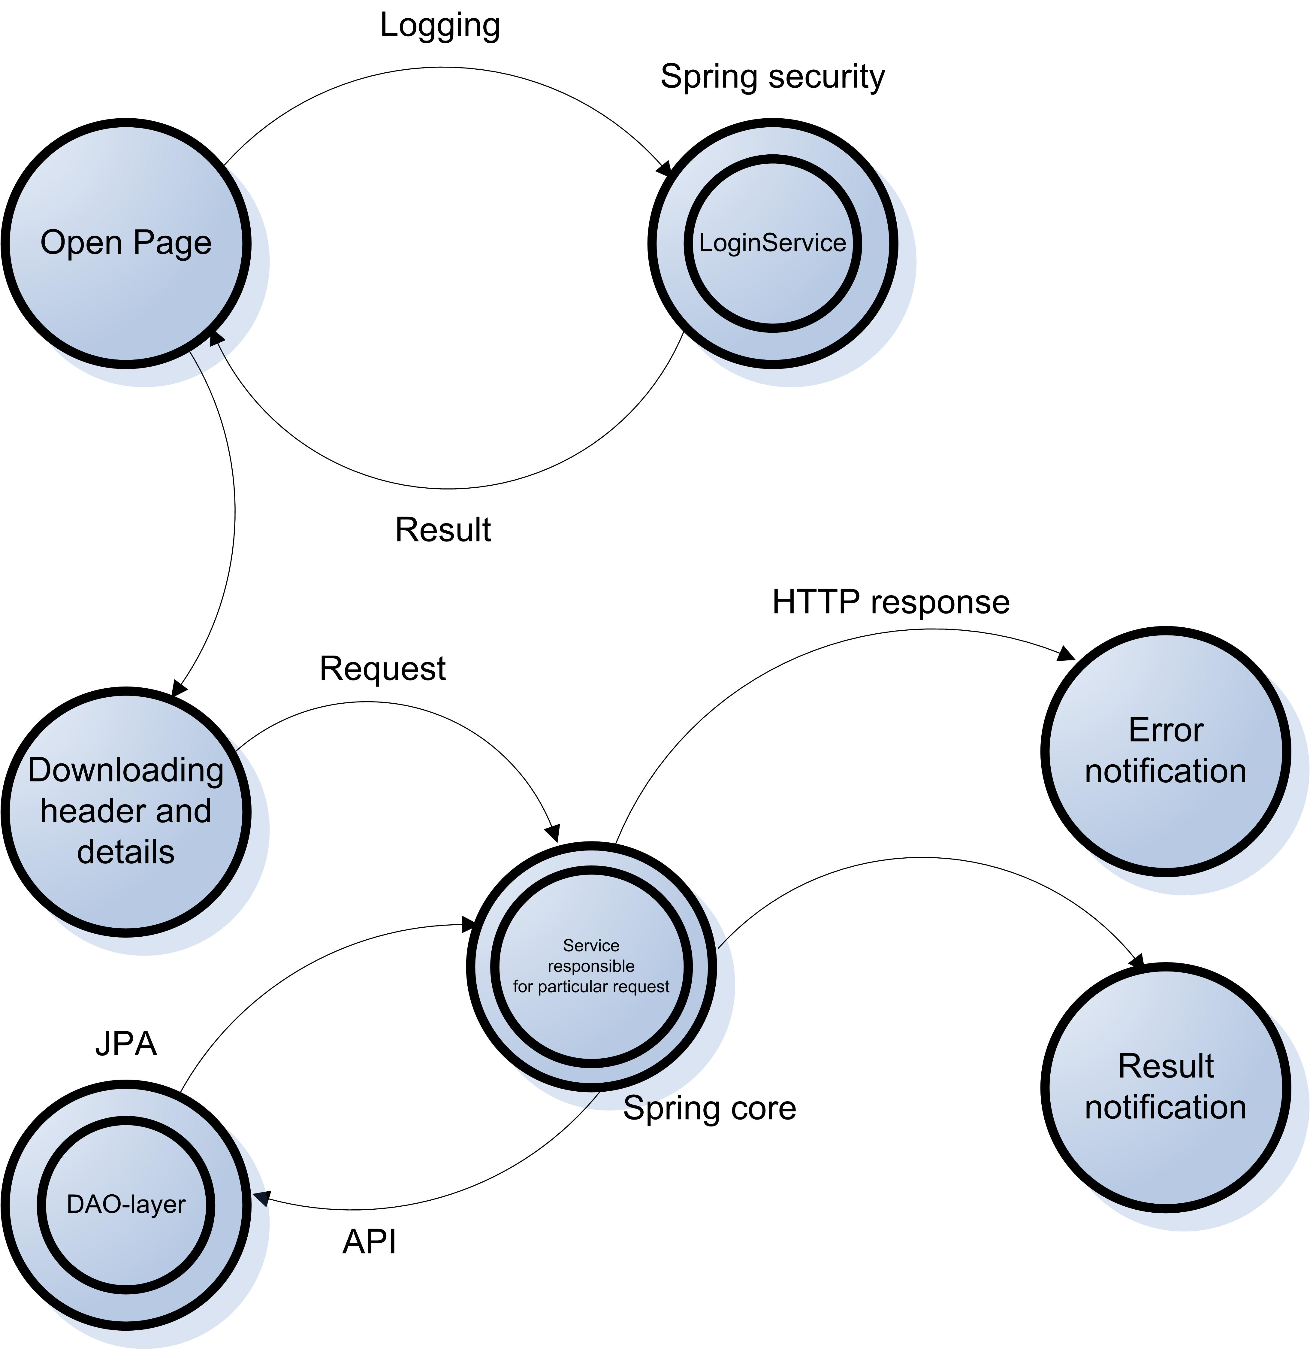

9. DAO

DAO layer is based on hibernate using JPA API, JPQL queries, MySQL5Dialect. Enums are used for storing status information of orders.
Database access layer is using models which are validate existing database with "hbm2ddl.auto=validate" configuration. That means none changes take place into existing database structure.
Besides models which copy database structure there are database transfer objects such as StatisticsClients and StatisticsGoods. These DTO provide convenient way of whether transferring information to view or to other service.
Transactions are handled by @Transactional feature of spring in service layer of the application.
GenericDao is an abstract class which provides base functionality of deleting, changing, creating rows in database. All other classes extends this class with additional features that are used in service layer.
You can familiarize with list of extending classes below (for more information please see section 5 and 6):
— CategoriesDao;
— ClientAddressDao;
— ClientsDao;
— GoodsDao;
— OrderDetailsDao;
— RolesDao;
— OrdersDao.

10. Tests

Overall, application has integration fifty eight integration tests which are combined into one test suite. These tests are using JUnit runner 4. Fifty lines of code are covered.
There are SonarQube using jacoco statistics about test coverage:
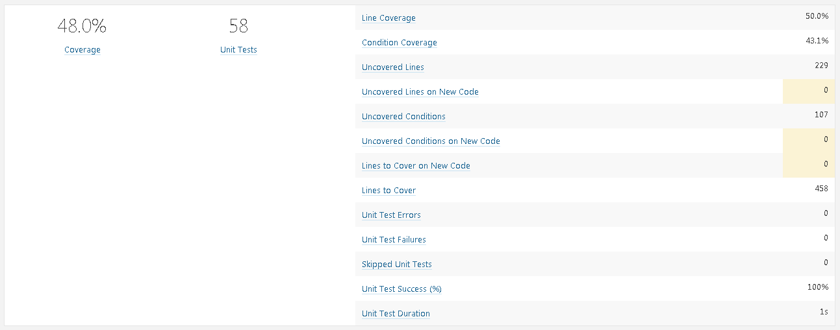

11. Build and deploy

Build may be done by one command below:
— mvn clean install;
Furthermore, it is possible to deploy the project by one command from root folder:
— mvn wildfly:deploy;

12. Logging

Slf4j with logback are used in the project for logging. It is configured to log exceptions and important information about what user are doing. Logging might be useful for statistics. Every day program does rollback of log file in archive folder.
Short example of logging file content is in image below:
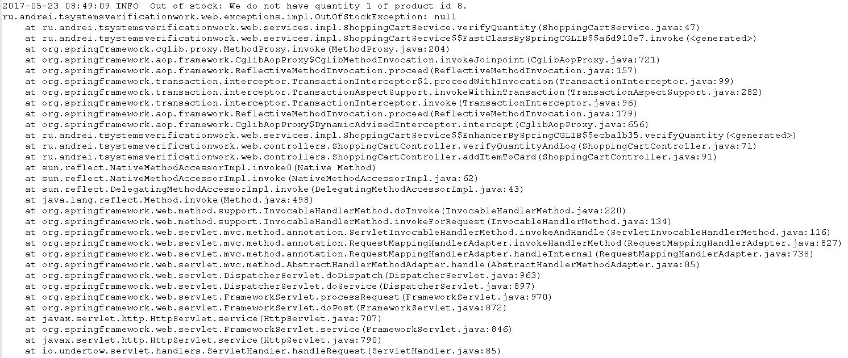

13. Security checks

Spring security provides security purposes for authorization of users. Access list identifies whether user is allowed to see requested information or not. Besides, in this project @Secured annotation is used for additional security level. This annotation ensures privileges on the method level.
Furthermore, I must say that additional verification was needed in the project, due to this fact methods that provide advanced functionality were developed.

14. Statistics

In the project SonarQube 6.3 was used for statistics. It is written in Java but is able to analyse code in about 20 different programming languages.
The results of an analysis are shown in an images below:

Quality Gate:
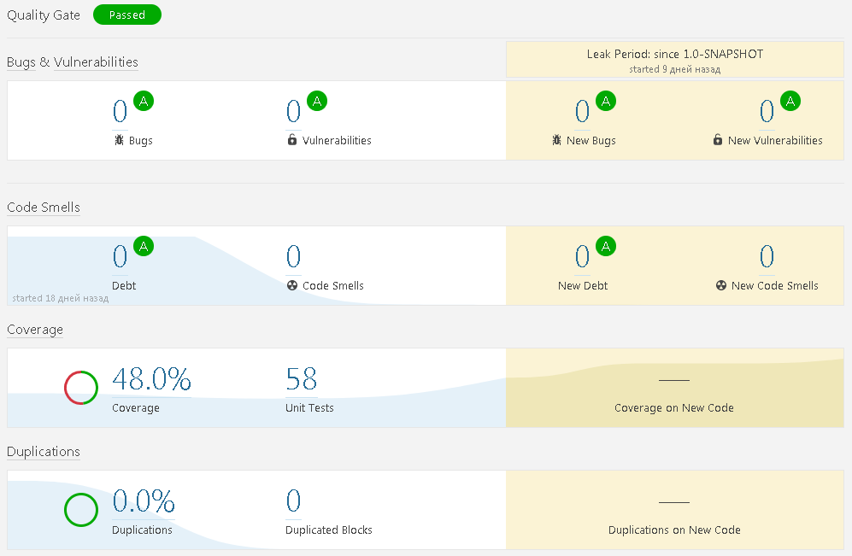
Code size:
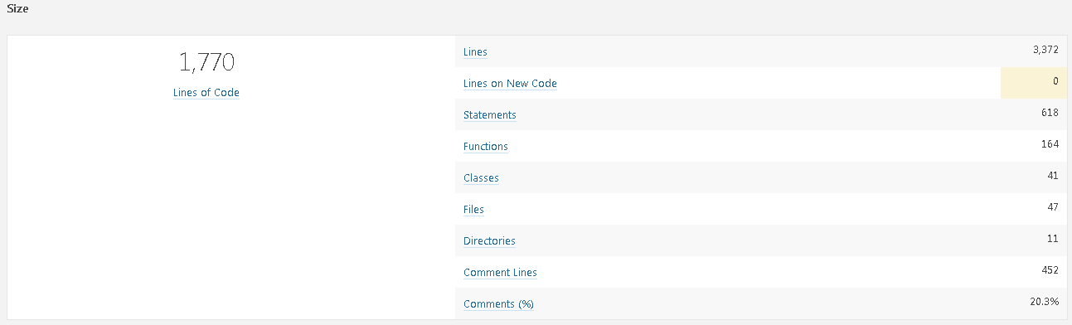

Complexity:
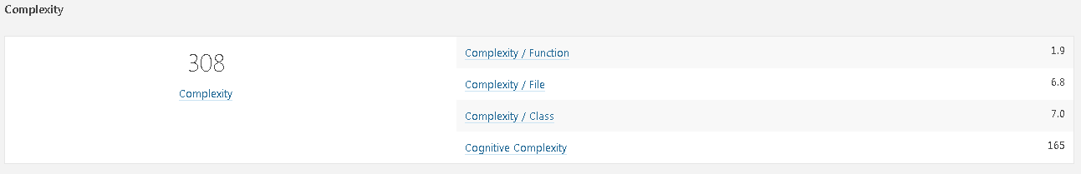
The important thing is numbers of code bugs, vulnerabilities and code smells which are eliminated. Complexity of methods is 1.9 due this we can say they are written simple avoiding complexity as much as possible. Source code is compact (1770 lines), simple and satisfies SonarQube requirements.

15. Next releases features

Some features which have not been developed yet may be included in the future:
— Uploading images to advertising stand using sockets or queue;
— Mobile optimization;
— Image galleries (more than one image per product shown in details);
— Discount information and user notification of current discounts or any other information in news bar;
— E-mail notifications.

