# MODELOS

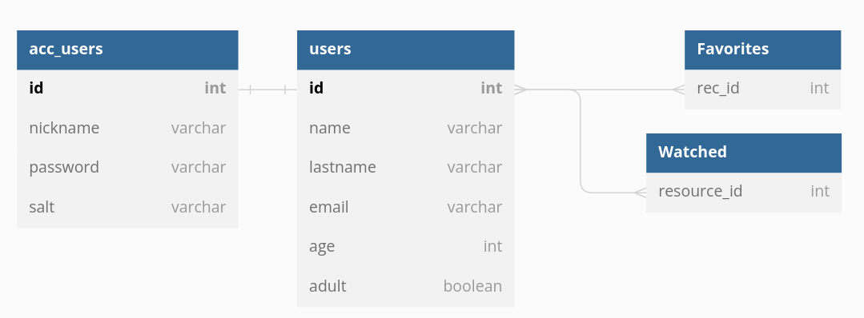

# **ROUTES**

## AccUser

|  |  |  |  |
| --- | --- | --- | --- |
| Objetivo | Req.Body/Params | Tipo | URL Completa |
| Pedido de HTML de LogIn | -nickname  -password hasheada | GET | /API/ACCUSER/ |
|  |  |  |  |
|  |  |  |  |
|  |  |  |  |