John Geddes

CS 460G

Homework 3 Report

March 5, 2018

**Implementation Decisions**

I decided to use Python 2.7 in this project. There was no particular reason other than it was already installed on my computer.

For the learning rates (alpha values) of the regression, I decided to initialize a list of alpha values, one for each coefficient rather than have one alpha value for the whole polynomial. I did this because I was having problems with degree 9 polynomial regression where the coefficients would diverge at the same rate and I thought that maybe having different learning rates for each coefficient would fix something. This didn’t fix anything but I kept the list of alpha values anyway because it decreased the mean squared error in most predictions.

I implemented a system that modifies the alpha values if the gradients are changing too much. If the gradient of a certain coefficient from one iteration flips sign going to the next iteration (i.e. goes from positive to negative or vice versa), then I divide that coefficient’s corresponding alpha value by 2. Then I discard the calculated gradient and coefficients and restart the current iteration. This ensures that if the gradients are changing sign, then the coefficients are not modified.

When initializing the alpha values, I first used the formula $α=1/2^{order}$, but when the order of the polynomial was 9, then the coefficients would grow out of control and become larger than the size of the float type. So, I then started trying to increase the exponent on the denominator until it didn’t crash. It stopped crashing when the initial alpha values were $α=1/2^{11}$. I then kept increasing the exponent until the mean squared error of the third synthetic data set was the smallest. This value turned out to be $α=1/2^{15}$. The other 3 polynomials with order 1, 2, and 4 still follow the formula $α=1/2^{order}$.

I used full batch gradient descent to complete this homework. I decided this because it uses the error as the cost function and I already needed the error of the entire data set for the final report. I wouldn’t have to write any more methods, so I chose full batch. The stopping criteria that I decided on were if the number of iterations reached 1000 or if the current error was less than 0.01 different from the last iteration’s error. I initialized all of the coefficients to 1.0 because I didn’t care to find better initial values. At first, I initialized the coefficients to random floats between -2.0 and 2.0 but that produced unreliable results.

The following pages include the graphs and plots of the polynomial predictions and the data of the corresponding data set. Beneath each figure is a list of the final mean squared errors and final lists of coefficients after the end of each training model. The coefficients are listed in increasing order:

$$polyprediction=θ_{0}+θ_{1}x^{1}+…+θ_{k}x^{k}$$

Where $θ_{0}$ is the first coefficient in the list, $θ_{k}$ is the last coefficient in the list, and *k* is the degree of the polynomial.

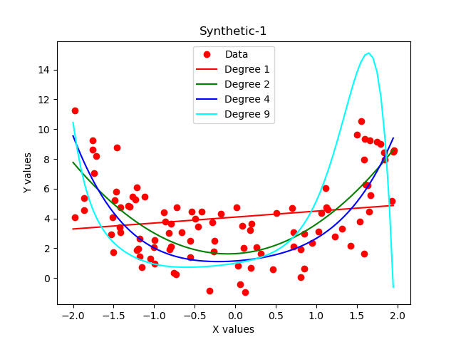

Polynomial regression on synthetic data set 1 with degree 1

Final error: 7.18366103686

Final coefficients: [4.090208177922414, 0.3995482121268575]

Polynomial regression on synthetic data set 1 with degree 2

Final error: 3.78903841182

Final coefficients: [1.6328754375056613, 0.29840250074263636, 1.6814256060676838]

Polynomial regression on synthetic data set 1 with degree 4

Final error: 4.4279410882

Final coefficients: [1.141882671646953, 0.38348786651187433, 0.8725098021678676, -0.06421983355814324, 0.3229668094724452]

Polynomial regression on synthetic data set 1 with degree 9

Final error: 17.636906353

Final coefficients: [0.9860461874994336, 0.8736265653227682, 0.929565199537626, 0.7486390964070065, 0.8091386228228447, 0.4905697753673382, 0.5163149369805556, 0.08084880380040534, -0.1940825899211199, -0.08440900473044644]

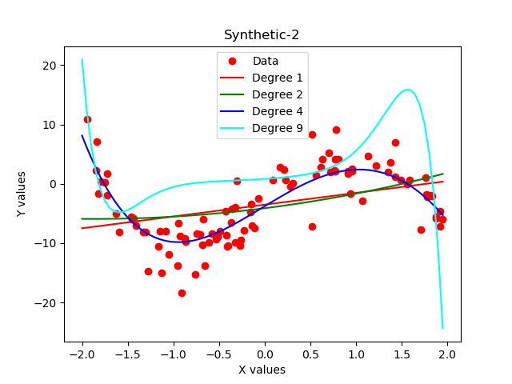

Polynomial regression on synthetic data set 2 with degree 1

Final error: 31.0631649517

Final coefficients: [-3.5142673723147757, 1.9872698087710274]

Polynomial regression on synthetic data set 2 with degree 2

Final error: 30.4525148521

Final coefficients: [-4.1100079364860145, 1.9412284026447069, 0.5225454453830229]

Polynomial regression on synthetic data set 2 with degree 4

Final error: 9.21972656872

Final coefficients: [-3.774063918656481, 9.314062446909677, -0.2913278123004497, -3.221324515159557, 0.36963309637664743]

Polynomial regression on synthetic data set 2 with degree 9

Final error: 65.1879707608

Final coefficients: [0.828537359354024, 0.9979007383269785, 0.8171174934967845, 0.9505046803735148, 0.6834701491709726, 0.8401928924612883, 0.3881593531185798, 0.5271839901959795, -0.1961818522817421, -0.2641429629620559]

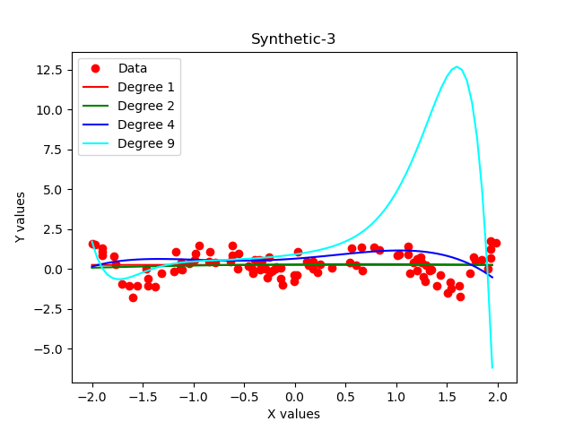

Polynomial regression on synthetic data set 3 with degree 1

Final error: 0.628723906088

Final coefficients: [0.24236860480977573, -0.0015380082125387926]

Polynomial regression on synthetic data set 3 with degree 2

Final error: 0.635971197418

Final coefficients: [0.2782444862201892, 0.0443044427664584, -0.03076602234717682]

Polynomial regression on synthetic data set 3 with degree 4

Final error: 1.05095673186

Final coefficients: [0.6367087431742844, 0.4604341377410164, 0.38032888595861086, -0.17235726130020293, -0.15462243592498112]

Polynomial regression on synthetic data set 3 with degree 9

Final error: 27.1909957459

Final coefficients: [0.907311869268698, 0.8728806836897512, 0.8388367520545125, 0.7507721820998212, 0.6795037851131148, 0.5073963344667769, 0.3681434225279472, 0.11436109721093106, -0.17652165374478004, -0.09147452115124771]